**Linked2Safety**

**FP7-288328**



***A Next-Generation, Secure Linked Data Medical Information Space for Semantically-Interconnecting Electronic Health Records and Clinical Trials Systems Advancing Patients Safety in Clinical Research***

**Deliverable D6.4**

**Linked2Safety Platform Release Engineers and Installation and End-User Guide**

|  |  |
| --- | --- |
| **Editor(s):** | Panagiotis Hasapis, Christos Georgousopoulos (INTRASOFT), Dimitris Ntalaperas (UBITECH), Aris Aristodimou (UCY), Cristi Potlog (SIVECO), Yasar Khan, Aftab Iqbal (NUIG) |
| **Responsible Partner:** | INTRASOFT INTERNATIONAL S.A. |
| **Status-Version:** | Final – v1.0 |
| **Date:** | 30/9/2014 |
| **EC Distribution:** | Public |

|  |  |
| --- | --- |
| **Project Number:** | FP7-288328 |
| **Project Title:** | Linked2Safety |

|  |  |
| --- | --- |
| **Title of Deliverable:** | Linked2Safety Platform Release Engineers Installation and End-User Guide |
| **Date of Delivery to the EC:** | 30/9/2014 |

|  |  |
| --- | --- |
| **Work package responsible for the Deliverable:** | WP6 - Linked2Safety Platform Integration and Testing |
| **Editor(s):** | INTRASOFT |
| **Contributor(s):** | SIVECO, UBITECH, NUIG, UNIMAN, UCY |
| **Reviewer(s):** | UBITECH |
| **Approved by:** | All partners |

|  |  |
| --- | --- |
| **Abstract:** | The current deliverable presents an end-user guide of the prototype Linked2Safety platform as well as an installation guide of all software components in the final release of Linked2Safety. |
| **Keyword List:** | end-user guide, installation guide, configuration manual |

**Document Description**

**Document Revision History**

|  |  |  |  |
| --- | --- | --- | --- |
| *Version* | *Date* | *Modifications Introduced* | |
| *Modification Reason* | *Modified by* |
| 0.2 | 1/9/2014 | Table of contents creation | INTRASOFT |
| 0.3 | 5/9/2014 | Input for sections “Introduction”, and ToC | INTRASOFT, UBITECH |
| 0.7 | 6/9/2014 | Input for sections Configuration | INTRASOFT, SIVECO,UCY,NUIG |
| 1.0 | 8/9/2014 | Final version | INTRASOFT |

**Contents**

Executive Summary 12

1. Introduction 13

1.1 Architecture 13

1.2 Topology 15

2. Installation and Configuration Guide 16

2.1 Linked2Safety Closed-World Room Software Components 16

2.1.1 Schema Mapping and Alignment Component 16

3. Configuring the application 20

3.1 Linked2Safety Public-Access Room Software Components 20

3.1.1 Non-Identifiable Data Cubes Creation Component 22

3.1.2 RDFizer Component 22

3.2 Linked2Safety Public-Access Room Software Components 24

3.2.1 Public Key Infrastructure Configuration and Installation 24

3.2.2 Galaxy Web Server Configuration and Installation 25

3.2.3 Installation of components in Galaxy Web Server 26

3.2.4 Annotation and Enrichment Tool 28

3.2.5 Query Interface 28

3.2.6 Data Access Mechanism Configuration and Installation 28

3.2.7 Federated Query Engine Configuration and Installation 28

3.2.8 Knowledge Base Configuration and Installation 30

3.2.9 RDF Triplestore Configuration and Installation 30

3.2.10 Linking Component 31

3.2.11 Periodic Validation of Workflow Results 32

4. Linked2Safety Platform End-User Guide 33

4.1 Mapping and Transformation Mechanism Usage 33

4.1.1 User Guide 33

4.1.1.1 Mapping Tool 34

Using Medical Dictionary for Regulatory Activities *(MedDRA)* 34

Creating a new mapping file 35

Editing an existing mapping file 38

Setting associations between raw file attributes and common schema attributes 40

Transformation Tool 43

Selecting necessary files 44

Generating transformed and aligned data 46

4.2 Annotation And Enrichment Mechanism Usage 47

4.2.1 User Guide 47

4.2.2 Main Canvas 48

4.2.3 Annotation Panel 49

4.2.4 Policy Editor 51

4.3 Galaxy Web Server and Components Usage 52

4.3.1 Query Interface 52

4.3.2 Pre-processing 53

4.3.2.1 Set the Target Variable 53

4.3.2.2 Quality Control 54

4.3.2.3 Non-Applicable Data Test 56

Processing 57

4.3.2.4 Single Hypothesis Testing 57

4.3.2.5 Dimensionality Reduction 62

4.3.2.6 Data Mining 66

4.3.2.7 Random Forest Cross Validation 71

4.3.3 Visualization 73

4.3.3.1 Profiles of Each Adverse Event Barchart 73

4.3.3.2 Adverse Events of Each Profile Bar chart 74

4.3.3.3 Profile Management 75

4.3.3.4 Adverse Events Detection 81

4.3.3.5 Generate Safety Alerts 82

4.3.3.6 Safety Alerts Notification Subscription 83

4.3.3.7 Safety Alerts Notification Un-subscription 86

4.3.3.8 View Safety Alerts Notifications 86

4.3.3.9 View Safety Alerts Notification Subscription 88

4.3.3.10 Visualization of Associations 89

Conclusions 92

References 93

APPENDIX A: Linked2Safety Software Components Listing 95

1. Query Interface 95

2. Knowledge Base Search 95

3. Periodic Validation of Workflow Results 95

4. Interoperable EHR Data Space Tools 95

5. Data Analysis Space and Database 96

Dimensionality Reduction Programs 98

Rough Set Dimensionality Reduction 98

Information Gain Dimensionality Reduction 98

Chi Squared Dimensionality Reduction 99

Decision Trees (Cross Validation) 99

Random Forest (Percentage Split) 99

Decision Trees (Percentage Split) 100

Profile Management Programs 102

Create Virtual Profile 102

Modify Virtual Profile 102

Delete Virtual Profile 103

View Virtual Profiles 103

Adverse Event Early Detection Mechanism Programs 104

View Safety Alerts Notifications 104

Generate Safety Alerts 104

Safety Alerts Notification Subscription 105

Safety Alerts Notification Unsubscription 107

View Safety Alert Notification Subscription 107

Setting of Permissions of Folders and Files 108

**List of Figures**

Figure 1: Linked2Safety Conceptual Architecture Reference 14

Figure 2: The Linked2Safety Platform. Figure presents the arrangement of closed-world room, public access and the Galaxy Web Portal 15

Figure 3 - DatacubeRDFizer configuration file 23

Figure 4 : User interface of the binomial logistic regression 27

Figure 5 : An example of the tool_conf.xml file 27

Figure 6 : Federated Query Engine Configuration File 29

Figure 7 : List of SPARQL Endpoints required for Query Federation 30

Figure 8: Apache Jena configuration file 31

Figure 9: Mapping and Transformation Tools home page 33

Figure 10: Mapping tool – Common EHR Variables 34

Figure 11: Mapping tool – with MedDRA Taxonomy 35

Figure 12: New mapping file - Dialog prompt 36

Figure 13: New mapping file – Browsing the file system 36

Figure 14: New mapping file – User selected a raw file 37

Figure 15: Open mapping file - Browsing the file system 39

Figure 16: Open mapping file - User selected a file 39

Figure 17: EXCEL file has been loaded 40

Figure 18 : Performing some mappings 41

Figure 19: Adding mapping 42

Figure 20: Saving the mapping file 43

Figure 20: Transformation tool 44

Figure 21: Transformation - Selecting input file 45

Figure 22: Transformation - Selecting mapping file 45

Figure 23: Transformation - Selecting output path 46

Figure 24 : Transformation - Progress Bar 46

Figure 25: Transformation - Notification message 47

Figure 26: Semantic Enrichment Basic Screen 48

Figure 27: Browsing for an RDF data cube 48

Figure 28: Graph representation of RDF cube 49

Figure 29: Annotation Menu 50

Figure 30: Main screen of the policy Editor 51

Figure 31: First pane of the Policy Editor. The name of the policy, the variables of the data cube that these policy will be applied to and further information about the policy can be applied here. 51

Figure 32 : User profile definition. 52

Figure 33 : Editing an existing Policy 52

Figure 34: Query Interface with the MedDra taxonomy presented 53

Figure 35: User interface of the Set the Target Variable tool 54

Figure 36: Output of the Set the Target Variable tool 54

Figure 37: User interface of the Hardy-Weinberg Equilibrium test 55

Figure 38: Output of the Hardy-Weinberg Equilibrium test 56

Figure 39: User interface of Non-Applicable data test 56

Figure 40: Output of the Non-Applicable Data Test 57

Figure 41: User interface of the Pearson’s Chi Square Test 58

Figure 42: Output of Pearson’s Chi Square Test 59

Figure 43: User interface of the Fisher’s Exact Test 59

Figure 44: Output of Fisher’s Exact Test 59

Figure 45: User interface of the Binomial Logistic Regression 60

Figure 46: Output of Binomial Logistic Regression 60

Figure 47: User interface of the Linkage Disequilibrium tool 61

Figure 48: Output of the Linkage Disequilibrium tool 61

Figure 49: User interface of the Odds Ratio tool 62

Figure 50: Output of the Odds Ratio tool 62

Figure 51: Rough Set Dimensionality Reduction 63

Figure 52: Output of Rough Set Dimensionality Reduction 64

Figure 53: Information Gain Dimensionality Reduction 64

Figure 54: Output of Information Gain Dimensionality Reduction 65

Figure 55: Chi Squared Dimensionality Reduction 65

Figure 56: Output of Chi Squared Dimensionality Reduction 66

Figure 57: Association Rules 66

Figure 58: Output of Association Rules 67

Figure 59: Decision Trees Percentage Split 67

Figure 60: Decision Tree Visualization 68

Figure 61: Association Rules of Decision Trees Percentage Split 68

Figure 62: Decision Trees Cross Validation 69

Figure 63: Decision Tree Visualization 70

Figure 64: Association Rules of Decision Trees Cross Validation 70

Figure 65: Random Forest Percentage Split 70

Figure 66: Random Forest Visualization 71

Figure 67: Association Rules of Random Forest Percentage Split 71

Figure 68: Random Forest Cross Validation 72

Figure 69: Random Forest Visualization 72

Figure 70: Association Rules of Random Forest Cross Validation 73

Figure 71: Profiles of Each Adverse Event Barchart 73

Figure 72: Output of Profiles of Each Adverse Event Bar chart 74

Figure 73: Adverse Events of Each Profile 74

Figure 74: Output of Adverse Events of Each Profile 75

Figure 75: Login Screen of Create Virtual Profiles 76

Figure 76: Create Virtual Profile 77

Figure 77: Confirmation of Virtual Profile Creation 77

Figure 78: Login Screen of View Virtual Profiles 77

Figure 79: All Profiles of the User 78

Figure 80: Login Screen of Modify Virtual Profiles 79

Figure 81: Select A Virtual Profile to Modify 79

Figure 82: Modify Virtual Profile 80

Figure 83: Confirmation of Modification of Virtual Profile 80

Figure 84: Login Screen of Delete Virtual Profiles 81

Figure 85: Select Profiles to Delete 81

Figure 86: Confirmation of Deletion of Virtual Profiles 81

Figure 87: Login Screen of Generate Safety Alerts Notifications 82

Figure 88: Select Profiles to Generate Safety Alerts 83

Figure 89: Safety Alerts of Profiles 83

Figure 90: Login Screen of Safety Alerts Notification Subscription 84

Figure 91: Select Profiles to Subscribe to Safety Alerts Notification 85

Figure 92: Schedule Safety Alerts Notifications 85

Figure 93: Confirmation of Safety Alerts Notifications Subscription 86

Figure 94: Login Screen of Safety Alerts Notification Un-subscription 86

Figure 95: Select Profiles to Unsubscribe to Safety Alerts Notification 86

Figure 96: Confirmation of Safety Alerts Notifications Un-subscription 86

Figure 97: Login Screen of View Safety Alerts Notifications 87

Figure 98: Safety Alerts Notifications of Profiles 88

Figure 99: Login Screen of View Safety Alert Notification Subscriptions 88

Figure 100: View Safety Alerts Notification Subscriptions 89

Figure 101: User interface of the Associations Bar Chart tool 89

Figure 102: Output of the Associations Bar Chart tool 90

Figure 103: User interface of the Associations Box Plot tool 90

Figure 104: Output of the Associations Box Plot tool 91

**List of Tables**

Table 1: Definitions, Acronyms and Abbreviations 11

Table 2: Revision List of Schema Mapping and Alignment Component 33

Table 3: Revision List of Query Interface Component 53

Table 4: Revision List of Quality Control Components 55

Table 5: Revision List of Single Hypothesis Testing Components 57

Table 6: Changes of Dimensionality Reduction Component 62

Table 7: Changes of Data Mining Component 66

Table 8: Changes of Visualization Component 73

Table 9: Revision List of Single Hypothesis Testing Components 89

**Definitions, Acronyms and Abbreviations**

Table 1: Definitions, Acronyms and Abbreviations

|  |  |
| --- | --- |
| **Acronym** | **Title** |
| HTTP | Hypertext Transfer Protocol |
| PKI | Public-Key Infrastructure |
| QA | Quality Assurance |
| SPARQL | SPARQL Protocol and RDF Query Language |
| API | Application Programming Interface |
| PDF | Portable Document Format |

Executive Summary

This deliverable is the last deliverable of Work Package 6, concluding the work of Linked2Safety project. It is a supplementary document of the main deliverable of this package (i.e. the software of the final version Integrated Linked2Safety Platform), which aims to provide an engineer’s guide of installation for the platform as well as a customisation guidelines cookbook for all components.

This deliverable summarizes the development choices that have been taken for the integrating of the various software components. These descriptions include:

1. the end-user guide of components included or changed in the second release
2. installation and configuration guide for the Integrated Platform

# Introduction

#### Architecture

The Linked2Safety initiative aimed to address legal and ethical issues while enabling the analysis of electronic health data across multiple data sites with different owners and with potentially diverse legal and ethical requirements. From the early months of the project, the technical architecture was devised to address all the facets of problems that are encountered in the project.

Each space is dedicated in providing components and services that address the multi-disciplinary principles and needs of this project. Below we present briefly each space and its associated deliverables:

* Linked2Safety Conceptual Artifacts: This space is dedicated to the creation of models and ontologies that are used to semantically describe and enrich the data cubes produced in context of this project. Description of the ontologies and models of Linked2Safety can be found in deliverables “D1.3-Linked2Safety Common EHR Schema” and “D1.4-Linked2Safety Biomedical Semantic EHR Model”.
* Linked2Safety Legal and Ethical Framework: The purpose of this space was to analyze and define the legal, ethical and security requirements and guidelines concerning the design and development of the Linked2Safety software components and integrated platform. Information on the work that has been conducted can be found in “D2.4 – Linked2Safety Public Summary”.
* Interoperable EHR Data Space: This space was dedicated to enabling the alignment, transformation, annotation, inter-connection and standardized bridging of data cubes, while also ensuring anonymity and protection of patients data. Information on the work that has been conducted can be found in “D3.1 - Interoperable EHR Data Space Design”, and “D3.3 - Linked2Safety Public Summary on Interoperable EHR Data Space”.
* Linked Medical Data Space: This space was dedicated to the creation of a rich private knowledge-base with data cubes that originate from different medical sources. Information on the work that has been conducted can be found in “D4.1 - Linked Medical Data Space Design” and “D4.2a,b Linked Medical Data Space”.

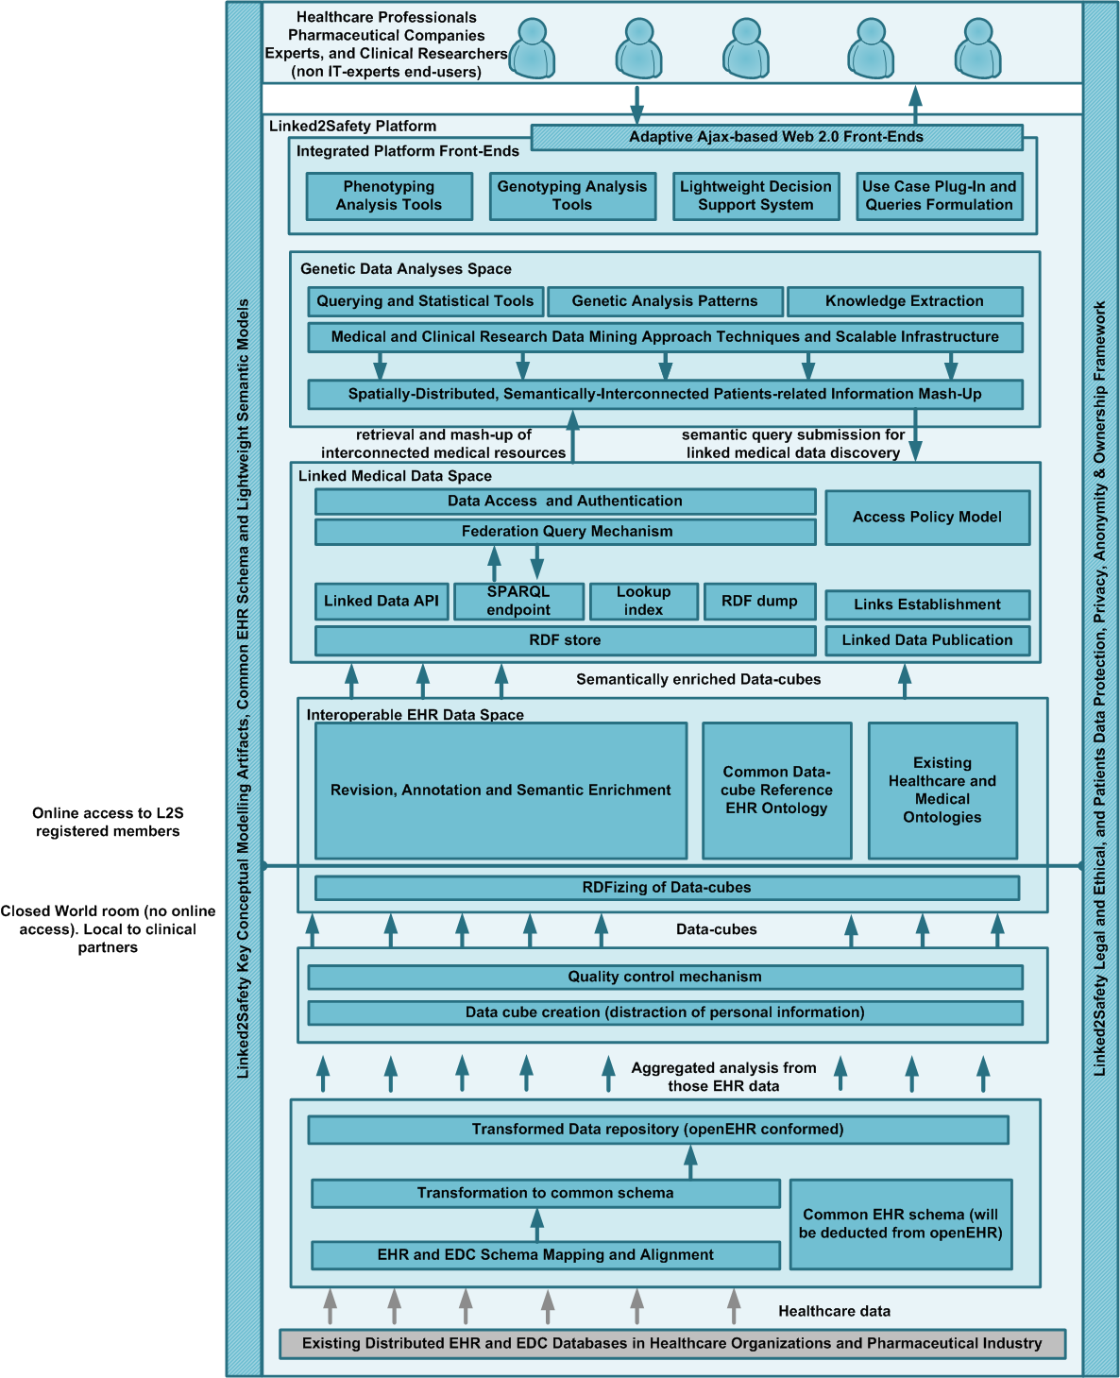

Figure 1: Linked2Safety Conceptual Architecture Reference

* Data Analysis Space: This space was dedicated to developing new and implementing existing state-of-the-art analytical approaches. Information on the work that has been conducted can be found in “D5.1 - Data Analysis Space Design”, “D5.2 - Data Analysis Patterns”, and “D5.4 - Linked2Safety Public Summary on Data Analysis Space”.

#### Topology

The Linked2Safety architecture [1] needed to address legal and ethical issues while enabling the analysis of electronic health data across multiple data sites with different owners and with potentially diverse legal and ethical requirements. With those two facets of the problem, a novel idea for addressing both legal and ethical problems, as well as the need to merge the data from multiple sites simultaneously is introduced. All processing and analysis on medical data should be done on aggregated data from each site. This is nothing new, since aggregated results from the analysis of electronic health records are published in the majority of medical research publications that involve medical studies. In Linked2Safety however a system is needed that will enable future analysis of the aggregated data using methodologies or ways of analysis that may have not been considered at the time of aggregating the data. The proposed method that enables this is the use of data cubes. Getting a contingency table from any subset of the variables within the data cube can easily be achieved by adding the values across the excluded dimensions.

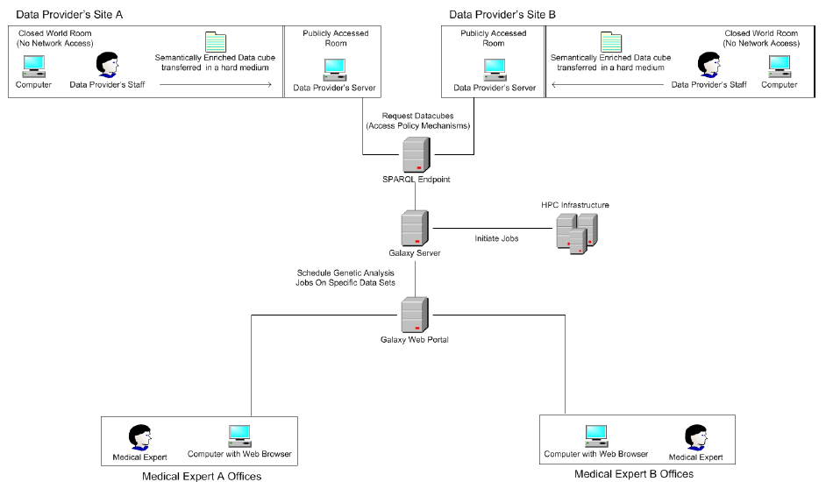

Figure 2: The Linked2Safety Platform. Figure presents the arrangement of closed-world room, public access and the Galaxy Web Portal

For tackling the issue of accessing electronic health records that contain potentially identifiable personal medical data, the concept of a ”closed-world” room is introduced (a room located within a data provider’s premises, featuring the required hardware infrastructure to process EHRs isolated from any kind of network connections). The public access room allows the transfer of the contingency tables (in the form of RDF data cubes).

# Installation and Configuration Guide



#### Linked2Safety Closed-World Room Software Components

#### Schema Mapping and Alignment Component

This component has been delivered in the first release of the Integrated Linked2Safety Platform and has been undergone some bug fixes and minor changes, but also a major change regarding the incorporation of MedDRA[1] standard into the mapping component.

The user needs to download the archive specific for its operating system, unzip it on a memory stick, and run the executable file *linked2safety_win??.exe* (where ?? is a placeholder for the platform specific version executable), which is located in the *linked2safety* directory, the root/default directory for the application.

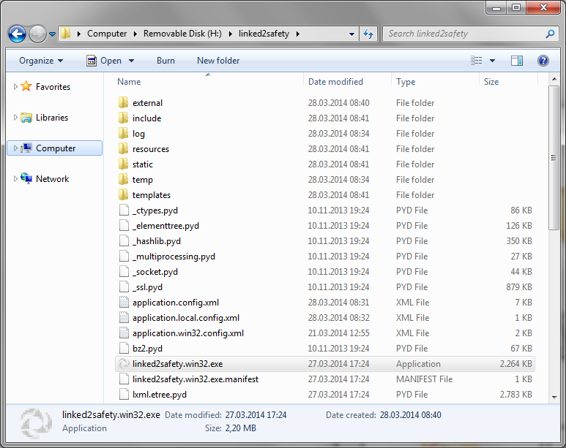

This will start the application in the default browser. At the same time a notification icon will appear in the system tray.



Note that closing the browser will not close the application. The user needs to close the application process, running in background, by right-clicking the system tray notification icon, and selecting the Exit option.

Upon MedDRA incorporation there is an option of enabling and disabling the usage of MedDRA classification, directly from the Linked2Safety system tray icon. By default MedDRA is enabled.

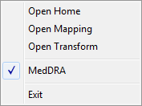

The application is tested on latest versions of Internet Explorer, Chrome, Firefox and Opera. Thus, it is required that the default browser on the host machine to be updated to the latest version available.

The Linked2Safety Transformation Tool requires Java to run. For distribution purposes, in order to reduce the size of the application archive, the Java Runtime Environment (JRE) is not included. If the host machine already includes Java, the following steps are not required, the application being able to use the JRE installed on the host. Otherwise, Java should be deployed on the memory stick along the application.

To deploy JRE on the memory stick, the latest version of Java Runtime Environment, specific to the target operating system, should be downloaded from the following link http://www.java.com/en/download/. During the installation process the destination directory of the JRE should be set to *\linked2safety\external\Java* directory.

To do so, on the welcome screen on the Java Setup the check box “*Change destination folder*” should be checked, as shown below:

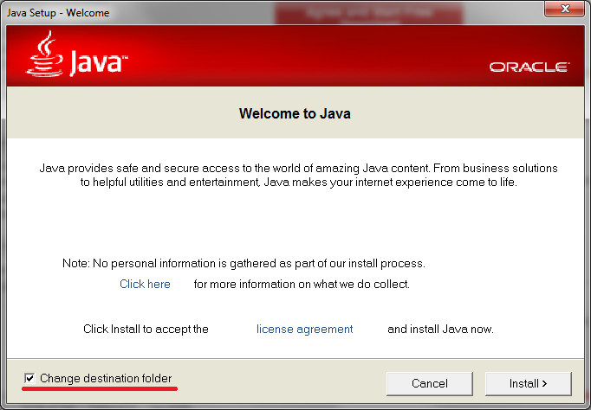

This will enable access to the following configuration page on the Java Setup. Pressing *Change* button will display a popup for selecting the installation folder. The user should select the *\linked2safety\external\Java* directory on the memory stick, as shown in the following screenshot.

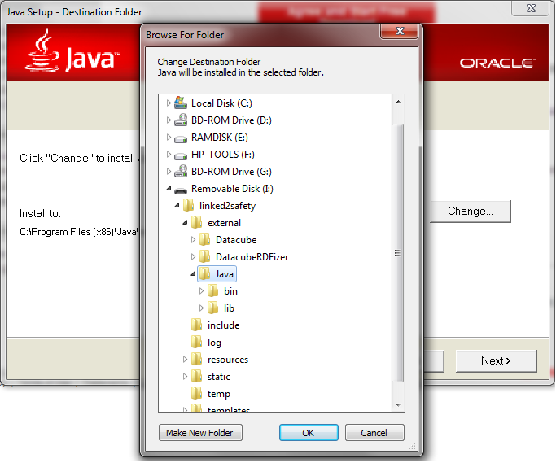

After this step, the user should press the *Next* button until the completion of the Java Setup, selecting desired configuration options based on the data provider company’s policies.

In conclusion, to install the application on memory stick, the user should perform the following steps:

* Dowload the application archive specific to the target operating system from the project collaboration area
* Extract the files from the archive on a (USB) memory stick (directly in the root folder)
* Deploy Java RunTime (optional, as described above)
* Run the application on the target machine for testing the installation

# Configuring the application



#### Linked2Safety Public-Access Room Software Components

The Linked2Safety Schema Mapping, Alignment and Transformation Tool allows the configuration of several runtime options.

There are two configuration files that can be edited by the user after the installation:

* *application.config.xml* – general application configuration;
* *application.win_x??.config.xml* – platform specific configuration (where ?? stands for 32 or 64 depending on the target machine architecture).

The following code listing represents the simplified contents of the application.config.xml configuration file. The sections highlighted bellow should be altered by the user prior to stating usage of the application, without altering the punctuation (quotation marks, brackets, etc.).

For example the provider name, provided with a default value in the distribution archive, should be changed to the actual name of the data provider. Same goes for the mapping description, which can be tailored to the needs of the specific user.

The values for the address and port should be changed only to avoid conflicts with other applications on the target machine that may use the same address and/or port.

|  |
| --- |
| <?xml version='1.0' encoding='UTF-8'?>  <configs>  <config name="providerName" value="Linked2Safety" />  <config name="mappingDescription" ><![CDATA[<enter description here>]]></config>  <config name="browseFileOn" value="server" />  <config name="port" value="8888" />  <config name="address" value="127.0.0.1" />  <config name="rdfIncludeEmptyAttributes" value="true" />  <config name="useMedDRA" value="true" />  <config name="ignoreOwlSubproperties" value="true" />  <config name="owlAttributesFiles">  <!-- List of owl files from where owl attributes should be retrieved-->  </config>  <config name="owlNamespaces">  <!--  List of namspace aliases for owl files:  Sample: <item name="alias" value="namespace-uri" />  -->  </config>  <config name="owlCategories">  <!--  List of Category names associated with the owl namespace aliases  Sample: <item name="alias" value="description" />  -->  </config>  <config name="owlIgnoredNamespaces">  <!--  List of owl namespaces that should be ignored  Sample: <item name="namespace-uri-or-alias" />  -->  </config>  </configs> |

***Note***: The remaining configurations are omitted from the listing, and should not be altered by the user.

The following code listing represents the actual contents of the *application.win??.config.xml* configuration file (where ?? is a placeholder for the platform specific version executable).

|  |
| --- |
| <?xml version='1.0' encoding='UTF-8'?>  <configs>  <config name="postTransformationConsoleCommands">  <!--  List of console commands that are executed after the transformation is completed.  %(rdfFile)s will be replaced with the location of the generated rdf file  %(appDir)s will be replaced with the home application directory  %(mappingFile)s will be replaced with the location of the mapping file Sample: notepad "%(rdfFile)s"  -->  <item><![CDATA["%(appDir)s\external\Datacube\DataCubes32.exe" "%(rdfFile)s" "%(rdfFile)s.csv"]]></item>  <item><![CDATA["%(appDir)s\external\Java\bin\java.exe" -jar "%(appDir)s\external\DatacubeRDFizer\DatacubeRDFizer.jar" "%(rdfFile)s.csv" "%(appDir)s\external\DatacubeRDFizer\MappingFileForCSV2_dim.xml" "%(rdfFile)s.ttl.rdf"]]></item>  <!--clean files-->  <item><![CDATA[DEL /F /S /Q /A "%(rdfFile)s.csv"]]></item>  <item><![CDATA[DEL /F /S /Q /A "%(rdfFile)s"]]></item>  </config>  </configs> |

***Note***: The user should not change the contents of this file. The configuration options are intended only for debugging purposes or for advanced usage scenarios.

The source code can be located at <https://github.com/linked2safety/code>, under section “Closed World Room/Interoperable EHR Space/Schema And Alignment Tool”.

#### Non-Identifiable Data Cubes Creation Component

The component of this space that has been delivered in the first release of the Integrated Linked2Safety Platform remains unchanged. Information on the configuration and usage of these components can be found in the accompanied configuration deliverable “D6.2.1 – Integrated Linked2Safety Platform” of the first release.

The source code can be located at <https://github.com/linked2safety/code>, under section “Closed World Room/Interoperable EHR Space/DatacubeCreation”.

#### RDFizer Component

The “DatacubeRDFizer” requires a configuration file, that controls the namespaces, URL structures and structure definitions for the datacube that is to be created. The filename of this file is “mappingfileforcsv.xml” and is used as a parameter in second item element as seen in figure 2.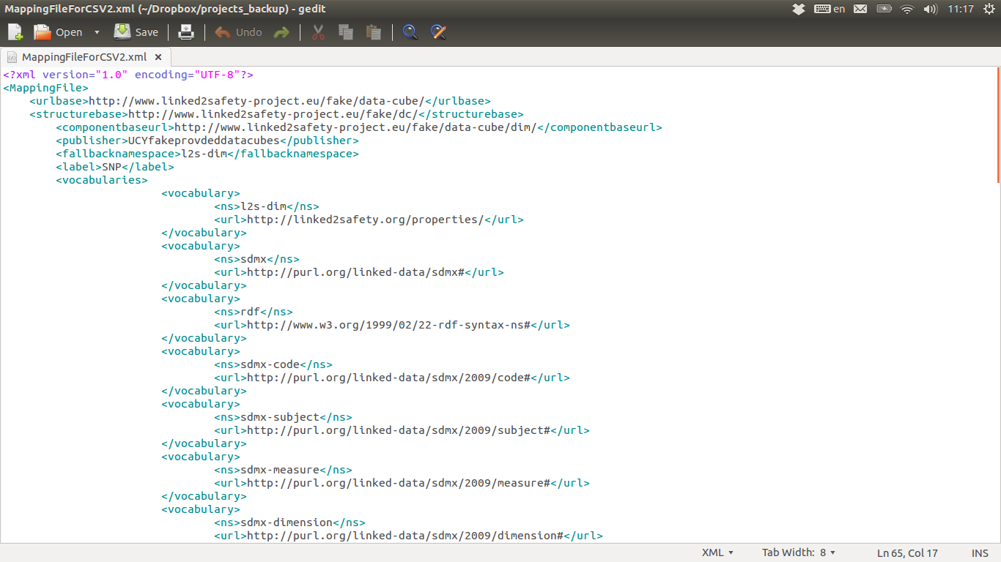

**Figure 3 - DatacubeRDFizer configuration file**

As it can be seen, the URL that is used as a base for a newly created data cube is handled by the tag element “<urlbase>”. The “<vocabularies>” facilitates the incorporation of namespaces that are to be used in the RDF/Turtle data cube file.

In order to cover the full legal and ethical aspects for the purposes of the Linked2Safety, this software should be copied and executed in a USB stick. This USB stick is used only in the closed-world room, as described in the previous section.

The source code can be located at <https://github.com/linked2safety/code>, under section “Closed World Room/Interoperable EHR Space/DatacubeRDFizer”.

The compiled files of “Non-identifiable Create Component” and “Datacube RDfizer” should be put under folder “external” (under folders “Datacube” and “DatacubeRDFizer” respectively), along with a folder named “Java” containing the latest Java Runtime Engine.

#### Linked2Safety Public-Access Room Software Components

#### Public Key Infrastructure Configuration and Installation

The Linked2Safety Public-Key Infrastructure is a Certification authority management system based on EJBCA[2] that offers the main web services for certificate revocation, tweaked for the purposes of Linked2Safety.

Note that the installation must be done with a user with privileges to write to APPSRV_HOME and sub directories.

1. Set the property 'appserver.home' in conf/pki.properties to where your JBoss is installed, examples:

appserver.home=/opt/jboss-5.1.0

appserver.home=/opt/jboss-6.0.0.Final

Also make sure the right java tools (javac/keytool) are available in your system PATH, ie. /usr/local/jdk1.6.0_24/bin.

1. Open a console and type:

ant bootstrap

3. Compile and build PKI and deploy it to JBoss. You will be prompted to enter the value for database.password if it has not already been defined in database.properties. Open a console (terminal) and start JBoss. You can start JBoss with the normal command 'run.sh/cmd' from APPSRV_HOME/bin. You should see JBoss picking up everything and deploying the ear without errors.

4. Type: ant install

it will generate all certificates, keys, etc needed to run with an initial CA. You will find admin keys in ${pki.home}/p12. (do not delete those files!)

The command 'ant install' is only run once, when the CA is first installed. It creates lots of things in the database, and cannot be run again (it will give an error if you try).

* tomcat.jks is for the Servlet container (don't bother with it)
* truststore.jks is for the Servlet container (don't bother with it)
* superadmin.p12 should be imported in your browser, that's your administration certificate.

1. Stop JBoss (Ctrl+C if you run JBoss in the foreground in a terminal)
2. Type: ant deploy

This will deploy everything again and configure the servlet container with the keystore file (this is why we needed to stop the container). You will again be prompted for httpserver.password, java.trustpassword and database.password, if these have not been predefined in web.properties and database.proproties respectively.This is the super administrators certificate used to access the admin GUI. Other administrators with specific privileges can be created later on. The default password for superadmin.p12 is pki, and is configured in web.properties.

Start a JBoss instance again and go to https://localhost:8443/pki/ to access the Admin GUI, or http://localhost:8080/pki for the public web pages.

#### Galaxy Web Server Configuration and Installation

Initially the files of the Linked2Safety Data Analysis Space need to be downloaded. The Linked2Safety Data Analysis Space is based on Galaxy [1], [2] and requires Python, Postgresql and a Unix machine to install.

For using the Linked2Safety tools additional software and libraries are needed. Specifically for python the following libraries are needed:

* psycopg2
* matplotlib

Some of the tools are using R[3] and hence R needs to be installed along with the following packages:

* genetics
* hash
* nnet
* RPostgreSQL

Once everything is set up the following steps should be followed:

1. Unzip the file with the Linked2Safety Data Analysis Space in a folder of your choice.
2. Login as postgres user

sudosu–postgres

1. Use createdb to create new database for galaxy:

createdbgalaxy_prod

1. Connect to database using psql:

psqlgalaxy_prod

1. Create galaxy user for PostgreSQL database with PASSWORD we need:

CREATE USER galaxy WITH PASSWORD 'password';

GRANT ALL PRIVILEGES ON DATABASE galaxy_prod to galaxy;

1. Galaxy requires a few things to run - configuration files, and dependent Python modules called "eggs". However, starting the server for the first time will create/acquire these things as necessary. Simply run the following command:

sh run.sh

This will also initialize the Galaxy main database

1. Log in to the database and execute “galaxyDB_08.sql” to install the Linked2Safety database tables.
2. Start server by typing “sh run.sh --daemon”.

#### Installation of components in Galaxy Web Server

One of the reasons Galaxy was selected for the Linked2Safety Data Analysis Platform is its ease of adding new tools to the platform. Galaxy allows the execution of any tool that can be run from the command line, and hence any programming language that satisfies this requirement can be used for the creation of a tool. To add a new tool in Galaxy the following four steps are needed:

1. Create a folder under the directory ‘galaxy-dist/tools‘, and add the executable or script of the new tool in the folder.
2. Create an XML tool descriptor file with the same name as the tool and insert it in the folder created in step 1. The XML file is used by Galaxy to create the user interface of the tool and to execute the tool with the input arguments selected by the users. Details about the structure of the XML file can be found at [4].
3. Update the file tool_conf.xml, which is located under the directory ‘galaxy-dist/tools‘, to inform the platform about the new tool.
4. Restart the platform

In the XML tool descriptor, the id and name of the tool are defined in the <tool> clause whereas the <command> clause contains the command that will be used to execute the tool. The <inputs> clause describes the input parameters of the tool and the <outputs> clause the output of the tool. The XML tool descriptor shown in the above figure results in the user interface illustrated in . As can be seen, drop down menus and text fields can be created for getting input from the user.

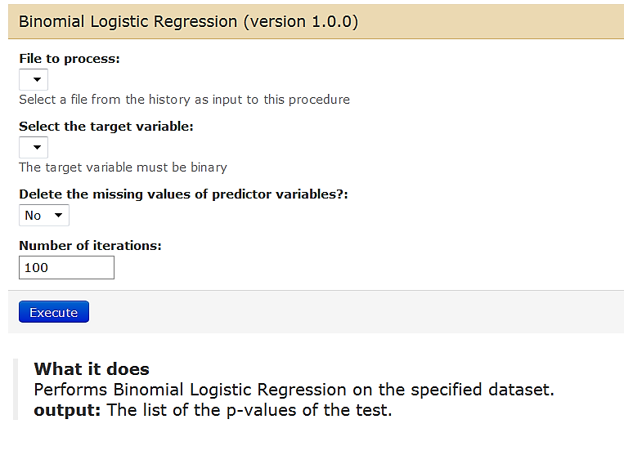

Figure 4 : User interface of the binomial logistic regression

In the following figure, the structure of the tool_conf.xml file is shown. Multiple tools can be listed in the same section as is the case with the quality control tools, which are all under the section “Quality Control”. If for example a new quality control tool would be added, a new line under the section “Quality Control” would be included. The new line must specify the path to the XML tool descriptor of the new tool.

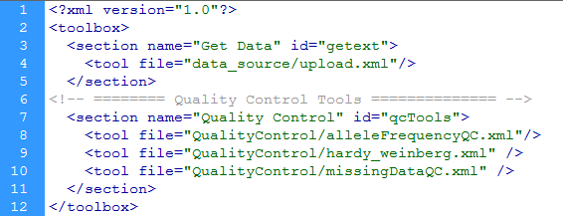

Figure 5 : An example of the tool_conf.xml file

The source code can be located at <https://github.com/linked2safety/code>, under section “Open Access Room/Galaxy”.

#### Annotation and Enrichment Tool

The "Semantic Annotator and Enrichment Tool" is a web based application and thus a servlet container is required to host the application either remotely or locally. The WAR file can easy be copied to the deployments folder of the container, so that it can be available online.

The source code can be located at <https://github.com/linked2safety/code>, under section “Open Access Room/Semantic Enrichment Tool”.

#### Query Interface

The “Query Interface” is a web based application and thus a servlet container is required to host the application either remotely or locally. The WAR file can easy be copied to the deployments folder of the container, so that it can be available online. To select MEDdra or the non-MEDDra for the L2SQueryInterface, the administrator of the platform points the configuration file of Galaxy (see section 3.2) to either query_interface_meddra.jsp or query_interface.jsp .

The source code can be located at <https://github.com/linked2safety/code>, under section “Open Access Room/L2SQueryInterface”.

#### Data Access Mechanism Configuration and Installation

The Data Access Mechanism is provided as a JAR file that is incorporated in the Federated Query Engine WAR files. After that, the classes that implement the connectivity between the PKI and the enforcing of the Access Policy Mechanism (described in “D6.1 - Linked2Safety Integrated Platform and Software Integration Plan”) as available to be used by Federated Query Engine.

The source code can be located at <https://github.com/linked2safety/code>, under section “Open Access Room/Linked Medical Data Space”.

#### Federated Query Engine Configuration and Installation

The Federated Query Engine intercepts the query coming from the Galaxy server and sends it to the Data Access Mechanism component for source selection and user authorization. Once the user is authorized and sources are selected, the federated query engine re-writes the query (i.e., adding named graphs to the query) and sends it to the respective SPARQL endpoints (i.e., sources selected during the authentication process) for execution. The results from all SPARQL endpoints are returned and aggregated by the federated query engine before sending it back to the Galaxy server.

The federated query engine works as a mediator between Galaxy server and the SPARQL endpoints of clinical data providers. It provides the SPARQL query federation service as a Linked2Safety SPARQL endpoint. The Linked2Safety SPARQL endpoint is hosted as a JENA Fuseki Server and can be configured as shown in Figure 16 in order to enable query federation. The Linked2Safety SPARQL endpoint can be accessed either through Web interface or via Application Programming Interface (API) by other applications. In the case of Linked2Safety project, it will be accessed through a set of APIs.

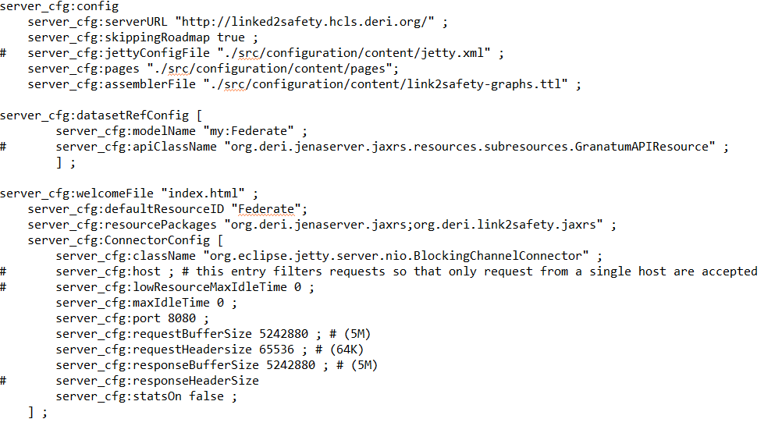

Figure 6 : Federated Query Engine Configuration File

The JENA Fuseki server does not support SPARQL query federation but rather provides SPARQL query over a single SPARQL endpoint. The JENA Fuseki server is extended to incorporate querying multiple SPARQL endpoints at the same time, i.e. query federation. This extension is incorporated in the Fuseki server in the form of a new component, named as SFedEngine (Secure Federation Engine). The SFedEngine is added as an external JAR to the JENA Fuseki server and the federation service is enabled in the configuration file of the server as shown in Figure 17.

In order to enable query federation, we have provided a list of SPARQL endpoints which will be used as candidates for federating the SPARQL query. These SPARQL endpoints, which are of interest to the query, is maintained by the SFedEngine as a list in the configuration file, as shown in Figure 7.

To run the query federation component do the followinf steps;

1. Open command console.
2. Go to the folder where the jar is located.
3. Type command “java –jar Link2Safety-Query-Federation.jar”.
4. The server will be started at port 8080 and can be accessed using any browser by typing “localhost:8080” into it.
5. Now the query federation server is up and running.

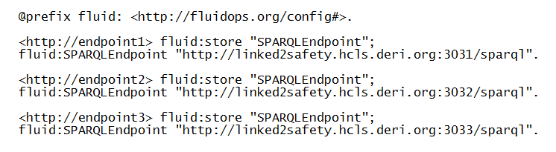

Figure 7 : List of SPARQL Endpoints required for Query Federation

The source code can be located at <https://github.com/linked2safety/code>, under section “Open Access Room/Linked Medical Data Space”.

#### Knowledge Base Configuration and Installation

This component is deployed as a WAR file in a Servlet Container server such as Apache JBOSS[3] or Tomcat[4]. The component needs to be able to connect via JDBC to the Galaxy Database that maintains the list of associations learned during several executions of the tools hosted in Galaxy. The configuration file for this WAR, only contains the data base parameter:

*jdbc_connection = postgress://<URL>:<PORT>/galaxy_prod*

where <URL>, is the URL of the POSTGRESS Server, and<PORT> is the port.

The source code can be located at <https://github.com/linked2safety/code>, under section “Open Access Room/Linked Medical Data Space”.

#### RDF Triplestore Configuration and Installation

The “Annotation and Enrichment Mechanism Tool” outputs the annotated RDF data cubes in a RDF Triplestore based in Apache Jena. The latter offers a HTTP web server facility using the Jetty web technology.

After unzipping the files contained in Jena Fuseki in a folder, the server can be run using the script fuseki-server:

fuseki-server --config=ConfigFile –port=4040 /l2sdatacubes

Option “--port=PORT”sets the port of that Fuseki listens to HTTP request (that will be coming only from the “Federated Query Engine”).“/l2sdatacubes” is the name under which the dataset will be accessible over HTTP for Linked2Safety. The server also provides an“-–update” argument which is not used in Linked2Safety, as we do not wish the data cubes to be changed from outside. The “--config” argument dictates the config file for the server to be used.

The full choice of dataset forms is:

--mem: Create empty, in-memory (non-persistent) dataset.

--file=FILE: Create empty, in-memory (non-persistent) dataset, load FILE

--loc=DIR: Usage an existing TDB database.

--config=ConfigFile: Construct one or more service endpoints based on the configuration .

In figure 12 the configuration file of Jena is presented. The service names for the “Federated Query Engine” to be able to connect as described from triple fuseki:serviceQuery, , where the endpoint name is dictated.

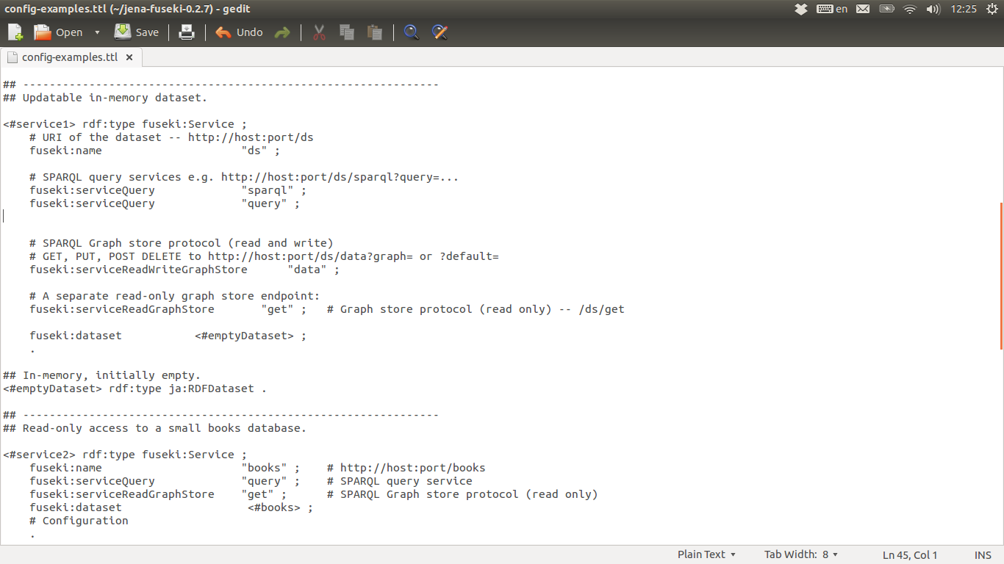

Figure 8: Apache Jena configuration file

#### Linking Component

In order to enable linking between RDF data cubes to the external public healthcare LOD (Linked Open Data) datasets, we developed a framework that automatically identifies a list of public healthcare LOD whose content relates to the clinical data cubes published by our clinical data providers.

In order to enable linking with public healthcare LOD datasets, we have selected a list of public healthcare LOD datasets which will be used as candidate LOD datasets for interlinking. The URLs of these SPARQL endpoint as well as the final results of the linking framework are stored in a MySQL database. In order to deploy the linking component, minor adjustments are required to the source code.

Some configuration steps are required in order to run the code:

1. A MySQL instance should be up and running that contains an empty database schema with name ’l2s’;
2. Import ’l2s.sql’ script into the database by runningthe following command in your console “mysql -u root -p l2s </path/to/l2s.sql“. ’l2s.sql’ can be found under project source code directory path at ’sql-script/ls2.sql’
3. In order to configure mysql instance with linking component source code, update the ’persistence.xml’ file under ’src/META-INF/’ directory (can be found at project source code directory) with correct values;

Assuming that the above steps are done correctly, code can be run either directly using any Java IDE orby building and deploying as a jar file using Maven. The main class to execute is ‘L2Smain.java’ that is contained inside ‘com.deri.l2s.main’ package. There are two core functions defined in the framework: (1) ‘collectVariables()’ takes as input a file containing clinical terms that are used in RDF data cubes by a particular clinical data provider and stores them in the MySQL database for later use by ‘collectResults()’ function; (2)‘collectResults()’ takes as input (directly from MySQL database) clinical dataset terms alongwith URLs of public healthcare endpoints and stores the linking results directly in the MySQL database.

The source code can be located at <https://github.com/linked2safety/code>, under section “Open Access Room/Linked Medical Data Space/Linking Component”.

#### Periodic Validation of Workflow Results

The Periodic Validation of Workflow Results has been developed after the first release of the Linked2Safety Platform. Its purpose is to periodically repeat the data analysis testing (e.g. quality control, dimensionality reduction, data mining, etc.) on updated data cubes and confirm that the association results remain valid. The validator is stored as a cron job script in the second release of the Linked2Safety Platform and runs in periodic intervals (once per week).

The source code can be located at <https://github.com/linked2safety/code>, under section “Open Access Room/Periodic Workflow Validator”.

# Linked2Safety Platform End-User Guide



#### Mapping and Transformation Mechanism Usage

In table you will see a revision list of changes made to this component since the first release of Linked2Safety:

Table 2: Revision List of Schema Mapping and Alignment Component

|  |  |
| --- | --- |
| Version Date | Changes Occured |
| 01.08.2013 | Included updated RDFizer |
| 18.02.2013 | Fixed Win-XP 32bit related issue (CHUV) |
| 31.03.2014 | Incorporated MedDRA Classification |

#### User Guide

From the home page, the user can access the mapping and transform tools.

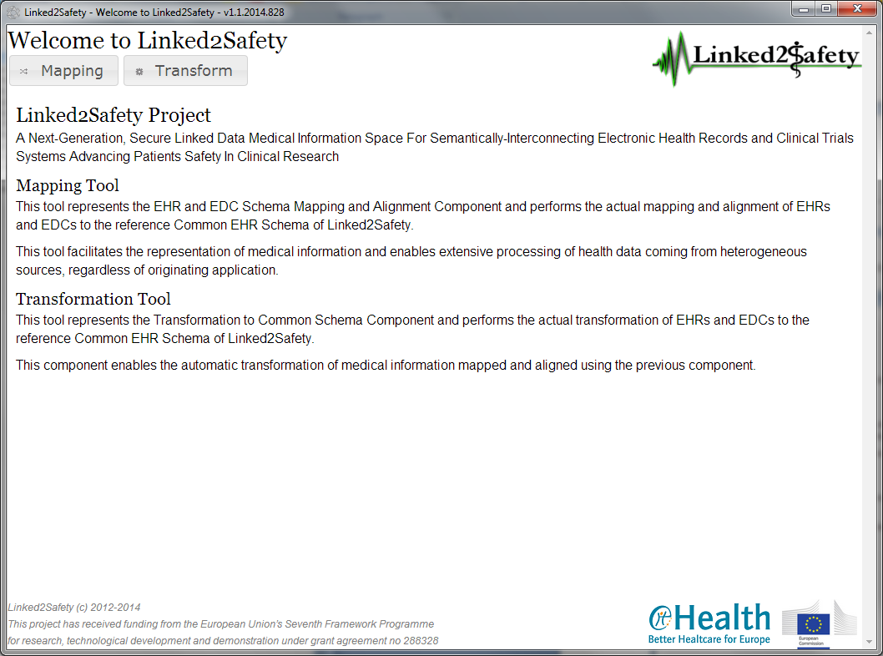

Figure 9: Mapping and Transformation Tools home page

From the home page, the user can access the mapping and transform tools through the buttons at the top of the page. There is also a short description of the Linked2Safety project and the purpose of the mapping and the transformation tools.

In order to return to home page, the user can click the application logo, found in the top-right corner of the screen.

#### Mapping Tool

By using the mapping tool, the user can create a new mapping file based on the raw data files or edit an existing mapping file.

The Mapping Tool is accessed from the home page, by pressing the Mapping button, found in the top left corner of the screen.

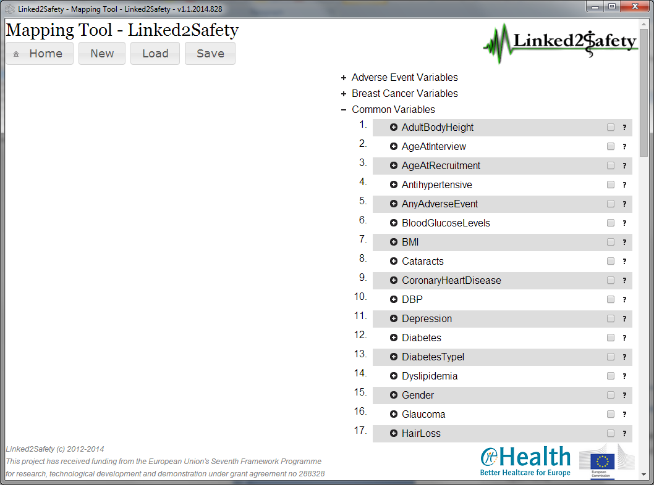

Figure 10: Mapping tool – Common EHR Variables

## Using Medical Dictionary for Regulatory Activities *(MedDRA)*

In order to use the Medical Dictionary for Regulatory Activities, the user right-clicks the system tray notification icon and selects the MedDRA option.

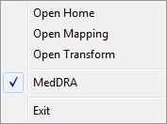

Upon changing the MedDRA option, the application notifies the user that it needs to be restarted.

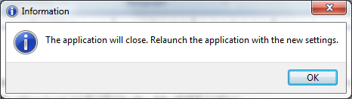

When launching the application with the MedDRA setting enabled, the mapping and alignment tool uses the attributes from the MedDRA system configured in the Semantic EHR Schema, as shown bellow.

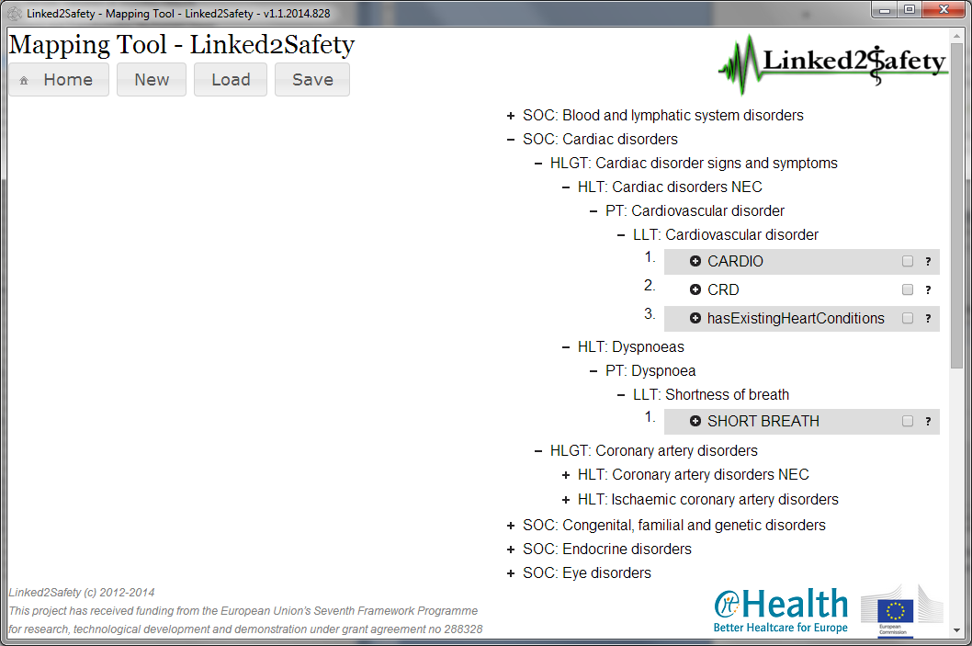

Figure 11: Mapping tool – with MedDRA Taxonomy

In order to stop using the Medical Dictionary for Regulatory Activities, the user right-clicks the system tray notification icon and deselects the MedDRA option. Again, the application notifies the user that it needs to be restarted.

#### Creating a new mapping file

In order to create a new mapping file, the user clicks the New button, found in the top-left corner of the screen.

On accessing the New button, the user is asked to enter the location of the raw/excel data file.

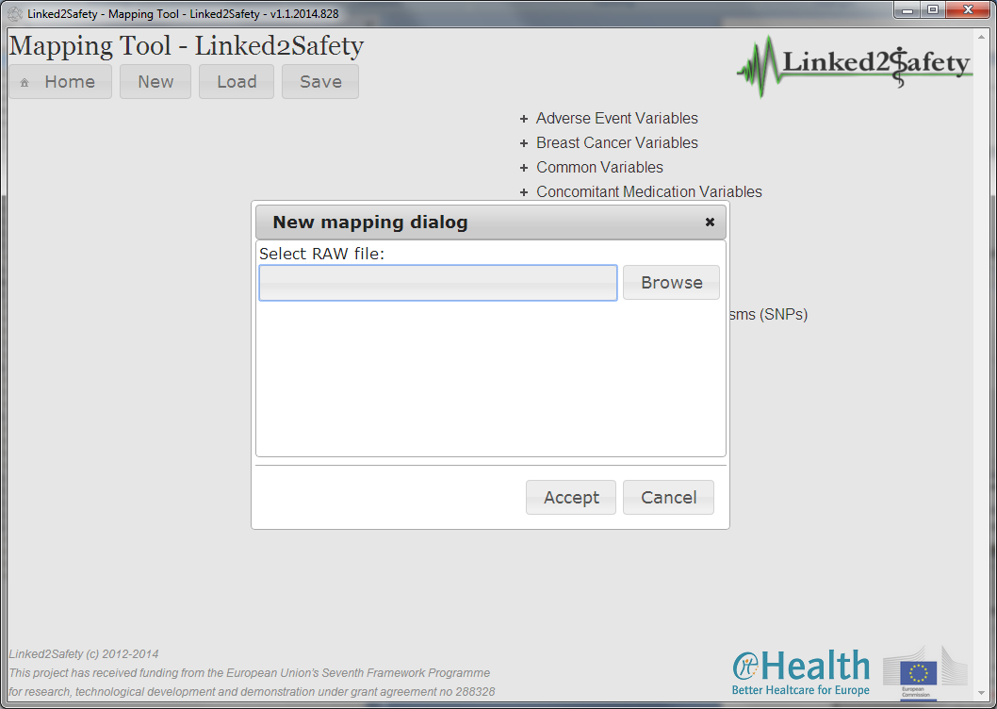

Figure 12: New mapping file - Dialog prompt

By clicking the *Browse* button, the user can navigate the file system and select the raw data file that will be used to generate the mapping file.

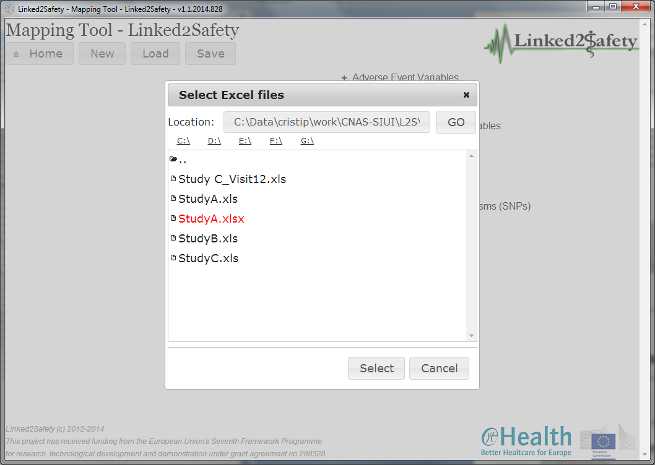Figure 13: New mapping file – Browsing the file system

After selecting the raw file, the user confirms the file by pressing the *Accept* button.

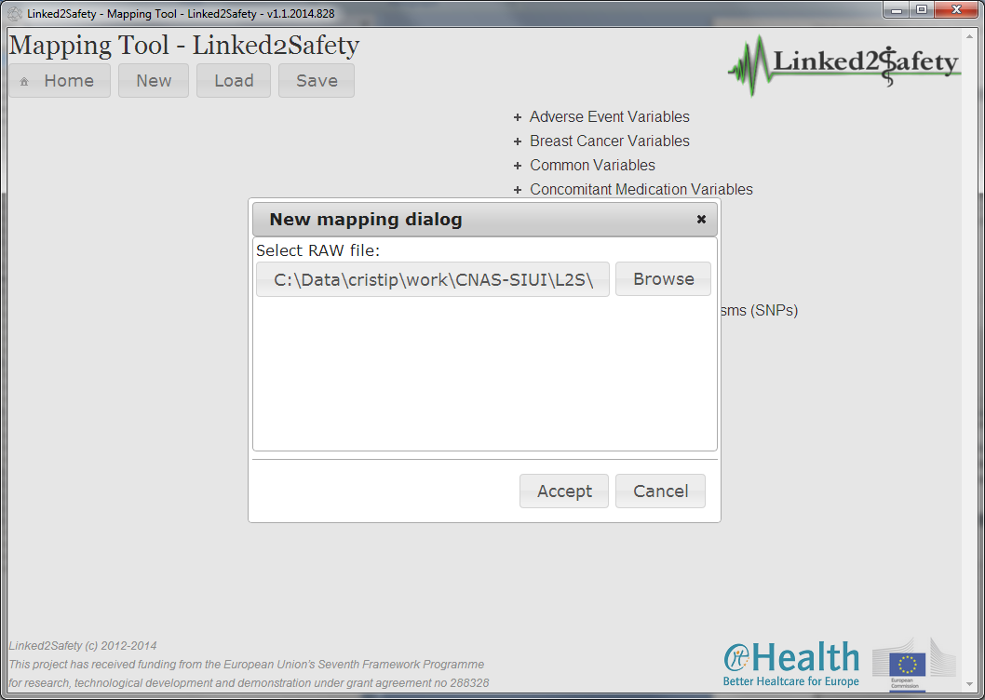

Figure 14: New mapping file – User selected a raw file

Based on the selected raw file, the mapping tool analyses and identifies the raw attributes, which will be displayed in a single column, situated on the left side of the screen. The raw attributes are grouped by the excel sheet name and ordered alphabetically.

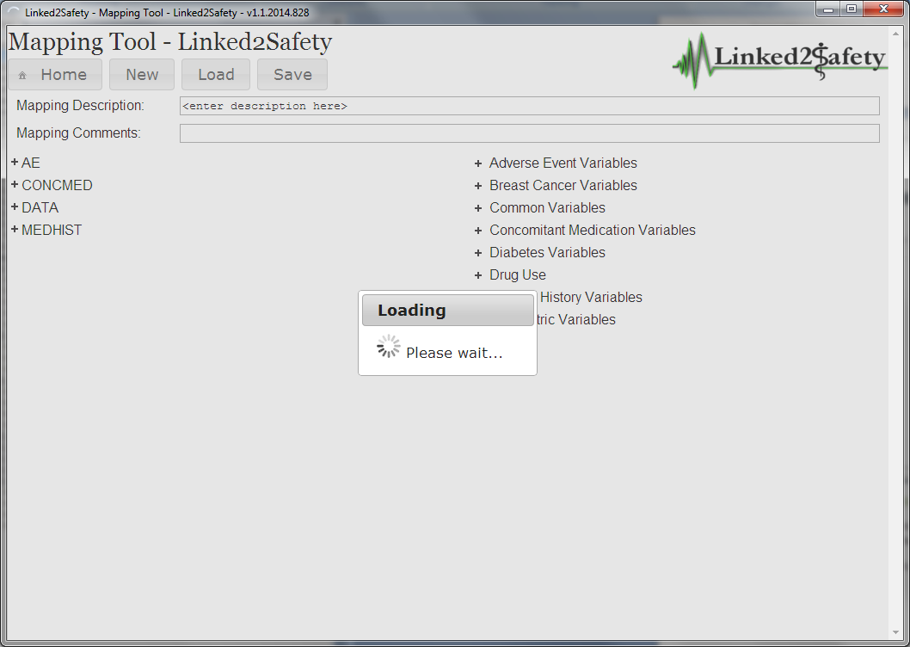

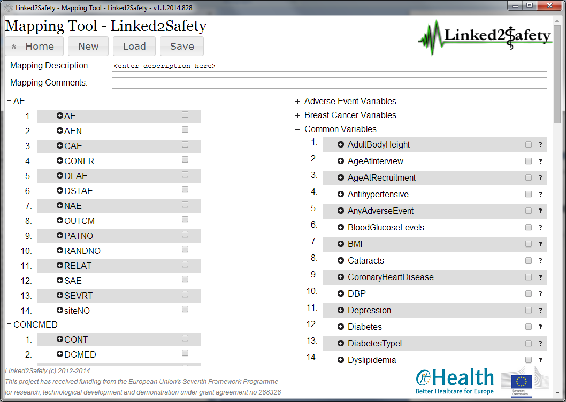

#### Editing an existing mapping file

In order to edit an existing mapping file, the user clicks the *Load* button, found next to the *New* button, in the top left corner of the screen. On accessing the *Load* button, the user is asked to enter the location of the raw data file.

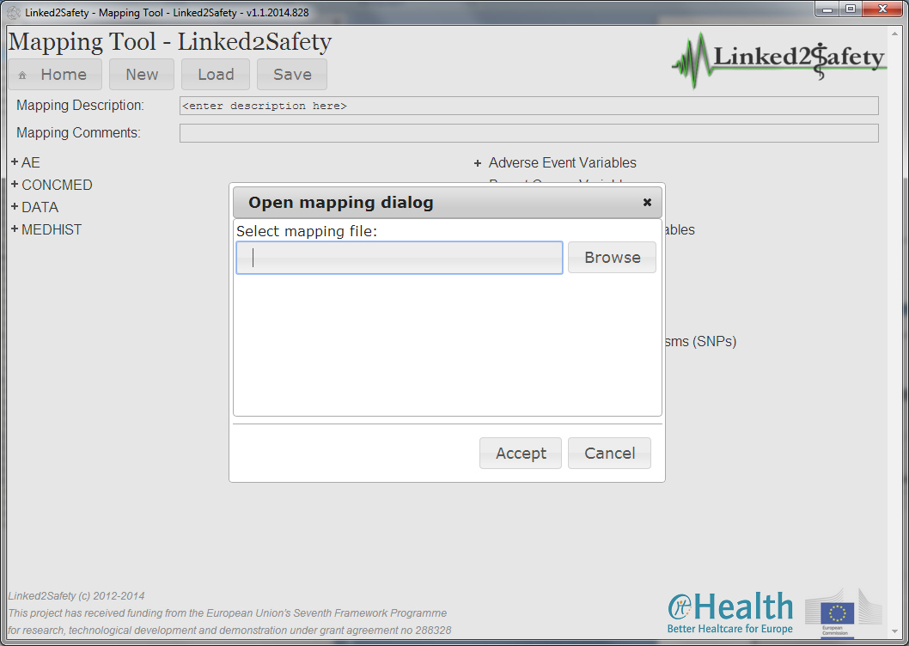

By clicking the *Browse* button, the user can navigate the file system and select an existing mapping file.

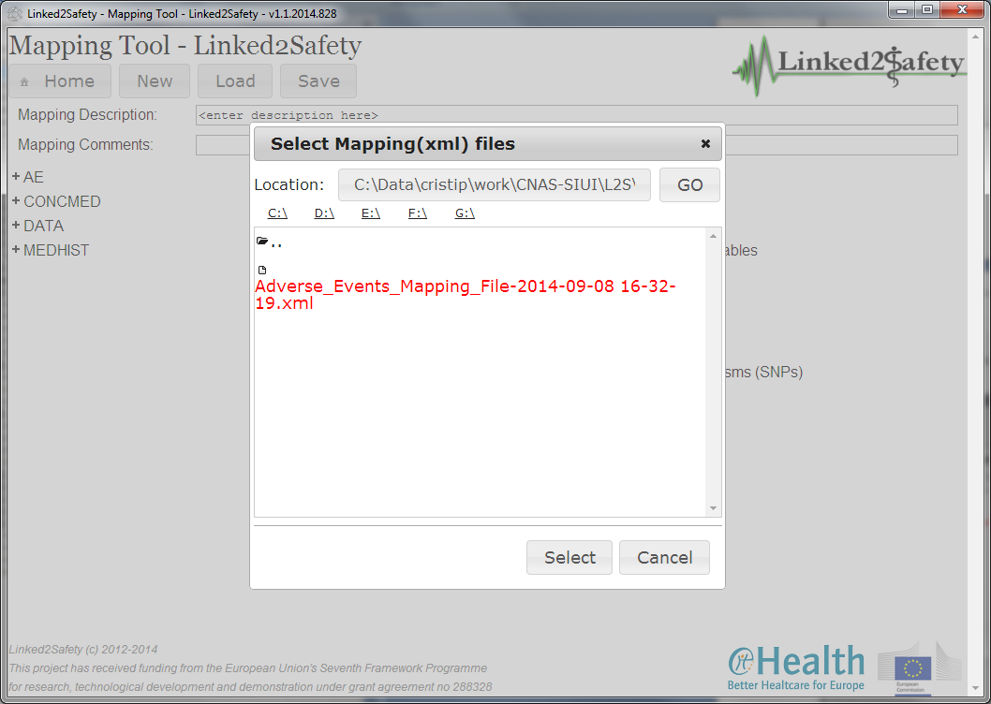

Figure 15: Open mapping file - Browsing the file system

After selecting the mapping file, the user confirms by pressing the *Accept* button.

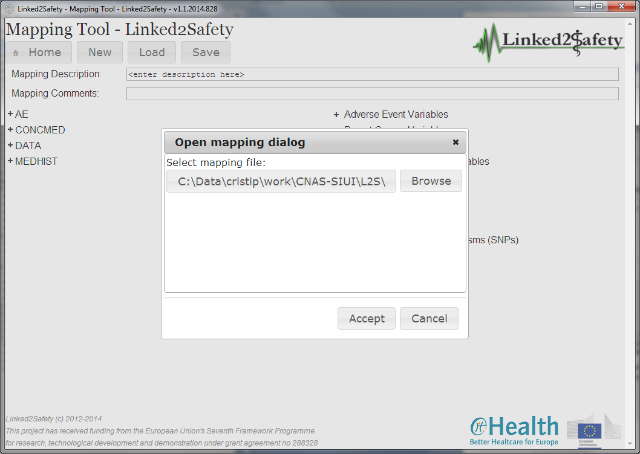

Figure 16: Open mapping file - User selected a file

Based on the selected mapping file, the application analyses and identifies the raw attributes and the existing mapping associations with the destination (owl) attributes.

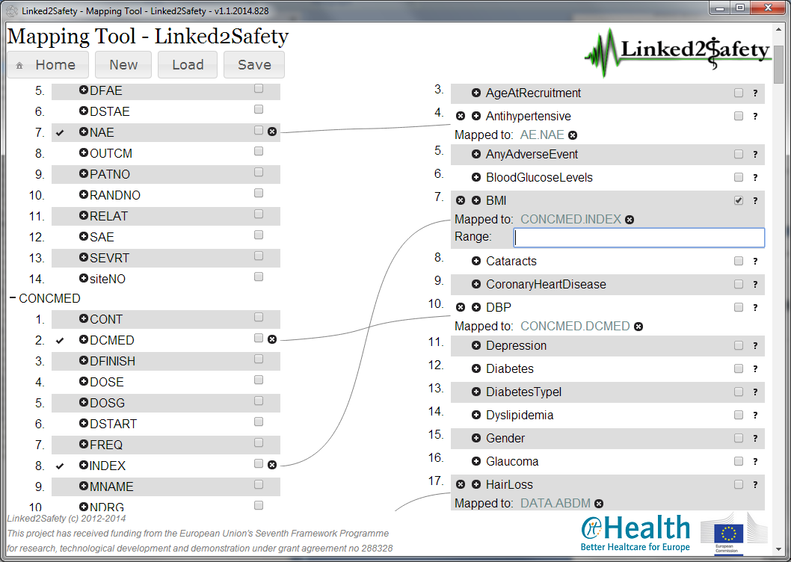

Figure 17: EXCEL file has been loaded

#### Setting associations between raw file attributes and common schema attributes

Mapping associations are represented in the application by a line connecting the raw attributes, in the left column, and the destination attributes, found on the right column.

Mapped raw attributes are preceded by a checked icon () and their names appear in the text boxes associated with the destination attributes.

In order to set an association, the user clicks the raw attribute and drags it using the mouse onto the text box of the destination attribute.

A raw attribute may be associated with only 1 (one) destination attribute, but a destination attribute may refer multiple raw attributes.

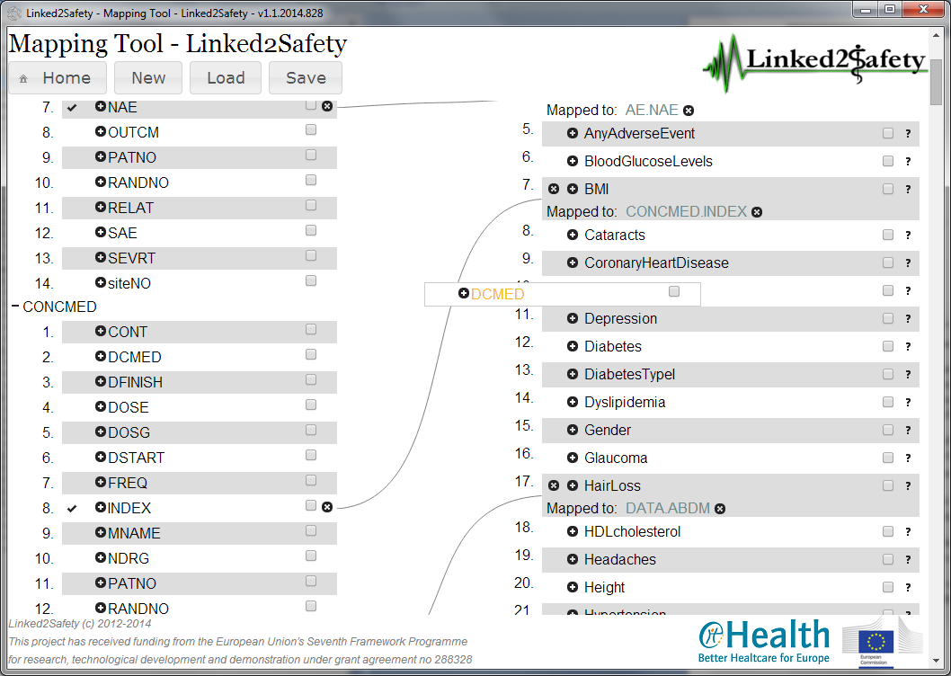

Figure 18 : Performing some mappings

Another method to make an association is to press  button next to the destination attribute and type the name of the raw attribute. On typing, a list of suggestions is presented below the text box. The user identifies the raw attribute within the suggestions and clicks the name.

In order to mark a raw attribute as being a key identifier or part of a collection of keys that identify uniquely a record in the raw data collection, the user checks the  box next to the specific raw attribute.

The user may enter optional range values by pressing the  box next to the destination attribute and enter the value in the text box displayed bellow.

An existing connection may be removed by pressing the button found next to the raw attribute associated with the selected connection.

All connections associated with a destination attribute may be removed by pressing the  button near the selected destination attribute.

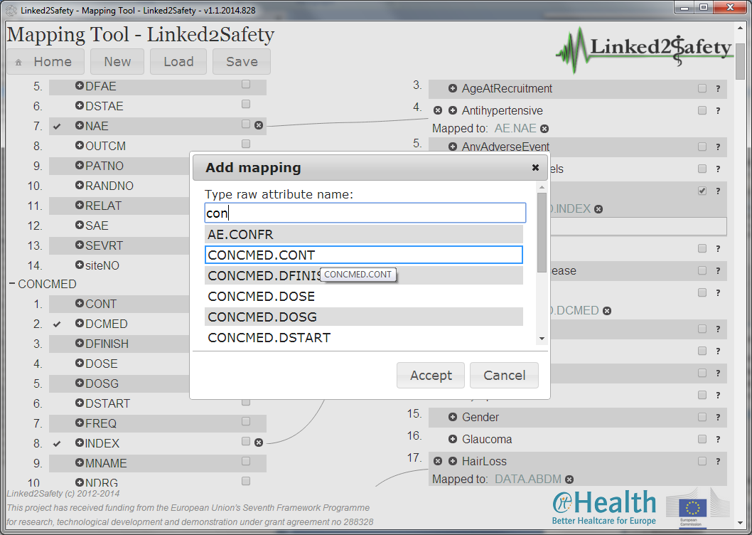

Figure 19: Adding mapping

Users have the possibility to initiate an association starting with the raw attribute. In this case, the user clicks the  button near the raw attribute and entering the name of the destination attribute in the popup window. Based on the selected destination attribute, a new connection shall be established.

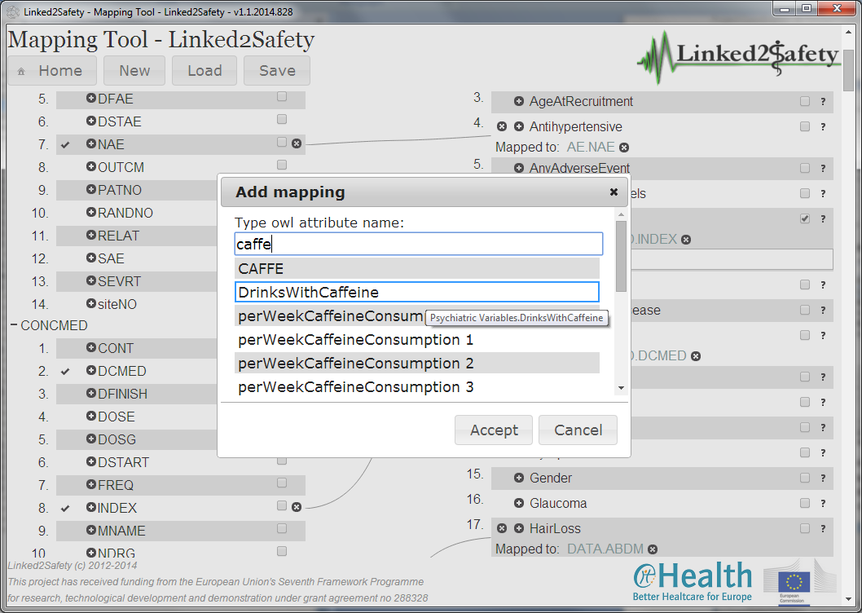

Upon completing, the user can save the mappings by pressing the Save button, found in the header section next to the New and Load buttons.

Based on the settings of the Browser application that the user uses, a Save As popup window should be displayed, allowing the user to specify the location where the mapping file will be saved.

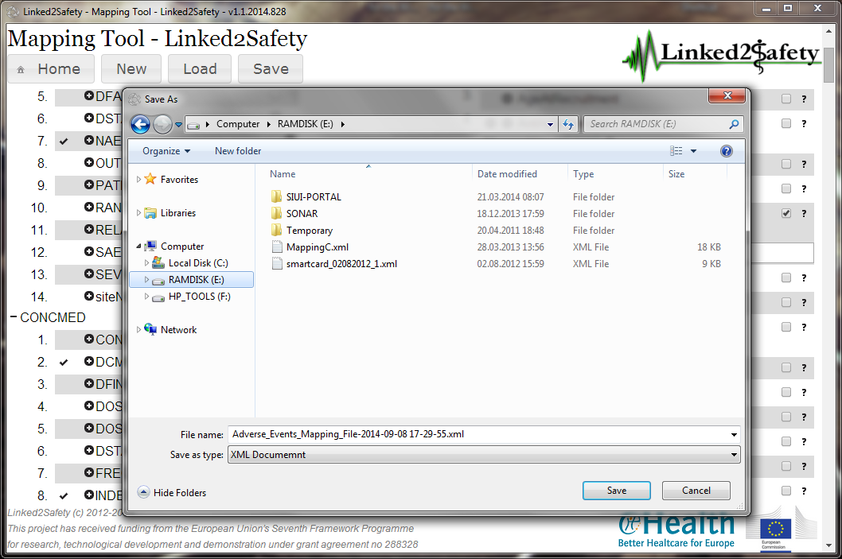

Figure 20: Saving the mapping file

### Transformation Tool

The Linked2Safety Transformation Tool is used to transform a raw data file and generate a RDF file based on a specified mapping file.

In order to access the Transformation Tool, the user should click the *Transform* button from the application home page, found in the top left corner of the screen.

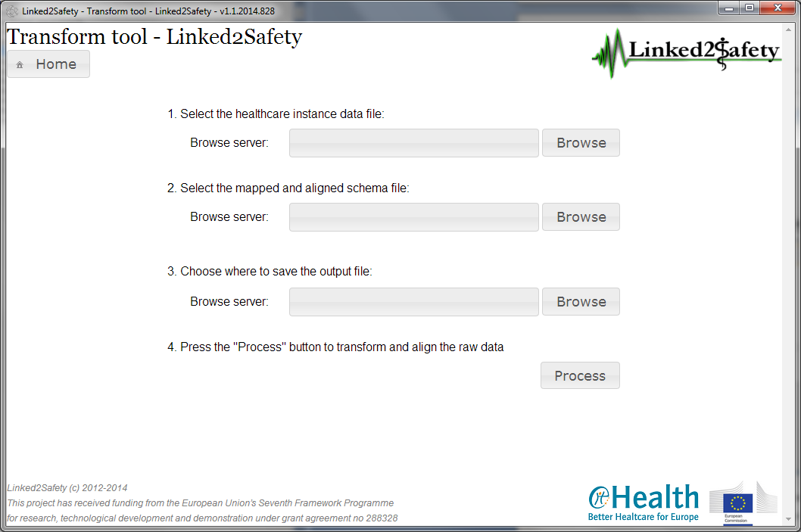

Figure 20: Transformation tool

#### Selecting necessary files

In order to initiate the transformation process, the user is asked to provide the following information:

* The raw data file (excel document)
* The mapping file (previously generated with the mapping tool)
* The location where the generated output data is to be saved

In order to specify the raw file, the user clicks the Browse button in the “1. Select the healthcare instance data file” section. A popup window is displayed allowing the user to navigate the file system on the local computer and select the raw file.

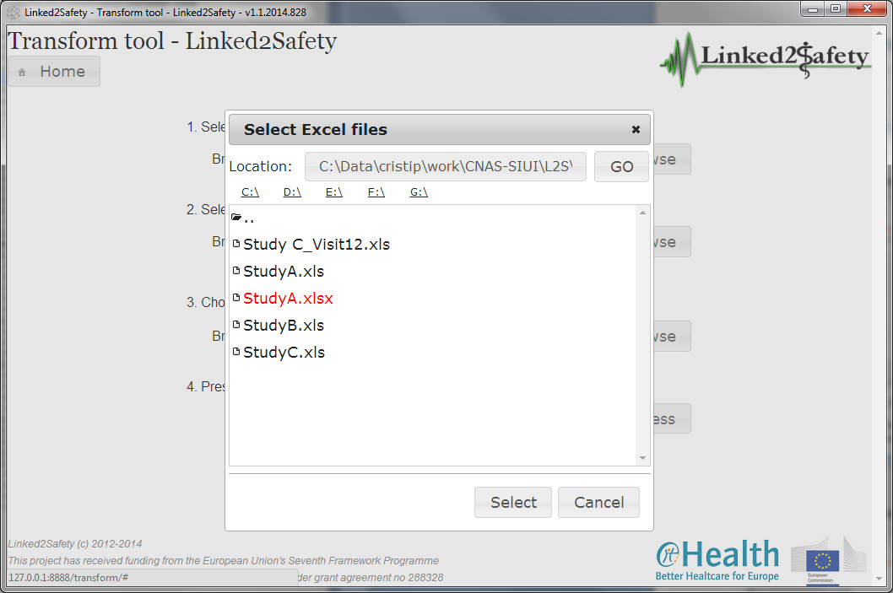

Figure 21: Transformation - Selecting input file

The user should set then the mapping file by pressing the *Browse* button in the “*2. Select the mapped and aligned schema file*”.

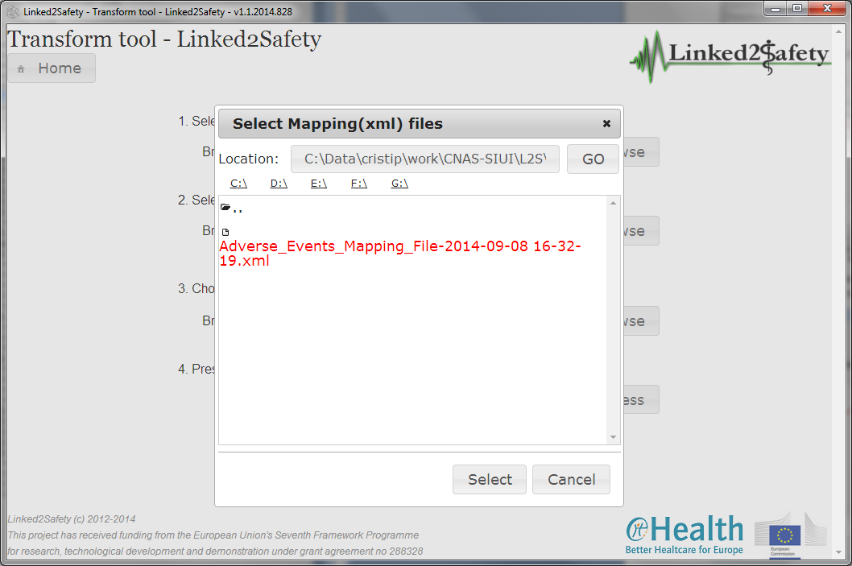

Figure 22: Transformation - Selecting mapping file

The final information required to be specified before initiating the transformation process is the location where the output file will be saved. Therefore, the user presses the *Browse* button in the “*3. Choose where to save the output file*”sectionand selects the desired location from the popup window displayed.

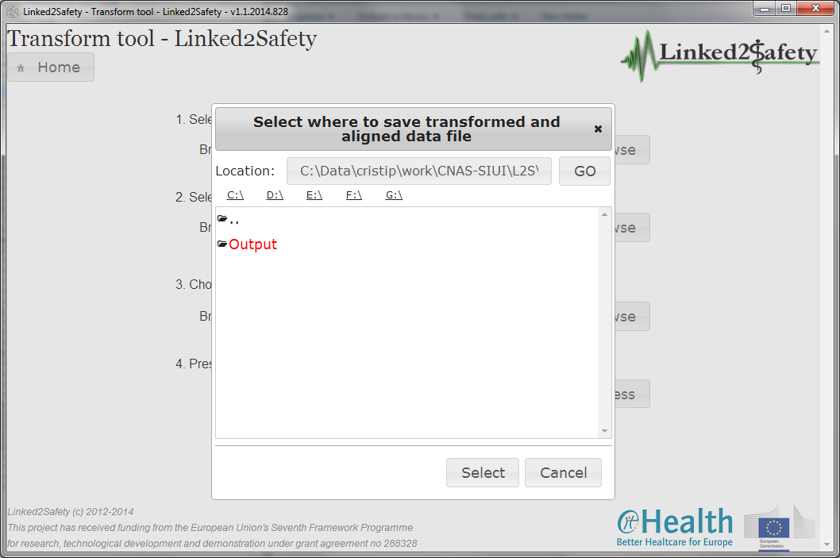

Figure 23: Transformation - Selecting output path

#### Generating transformed and aligned data

After the necessary information has been provider, the user clicks the *Process* button in the “*4. Press the "Process" button to transform and align the raw data*” section. During the processing operation, a progress bar is displayed providing the user with feedback on the progress of the operation.

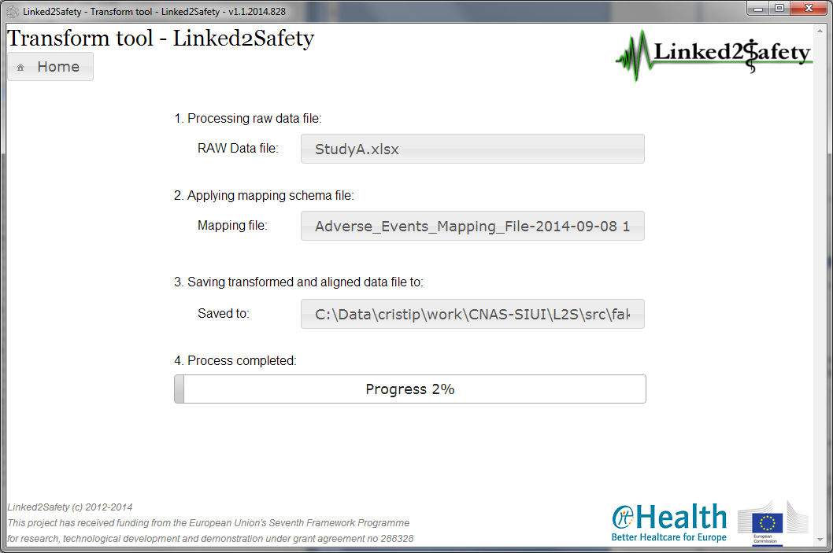

Figure 24 : Transformation - Progress Bar

After the operation is completed, the application displays a popup window informing the user where the output file has been saved.

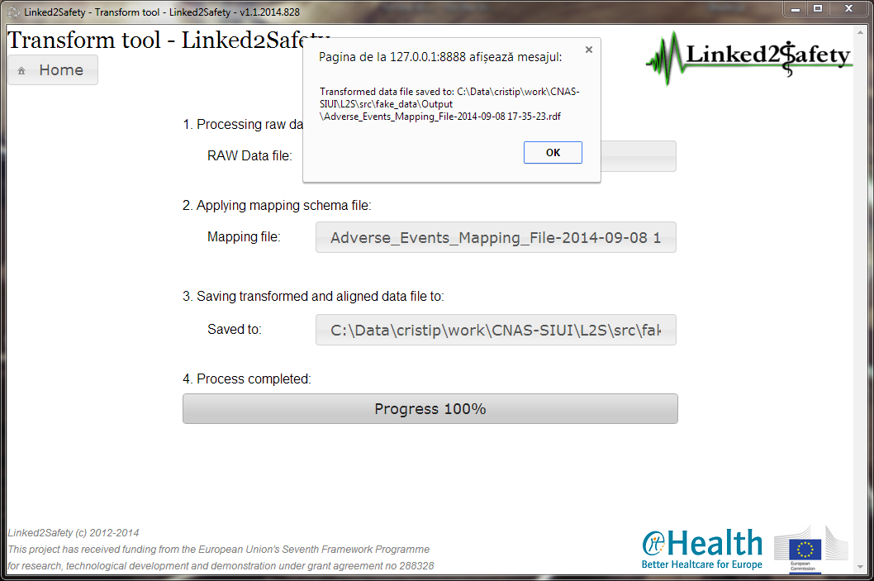

Figure 25: Transformation - Notification message

#### Annotation And Enrichment Mechanism Usage

#### User Guide

The "Semantic Annotator" can be accessed from any web server by typing the URL address in which the application resides. The main screen is depicted in figure 37. The application window consists of the following panels:

* The main canvas. Here, the user can upload a data cube in RDF and see a graphical represantation of the data cube uploaded.
* The annotation panel. The data cube can be semantically enriched by the user by adding the desired annotations
* Policy model panel. A policy model may be selected and applied to the data cube by the user.

Each panel is described in more detail in the following sections.

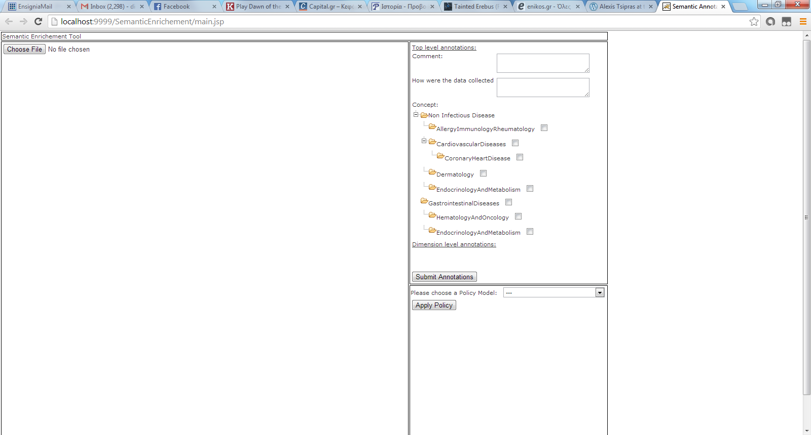

Figure 26: Semantic Enrichment Basic Screen

#### Main Canvas

This panel is used for loading a data cube and displaying the data cube's data in a graphical way. At first the user presses the "Choose File" button to select a data cube to upload.

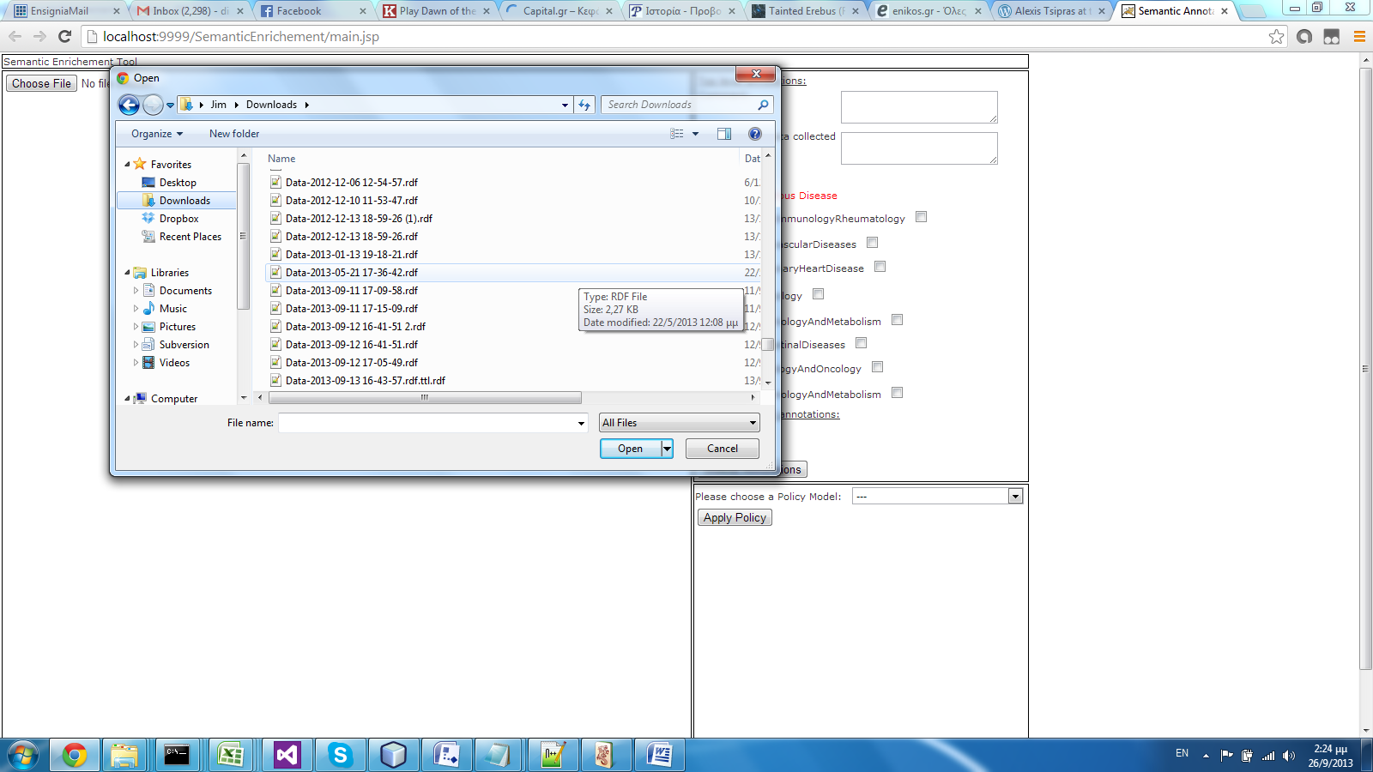

Figure 27: Browsing for an RDF data cube

After selecting the data cube the data cube is presented in a tabular form as to give to the user a detailed view of the data cube's variables and the corresponding values for all the combinations of aggregation. After the data cube is loaded, the user may proceed by adding her annotations.

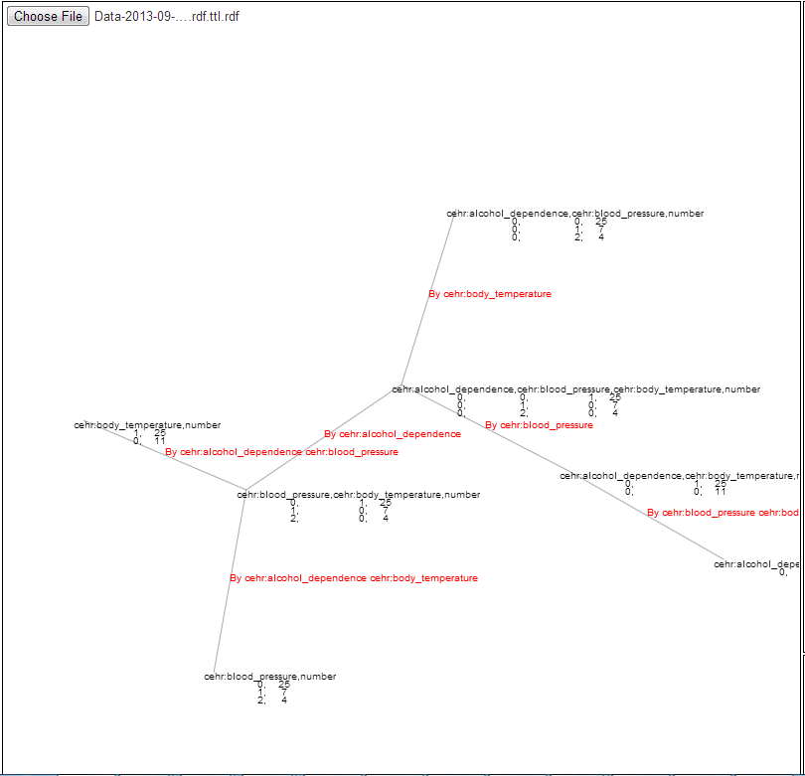

Figure 28: Graph representation of RDF cube

#### Annotation Panel

In the annotation Panel the data cube can be semantically enriched. The panel is depicted in Figure 4. The annotations added are of two types:

* Top level annotations: These annotations concern the whole data set. The user can add a general comment in text form and provide a description about the process by which the data cube were collected. Furthermore, concepts from the SEHR ontology, namely the ones corresponding to diseases, may be linked to the data cube by selecting them from the check boxes. More than one concept may be applied.
* Variable annotations: These are annotations that correspond to each variable of the data cube individually. For each variable, the user may enter annotations concerning information specific to this variable, e.g. whether the variable was self reported by the patient or the data were collected by previous records, etc.

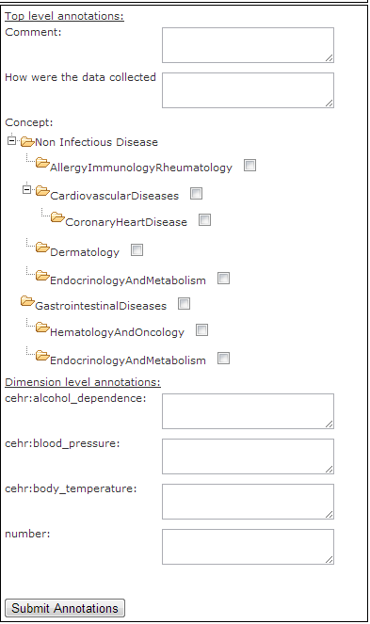

Figure 29: Annotation Menu

The use of this tool is as follows:

1. Import an RDF datacube by selecting “Choose File“
2. Browse file system and select the file you want
3. Select dimension of loaded file and associate them with annotation from the right-hand-side tree
4. Select “Submit Annotation“ to save the RDF data cubes with annotations in the triplestore.

#### Policy Editor

The policy editor is a new component that allows the user to define and edit policies that can be applied to data cubes in order to restrict access to a specific set of users. The main screen of the policy editor is depicted in Figure 6.

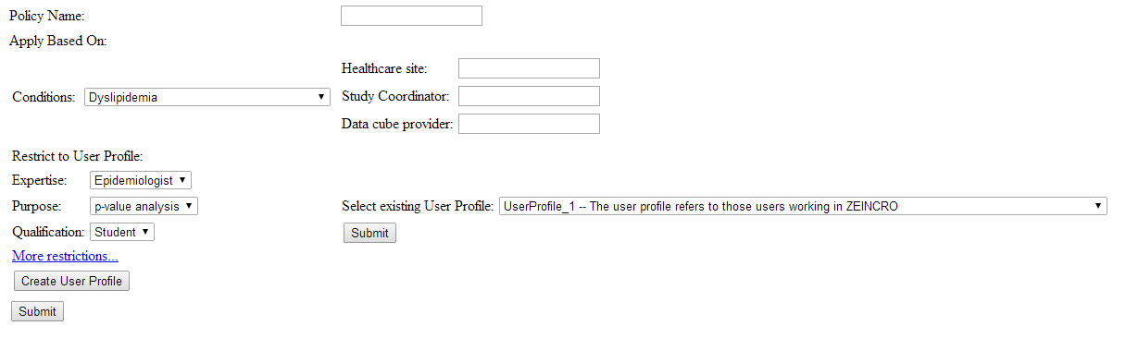

Figure 30: Main screen of the policy Editor

The pane of the policy editor can be separated in two sub panes. In the first pane the user can insert the name of the new policy to be inserted and define the fields (variables) of the data cube for which the policy is to be applied (that is, each definition can be applied to different cubes of the same dimensions). Additional information regarding the site, coordinator and provider of the data cubes can also be applied in the first sub pane. This pane is depicted in Figure 31.

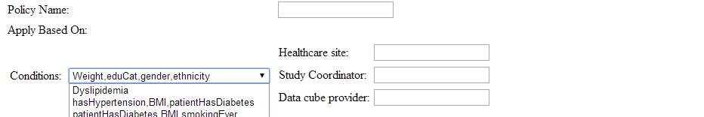

Figure 31: First pane of the Policy Editor. The name of the policy, the variables of the data cube that these policy will be applied to and further information about the policy can be applied here.

In the second pane, the user can select the user profile that will match the policy to be created. The user profile can be created from new, or an existing user profile may be applied to the policy. In the first case, the user selects the user profile from the drop down list on the right area of the pane (Figure 32), whereas in the latter each attribute for the new User profile is defined from the collapsible drop down list in the left area. After the user finalizes her/his selections the corresponding button must be pressed in order for the User profile to become attached to the policy. The user can then press the "Submit" button and the policy will be submitted and stored to the local triple store.

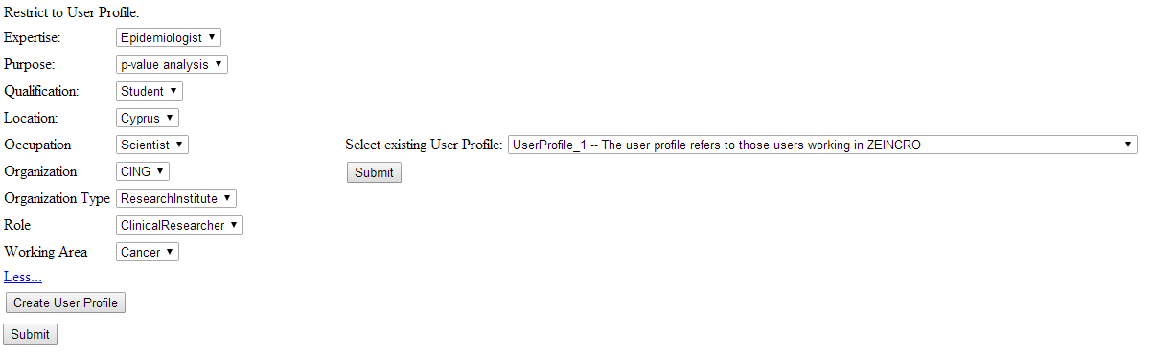

Figure 32 : User profile definition.

An accompanying component has also been developed that allows the user to alter existing policies. This component is depicted in Figure 33. Here, the user selects a Policy to be edited and then presses the first "Submit Button". The fields then are filled with the values of the corresponding policy. The user can then alter all the fields of interest and submit the altered policy to the triple store.

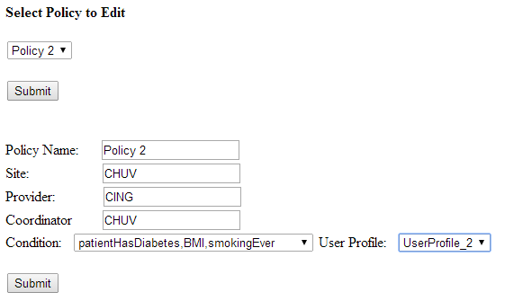

Figure 33 : Editing an existing Policy

#### Galaxy Web Server and Components Usage

In this section an updated manual for using the components of the Linked2Safety Data Analysis platform is provided due to some UI changes in the tools and the creation of some additional tools.

#### Query Interface

The Query Interface functionality has been fundamentally the same, with the exception of including the MedDra taxonomy. The user can now use the vocabulary to find easier the variables he/she wants to be included for the data cubes that need to be retrieved.

The use of this tool is as follows:

1. Select the target variables from the menu that features The MedDra taxonomy.
2. Select type of study that the data came originally from.
3. Press the Search button, to retrieve the datacubes (if they are found through the Federated Query Engine)
4. Press the Subject Count button, to retrieve the number of subjects (if any are found through the Federated Query Engine with these search criteria)

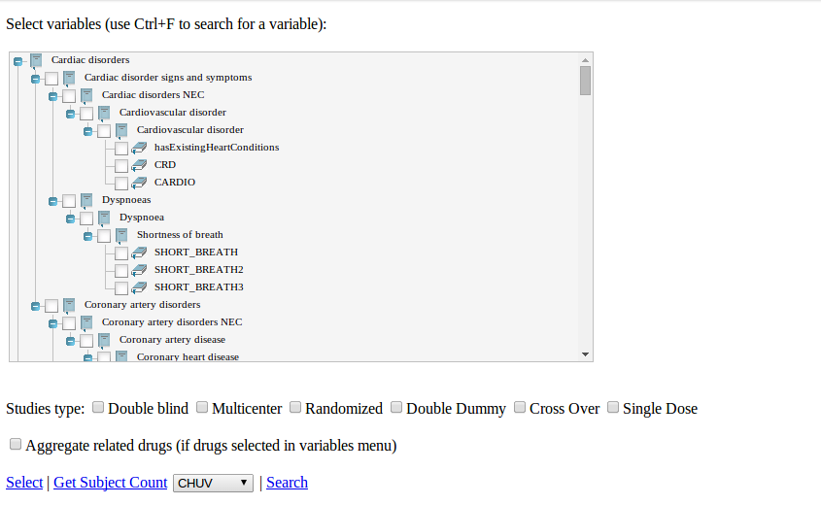

Figure 34: Query Interface with the MedDra taxonomy presented

In the table you will see a revision list of changes made to the component since the first release of Linked2Safety:

Table 3: Revision List of Query Interface Component

|  |  |
| --- | --- |
| Component | Changes Occured |
| Query Interface | Meddra taxonomy incorporation |

#### Pre-processing

#### Set the Target Variable

This tool is responsible for selecting the target variable (also known as the response/dependent variable) for the analysis that will follow. It can also be used to manually select a subset of the variables that are of interest and only retrieve those in the outputted data cube. The user interface of the tool is shown in the following figure.

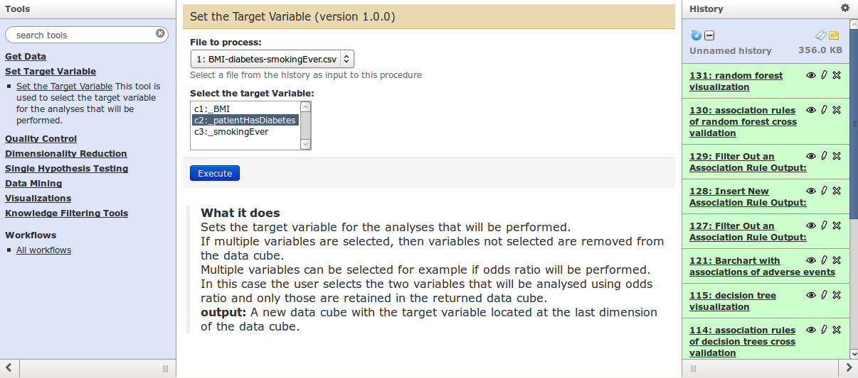

Figure 35: User interface of the Set the Target Variable tool

The use of this tool is as follows:

1. Select the file that will be used. This is done by selecting the input file from a drop-down menu under the label “File to process:”.
2. Select the target variable from the drop down list or select the subset of variables that want to be retained.
3. Press the execute button.
4. Once the process is executed, its output is presented in the history pane. The tool outputs a new data cube with the target variable as the last variable in the data cube or a data cube with only the selected variables as shown in the following figure.

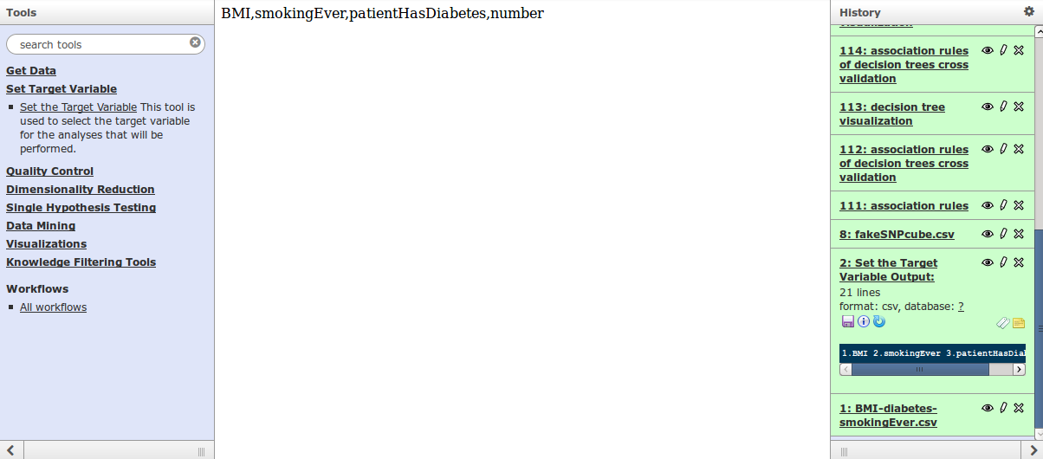

Figure 36: Output of the Set the Target Variable tool

The programs implementing this tool are referenced in Appendix A.

#### Quality Control

A component of this space that was delivered in the first release of the Integrated Linked2Safety Platform has undergone some User Interface changes. In the table you will see a revision list of changes made to the component since the first release of Linked2Safety:

Table 4: Revision List of Quality Control Components

|  |  |
| --- | --- |
| Component | Changes Occured |
| Hardy-Weinberg Equilibrium Test | No target variable selection option |

Additionally a new tool was created for handling datasets with non-applicable values.

##### Hardy-Weinberg Equilibrium Test

The user interface change in this tool is the removal of the selection of the target variable from the user defined options. The updated user interface of the tool is shown in the following figure.

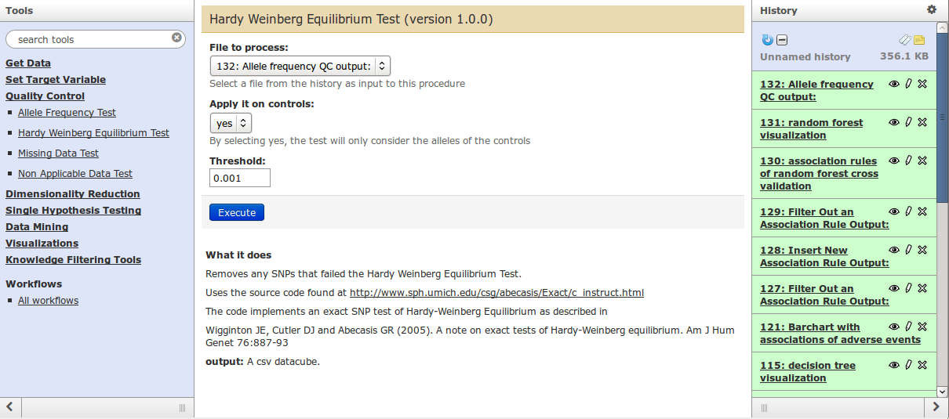

Figure 37: User interface of the Hardy-Weinberg Equilibrium test

The use of this tool is as follows:

1. Select the file that will be used in the analysis. This is done by selecting the input file from a drop-down menu under the label “File to process:”.
2. Select whether the test will be applied only on controls or on all of the subjects from a drop-down menu under the label “Apply it on controls”.
3. Set the threshold of the Hardy-Weinberg Equilibrium Test. The value given must be in the range [0,1]
4. Press the Execute button.

Once the algorithm is executed, its output is presented in the history pane. The algorithm outputs a new data cube without the SNPs that failed the test. By clicking on the “eye” icon, the variables that passed the Hardy-Weinberg Equilibrium Test are shown as illustrated in the following figure.

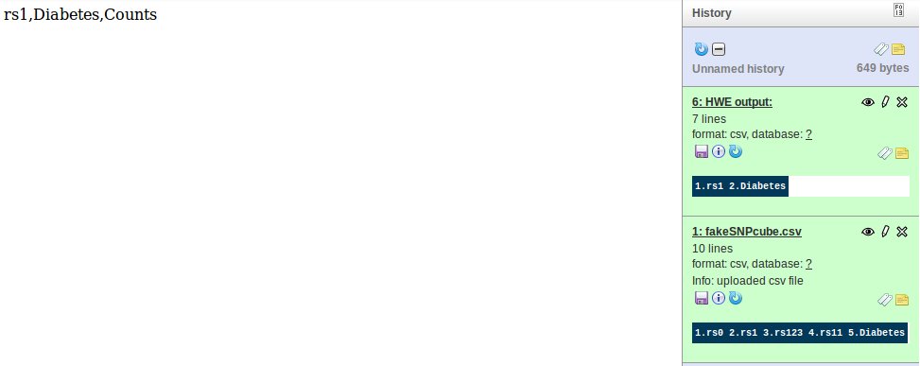

Figure 38: Output of the Hardy-Weinberg Equilibrium test

The programs implementing this tool are referenced in Appendix A.

#### Non-Applicable Data Test

This tool is used to remove any instances with non-applicable data. It can only consider the values of the target variable or the values of all variable in the data cube. The user interface of the tool is shown in .

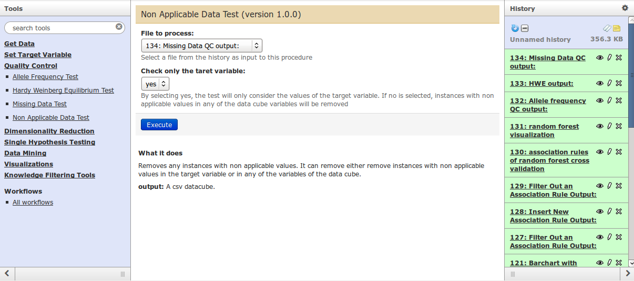

Figure 39: User interface of Non-Applicable data test

The use of this tool is as follows:

1. Select the file that will be used in the analysis. This is done by selecting the input file from a menu under the label “File to process:”.
2. Select whether the test will only consider the values of the target variable or the values of all variables in the data cube.
3. Press the Execute button.

Once the algorithm is executed, its output is presented in the history pane. The algorithm outputs a new data cube without the variables that failed the test. By clicking on the “eye” icon, the variables that passed the Missing Data Test are shown as illustrated in .

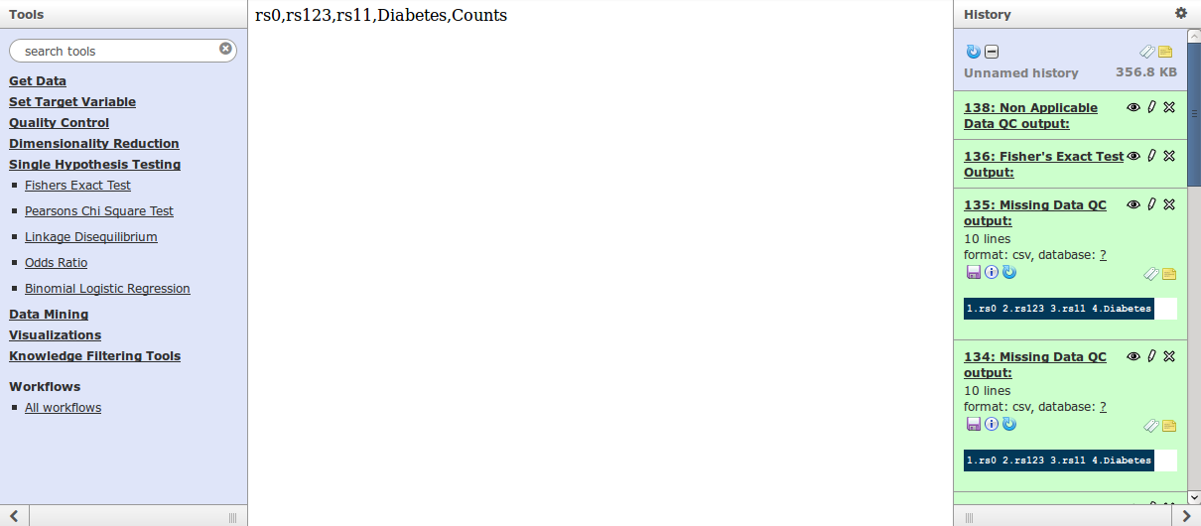

Figure 40: Output of the Non-Applicable Data Test

The programs implementing this tool are referenced in Appendix A.

## Processing

This section reports on the tools developed to perform single hypothesis testing and data mining.

#### Single Hypothesis Testing

Components of this space that were delivered in the first release of the Integrated Linked2Safety Platform have undergone some User Interface changes. In the following table you will see a revision list of changes made to the components since the first release of Linked2Safety:

Table 5: Revision List of Single Hypothesis Testing Components

|  |  |
| --- | --- |
| Component | Changes Occured |
| Pearson’s Chi Square Test | No target variable selection option added |
| Fisher’s Exact Test | No target variable selection option added |
| Binomial Logistic Regression | No target variable selection option added |
| Linkage Disequilibrium Test | No target variables selection option added |
| Odds Ratio | No target variables selection option added |

##### Pearson’s Chi Square Test

The updated user interface of the tool is shown in .

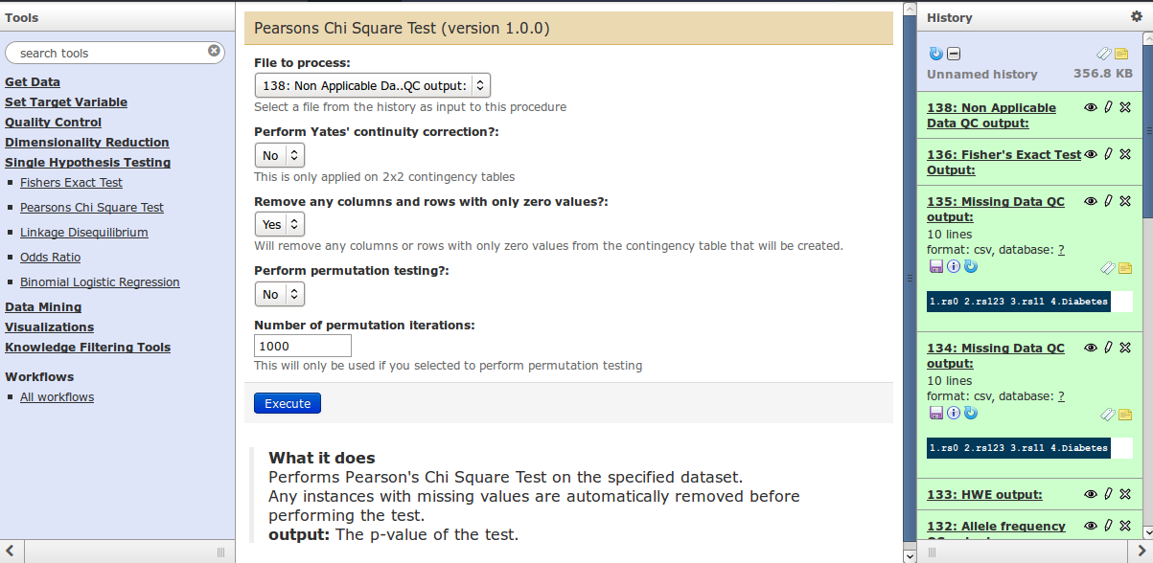

Figure 41: User interface of the Pearson’s Chi Square Test

The use of this tool is as follows:

1. Select the file that will be used in the analysis. This is done by selecting the input file from a menu under the label “File to process:”.
2. Select if Yates’ continuity correction [17] will be used from the list. This correction will only be applied if the contingency table has a 2x2 size.
3. Select if the rows and columns in the created contingency table with only zero values will be removed using a menu. If such columns or rows exist during the execution of the algorithm, an error message will be displayed to the user.
4. Select if permutation testing will be performed from the menu.
5. Set the number of iterations that will be performed during the permutation test. This will only be considered if “yes” was selected at the previous step.
6. Press the Execute button.

Once the algorithm is executed, its output is presented in the history pane. The algorithm outputs the association tested and the p value of the test performed. The association is in the format “a & b => c”, which denotes that what was tested was whether variables “a” and “b” are associated with variable “c”. By clicking on the “eye” icon, the association tested and the p value of the test performed are shown as illustrated in .

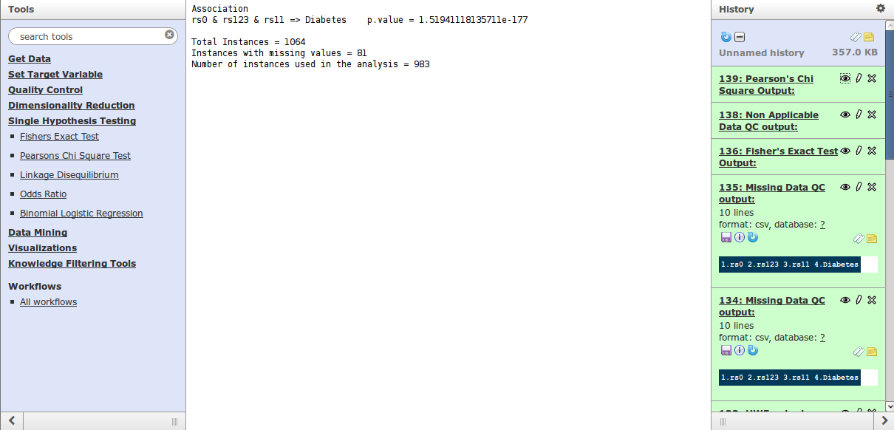

Figure 42: Output of Pearson’s Chi Square Test

The programs implementing this tool are referenced in Appendix A.

##### Fisher’s Exact Test

The updated user interface of the tool is shown in .

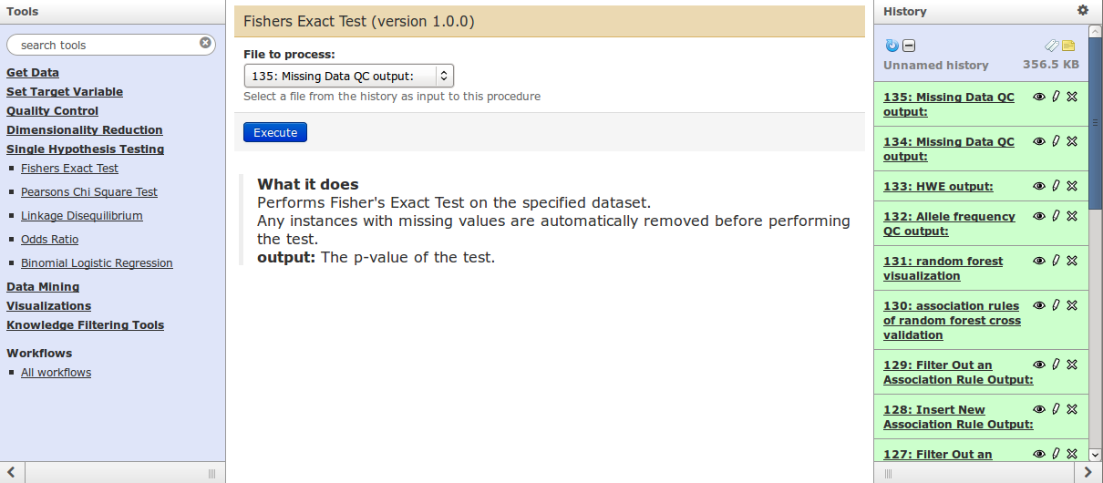

Figure 43: User interface of the Fisher’s Exact Test

The use of this tool is as follows:

1. Select the file that will be used in the analysis. This is done by selecting the input file from a menu under the label “File to process:”.
2. Press the Execute button.

Once the algorithm is executed, its output is presented in the history pane. The algorithm outputs the association tested and the p value of the test performed. The association is in the format “a & b => c”, which denotes that what was tested was whether variables “a” and “b” are associated with variable “c”. By clicking on the “eye” icon, the association tested and the p value of the test performed are shown as illustrated in .

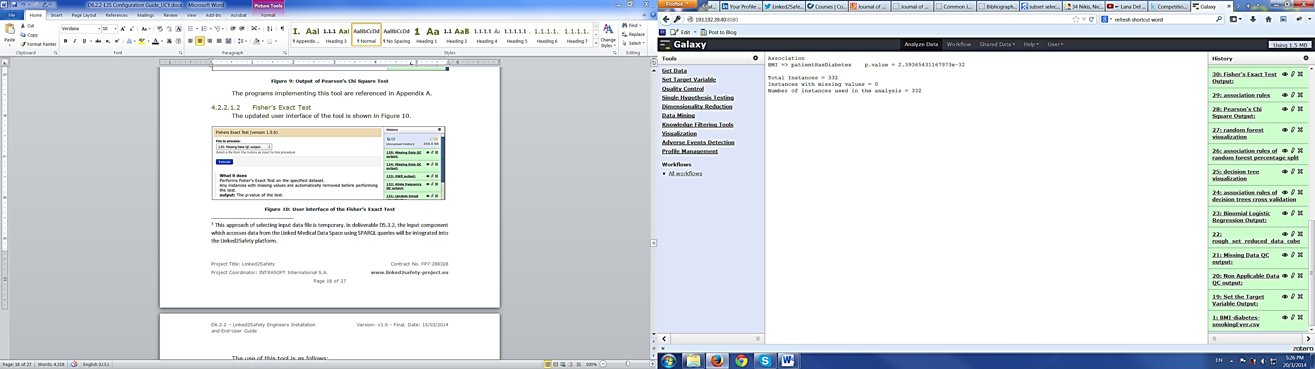

Figure 44: Output of Fisher’s Exact Test

The programs implementing this tool are referenced in Appendix A.

##### Binomial Logistic Regression

The updated user interface of the tool is shown in .

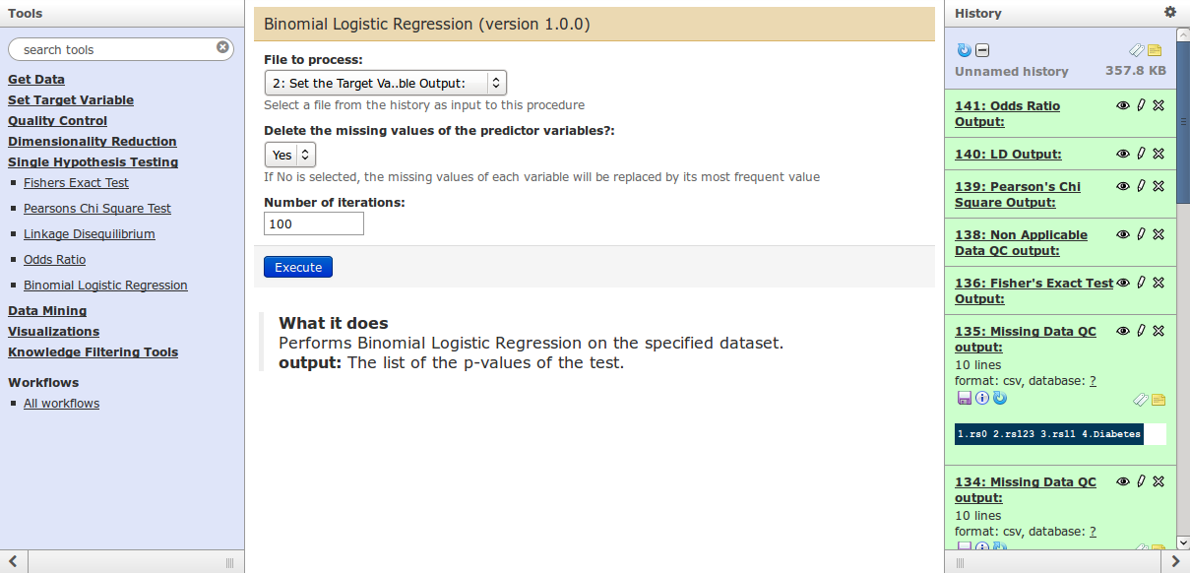

Figure 45: User interface of the Binomial Logistic Regression

The use of this tool is as follows:

1. Select the file that will be used in the analysis. This is done by selecting the input file from a menu under the label “File to process:”.
2. Select if instances with missing data will be removed from the analysis.
3. Set the number of iterations that will be performed during the training of the algorithm.
4. Press the Execute button.

Once the algorithm is executed, its output is presented in the history pane. The algorithm outputs the associations tested and the p values of the tests performed. The associations are in the format “a => b”, which denotes that what was tested was whether variable “a” is associated with variable “b”. By clicking on the “eye” icon, the associations tested and the p values of the tests performed are shown as illustrated in .

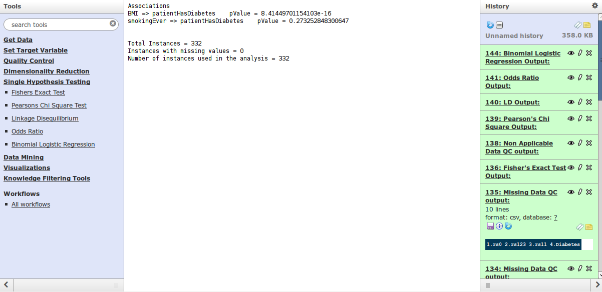

Figure 46: Output of Binomial Logistic Regression

The programs implementing this tool are referenced in Appendix A.

##### Linkage Disequilibrium

The updated user interface of the tool is shown in .

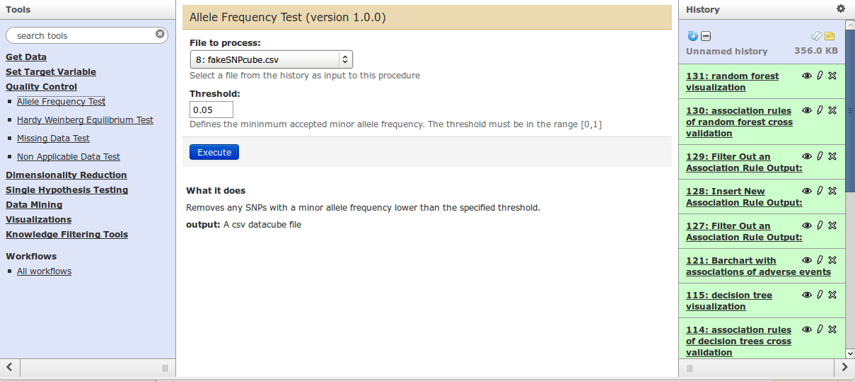

Figure 47: User interface of the Linkage Disequilibrium tool

The use of this tool is as follows:

1. Select the file that will be used in the analysis. This is done by selecting the input file from a menu under the label “File to process:”.
2. Select the LD measure that will be used. There are three available options (D, D’ and r) given in a menu.
3. Press the Execute button.

Once the algorithm is executed, its output is presented in the history pane. The algorithm outputs the LD value of the test performed. By clicking on the “eye” icon, the SNPs tested and their LD value are shown as illustrated in . “rs0 => rs1” in , denotes that the tool tested the linkage disequilibrium between SNPs “rs0” and “rs1”.

The programs implementing this tool are referenced in Appendix A.

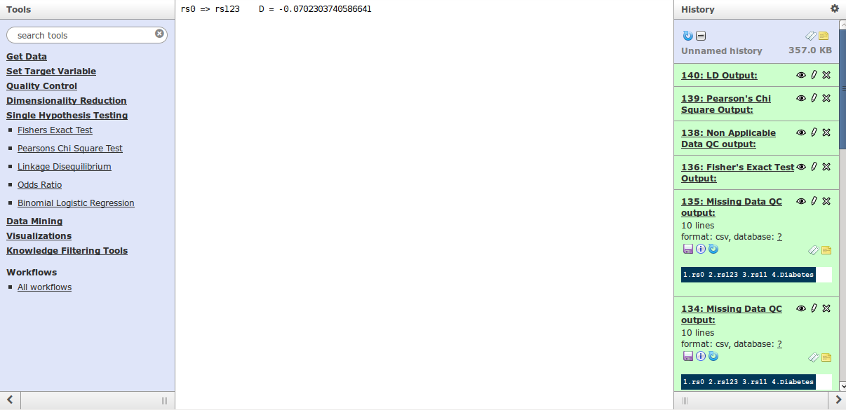

Figure 48: Output of the Linkage Disequilibrium tool

##### Odds Ratio

The updated user interface of the tool is shown in .

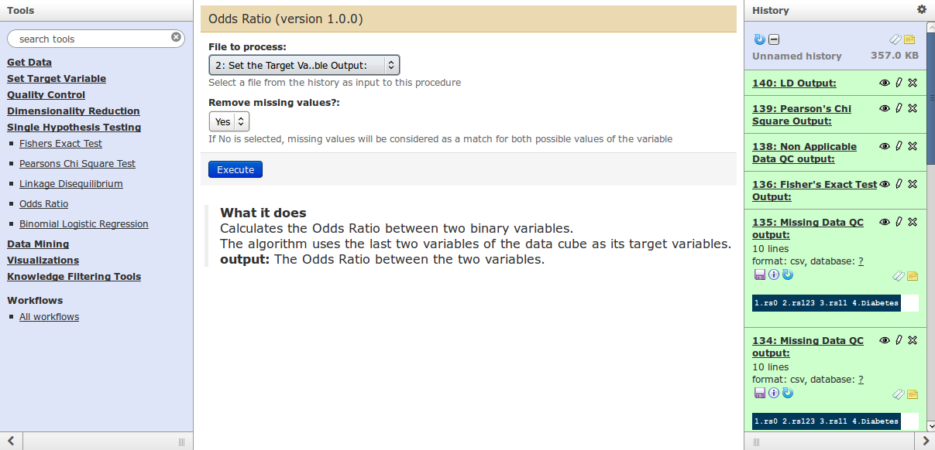

Figure 49: User interface of the Odds Ratio tool

The use of this tool is as follows:

1. Select the file that will be used in the analysis. This is done by selecting the input file from a menu under the label “File to process:”.
2. Select if missing values will be ignored from the test using a menu with the two options (yes, no).
3. Press the Execute button.

Once the algorithm is executed, its output is presented in the history pane. The algorithm outputs the association tested and the odds ratio of the test performed. The association is in the format “a => b”, which denotes that variable “a” was tested for association with variable “b”. By clicking on the “eye” icon, the association tested and the odds ratio of the test performed are shown as illustrated in .

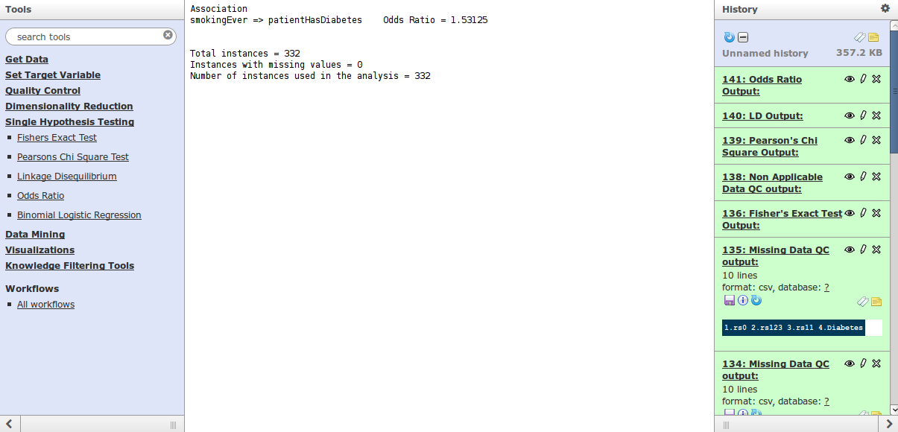

Figure 50: Output of the Odds Ratio tool

The programs implementing this tool are referenced in Appendix A.

#### Dimensionality Reduction

This component of the Data Analysis space that has been delivered in the first  
release of the Integrated Linked2Safety Platform has been undergone some  
bug fixes and minor changes. In Table 6 you will see a revision list of changes made to this component since the first release of Linked2Safety:

Table 6: Changes of Dimensionality Reduction Component

|  |  |
| --- | --- |
| Tools of Dimensionality Reduction Component | Changes Occurred |
| Rough Set Dimensionality Reduction | No Target Variable Selection Option  Added Delete Missing Values Option |
| Information Gain Dimensionality Reduction | No Target Variable Selection Option  Added Delete Missing Values Option |
| Chi Squared Dimensionality Reduction | No Target Variable Selection Option  Added Delete Missing Values Option |

##### Rough Set Dimensionality Reduction

The updated user interface of the tool is shown in Figure 51.

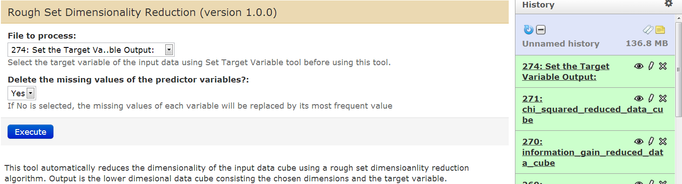

Figure 51: Rough Set Dimensionality Reduction

The use of this tool is as follows:

1. Use the SetTargetVariable tool to set the target variable of the data cube. The SetTargetVariable tool outputs a new data cube with the target variable as the last variable in the data cube.
2. Go the the user interface of Rough Set Dimensionality Reduction.
3. Select the data cube that is output by the SetTargetVariable tool. This is done by selecting the input file from a menu under the label “File to process:”.
4. Select if instances with missing data will be removed from the analysis.
5. Press the Execute button.

Once the algorithm is executed, its output is presented in the history pane. The algorithm outputs the lower dimensional data consisting of the target variable and the most strongly correlated variables. By clicking on the “eye” icon, the target variable and the variables that are most strongly correlated with the target variable are shown as illustrated in Figure 52.

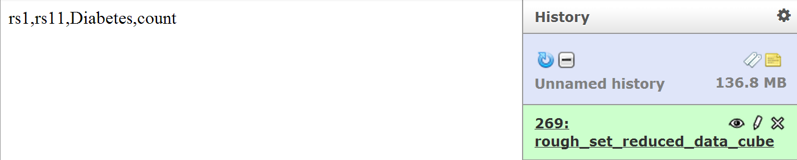

Figure 52: Output of Rough Set Dimensionality Reduction

##### Information Gain Dimensionality Reduction

The updated user interface of the tool is shown in Figure 53.

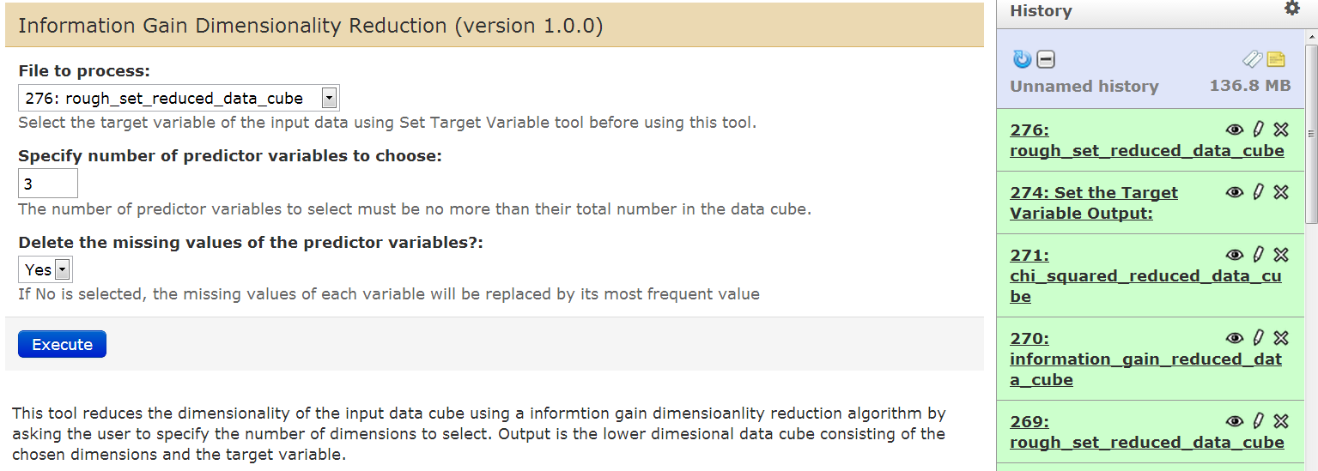

Figure 53: Information Gain Dimensionality Reduction

The use of this tool is as follows:

1. Use the SetTargetVariable tool to set the target variable of the data cube. The SetTargetVariable tool outputs a new data cube with the target variable as the last variable in the data cube.
2. Go the the user interface of Information Gain Dimensionality Reduction.
3. Select the data cube that is output by the SetTargetVariable tool. This is done by selecting the input file from a menu under the label “File to process:”.
4. Select if instances with missing data will be removed from the analysis.
5. Press the Execute button.

Once the algorithm is executed, its output is presented in the history pane. The algorithm outputs the lower dimensional data consisting of the target variable and the most strongly correlated variables. By clicking on the “eye” icon, the target variable and the variables that are most strongly correlated with the target variable are shown as illustrated in Figure 54.

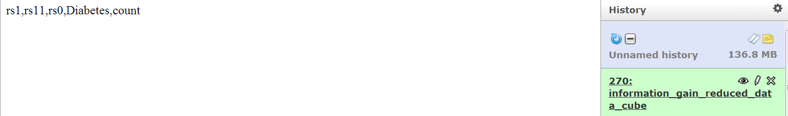

Figure 54: Output of Information Gain Dimensionality Reduction

##### Chi Squared Dimensionality Reduction

The updated user interface of the tool is shown in Figure 55.

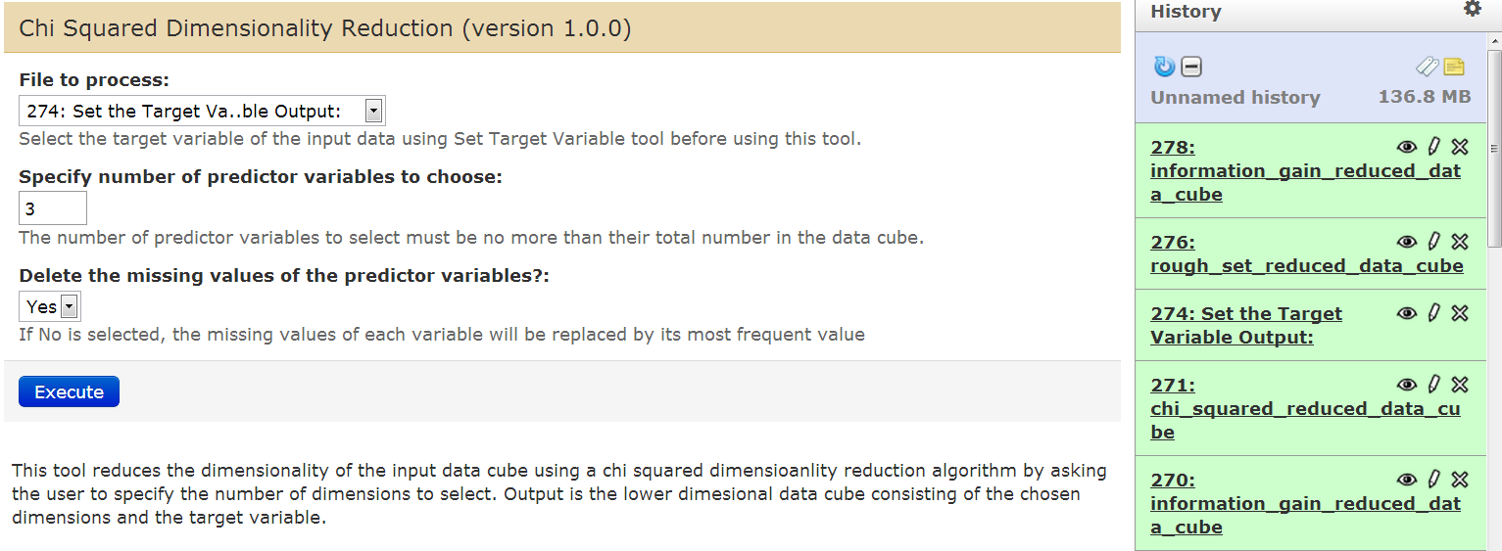

Figure 55: Chi Squared Dimensionality Reduction

The use of this tool is as follows:

1. Use the SetTargetVariable tool to set the target variable of the data cube. The SetTargetVariable tool outputs a new data cube with the target variable as the last variable in the data cube.
2. Go the the user interface of Chi Squared Dimensionality Reduction.
3. Select the data cube that is output by the SetTargetVariable tool. This is done by selecting the input file from a menu under the label “File to process:”.
4. Select if instances with missing data will be removed from the analysis.
5. Press the Execute button.

Once the algorithm is executed, its output is presented in the history pane. The algorithm outputs the lower dimensional data consisting of the target variable and the most strongly correlated variables. By clicking on the “eye” icon, the target variable and the variables that are most strongly correlated with the target variable are shown as illustrated in Figure 56.

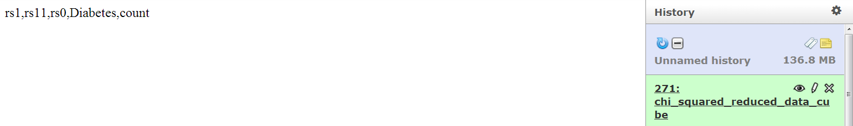

Figure 56: Output of Chi Squared Dimensionality Reduction

#### Data Mining

This component of the Data Analysis space that has been delivered in the first  
release of the Integrated Linked2Safety Platform has been undergone some  
bug fixes and minor changes. In you will see a revision list of changes made to this component since the first release of Linked2Safety:

Table 7: Changes of Data Mining Component

|  |  |
| --- | --- |
| Tools of Data Mining Component | Changes Occurred |
| Association Rules | Added Delete Missing Values Option |
| Decision Trees Percentage Split | No Target Variable Selection Option  Added Delete Missing Values Option |
| Decision Trees Cross Validation | No Target Variable Selection Option  Added Delete Missing Values Option |
| Random Forest Percentage Split | No Target Variable Selection Option  Added Delete Missing Values Option |
| Random Forest Cross Validation | No Target Variable Selection Option  Added Delete Missing Values Option |

##### Association Rules

The updated user interface of the tool is shown in Figure 57.

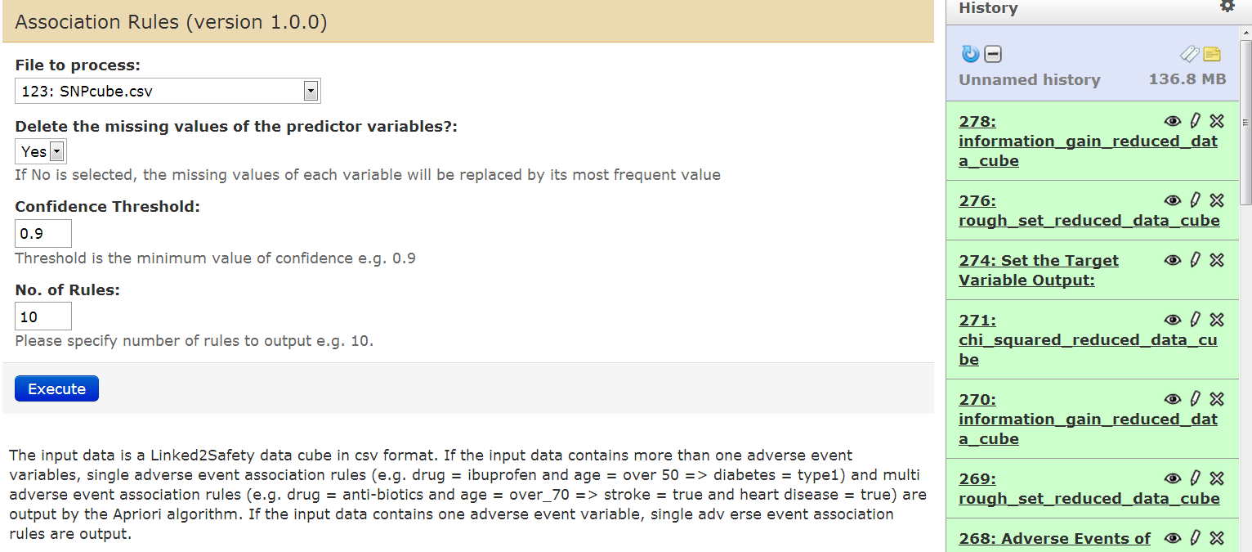

Figure 57: Association Rules

The use of this tool is as follows:

1. Select the file that will be used in the analysis. This is done by selecting the input file from a menu under the label “File to process:”.
2. Select if instances with missing data will be removed from the analysis.
3. Specify the confidence threshold of association rules so that only the rules with confidence values greater than or equal to the confidence threshold are returned.
4. Specify the number of rules to output.
5. Press the Execute button.

Once the algorithm is executed, its output is presented in the history pane. The algorithm outputs the specified number of association rules whose confidence are greater than or equal to the confidence threshold.

By clicking on the “eye” icon, the association rules, their support, confidence and lift are shown as illustrated in Figure 58.

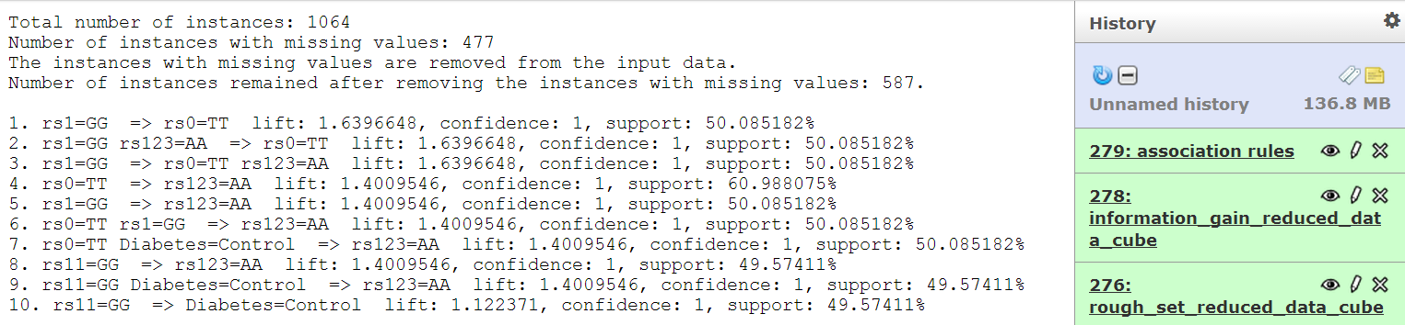

Figure 58: Output of Association Rules

##### Decision Trees Percentage Split

The updated user interface is shown in Figure 59.

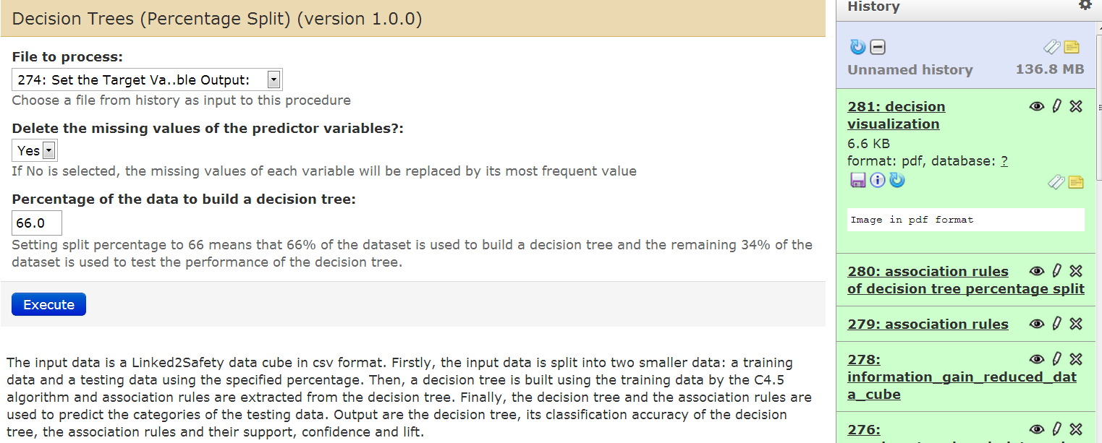

Figure 59: Decision Trees Percentage Split

The use of this tool is as follows:

1. Use the SetTargetVariable tool to set the target variable of the data cube. The SetTargetVariable tool outputs a new data cube with the target variable as the last variable in the data cube.
2. Go the the user interface of Decision Trees Percentage Split.
3. Select the data cube that is output by the SetTargetVariable tool. This is done by selecting the input file from a menu under the label “File to process:”.
4. Select if instances with missing data will be removed from the analysis.
5. Set the percentage of the input data to be used to build the decision tree.
6. Press the Execute button.

Once the algorithm is executed, its outputs are presented in the history pane. The algorithm outputs a decision tree visualization and the association rules of the decision tree. The association rule is in the format “LHS => RHS”, which denotes that LHS is associated with RHS where LHS is the part of the rule on the left hand side of “=>” and RHS is the part of the rule on the right hand side of “=>”.

By clicking on the “eye” icons, the decision tree visualization and the association rules are shown as illustrated in Figure 60 and Figure 61.

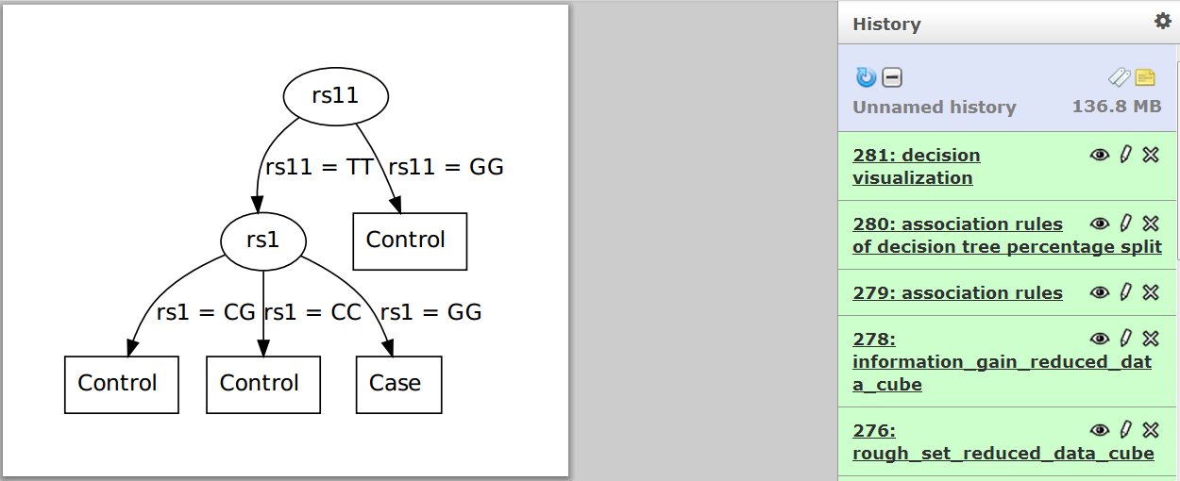

Figure 60: Decision Tree Visualization

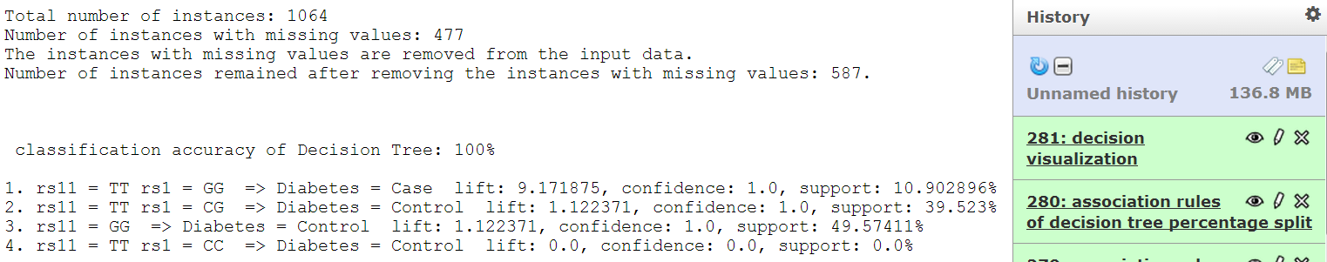

Figure 61: Association Rules of Decision Trees Percentage Split

##### Decision Trees Cross Validation

The updated user interface is shown in Figure 62.

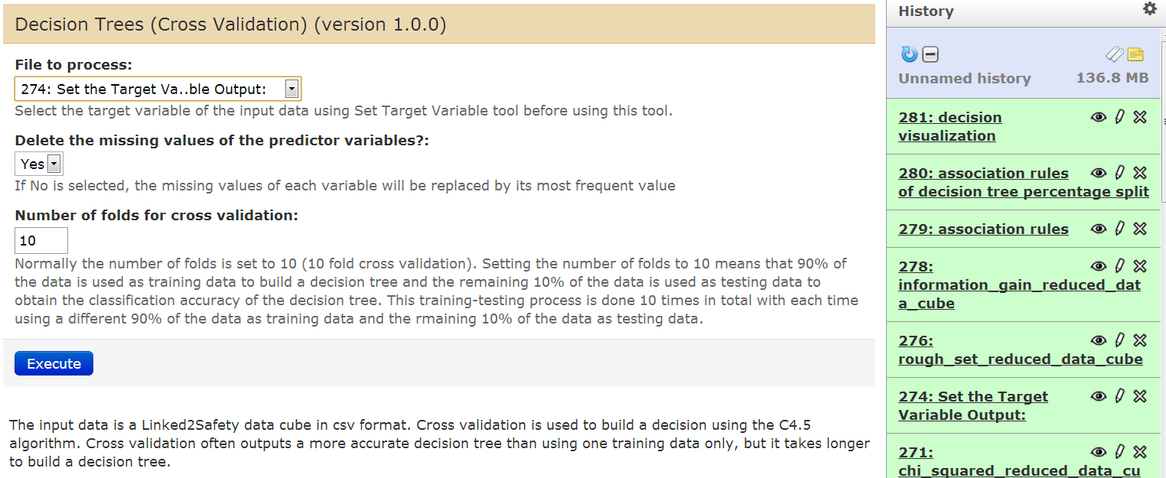

Figure 62: Decision Trees Cross Validation

The use of this tool is as follows:

1. Use the SetTargetVariable tool to set the target variable of the data cube. The SetTargetVariable tool outputs a new data cube with the target variable as the last variable in the data cube.
2. Go the the user interface of Decision Trees Cross Validation.
3. Select the data cube that is output by the SetTargetVariable tool. This is done by selecting the input file from a menu under the label “File to process:”.
4. Select if instances with missing data will be removed from the analysis.
5. Set the number of folds (e.g. 10) for cross validation.
6. Press the Execute button.

Once the algorithm is executed, its outputs are presented in the history pane. The algorithm outputs a decision tree visualization and the association rules of the decision tree. The association rule is in the format “LHS => RHS”, which denotes that LHS is associated with RHS where LHS is the part of the rule on the left hand side of “=>” and RHS is the part of the rule on the right hand side of “=>”.

By clicking on the “eye” icons, the decision tree visualization and the association rules are shown as illustrated in Figure 63 and Figure 64.

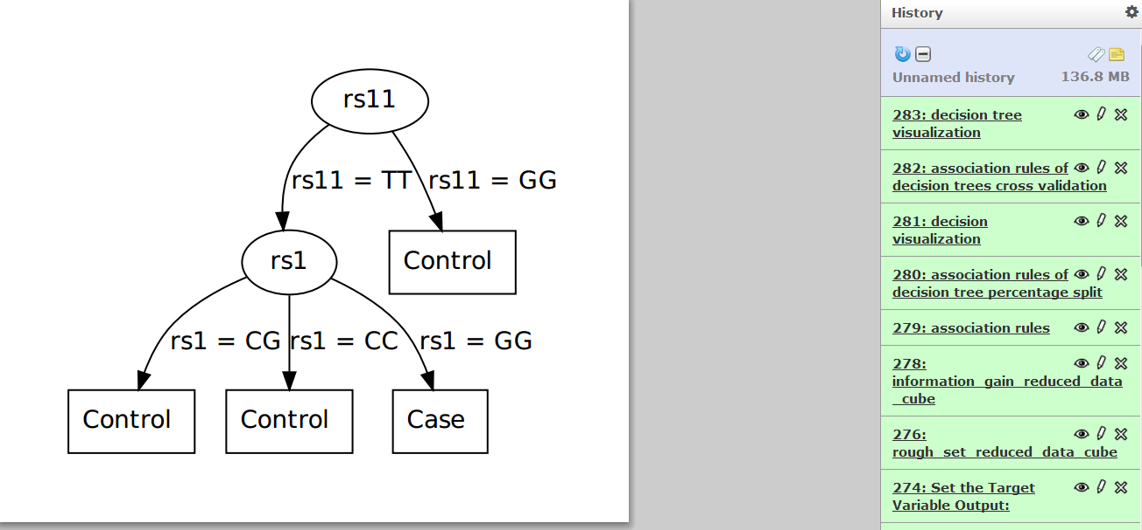

Figure 63: Decision Tree Visualization

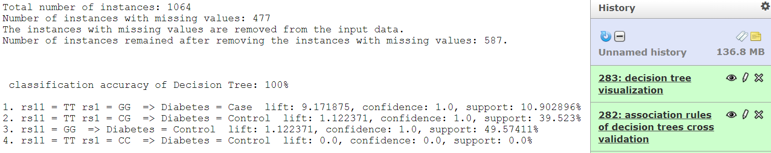

Figure 64: Association Rules of Decision Trees Cross Validation

##### Random Forest Percentage Split

The updated user interface of this tool is shown in Figure 65.

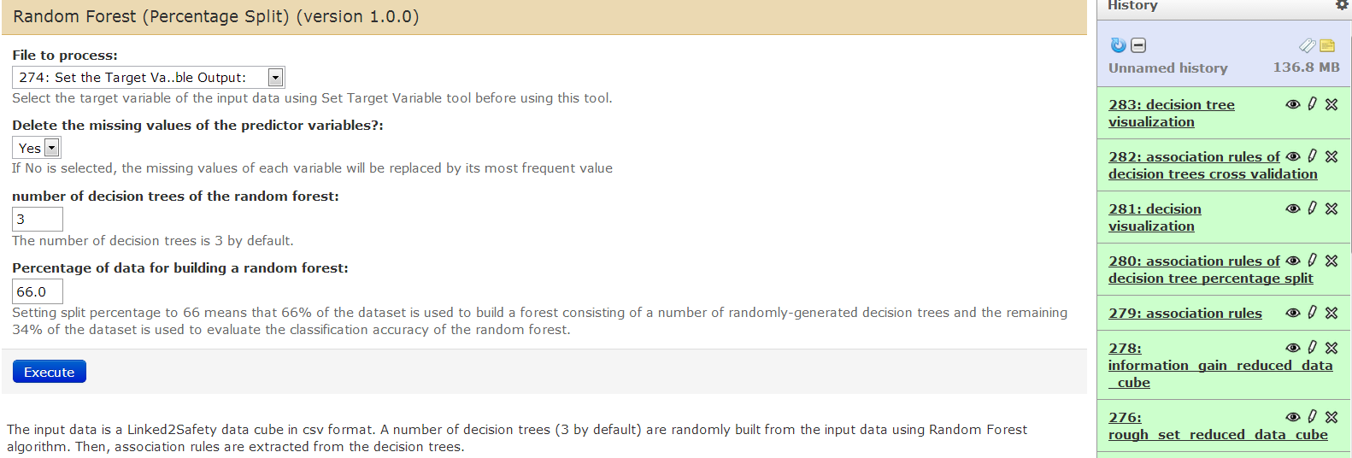

Figure 65: Random Forest Percentage Split

The use of this tool is as follows:

1. Use the SetTargetVariable tool to set the target variable of the data cube. The SetTargetVariable tool outputs a new data cube with the target variable as the last variable in the data cube.
2. Go the the user interface of Random Forest Percentage Split.
3. Select the data cube that is output by the SetTargetVariable tool. This is done by selecting the input file from a menu under the label “File to process:”.
4. Select if instances with missing data will be removed from the analysis.
5. Specify the number of decision trees to build.
6. Specify the percentage of the input data to be used to build the decision trees.
7. Set the percentage of the input data to be used to build the decision tree.
8. Press the Execute button.

Once the algorithm is executed, its outputs are presented in the history pane. This algorithm outputs a random forest visualization and the association rules of the random forest. By clicking on the “eye” icons, the random forest visualization and the association rules are shown as illustrated in Figure 66 and

Figure 67.

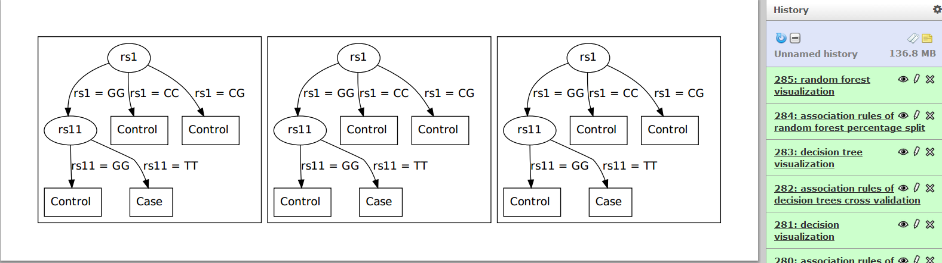

Figure 66: Random Forest Visualization

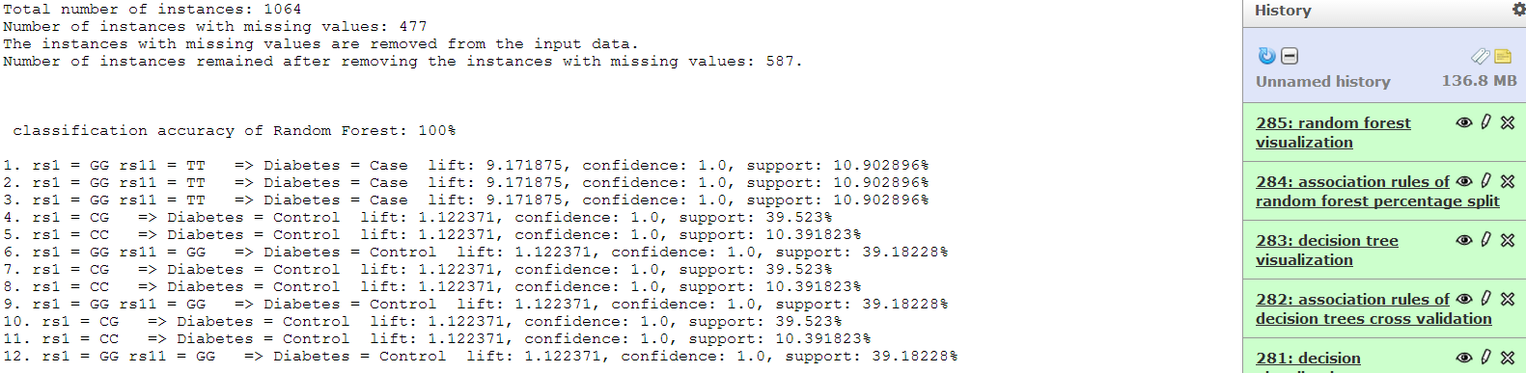

Figure 67: Association Rules of Random Forest Percentage Split

#### Random Forest Cross Validation

The updated user interface of this tool is shown in Figure 68.

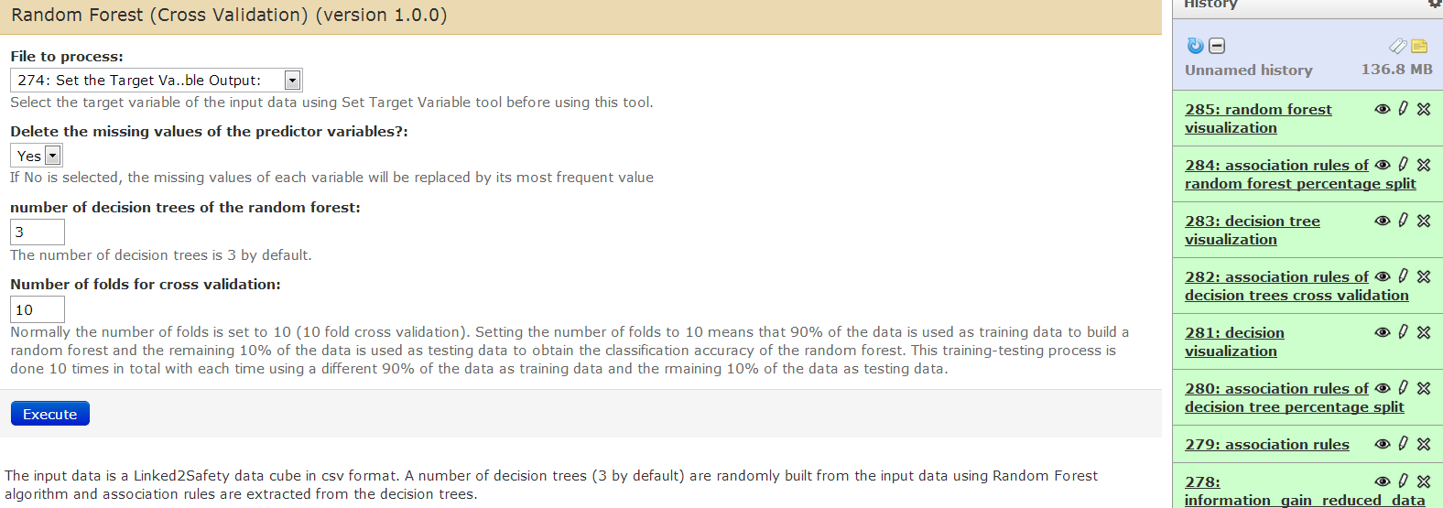

Figure 68: Random Forest Cross Validation

The use of this tool is as follows:

1. Use the SetTargetVariable tool to set the target variable of the data cube. The SetTargetVariable tool outputs a new data cube with the target variable as the last variable in the data cube.
2. Go the the user interface of Random Forest Cross Validation.
3. Select the data cube that is output by the SetTargetVariable tool. This is done by selecting the input file from a menu under the label “File to process:”.
4. Select if instances with missing data will be removed from the analysis.
5. Specify the number of decision trees to build.
6. Specify the number of folds for cross validation.
7. Press the Execute button.

Once the algorithm is executed, its outputs are presented in the history pane. This algorithm outputs a random forest visualization and the association rules of the random forest. By clicking on the “eye” icons, the random forest visualization and the association rules are shown as illustrated in Figure 69 and Figure 70.

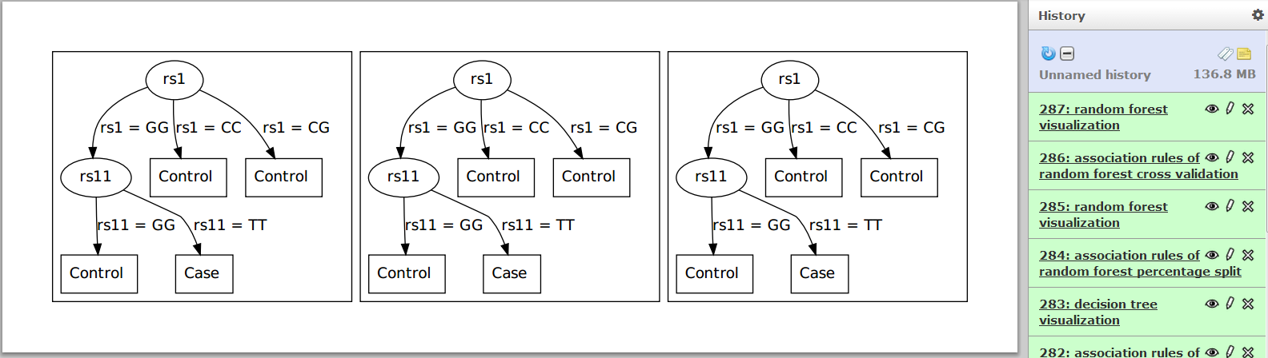

Figure 69: Random Forest Visualization

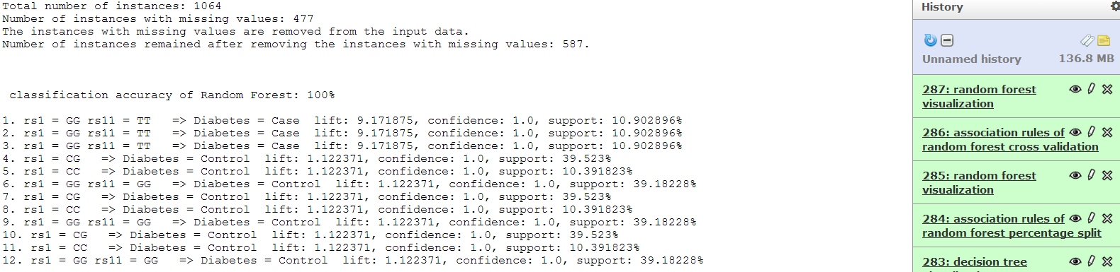

Figure 70: Association Rules of Random Forest Cross Validation

#### Visualization

This component of the Data Analysis space that has been delivered in the first  
release of the Integrated Linked2Safety Platform has been undergone some  
bug fixes and minor changes. In

, you will see a revision list of  
changes made to this component since the first release of Linked2Safety:

Table 8: Changes of Visualization Component

|  |  |
| --- | --- |
| Tools of Visualization Component | Changes Occurred |
| Profiles of Each Adverse Event Barchart | This tool is renamed; its previous name is  Adverse Events Occurrence Barchart |
| Adverse Events of Each Profile Barchart | The user interface is changed |

#### Profiles of Each Adverse Event Barchart

This tool is used to create a bar chart that illustrates the number of profiles which contain each adverse event in the knowledge base. The user interface of the tool is shown in

Figure 71.

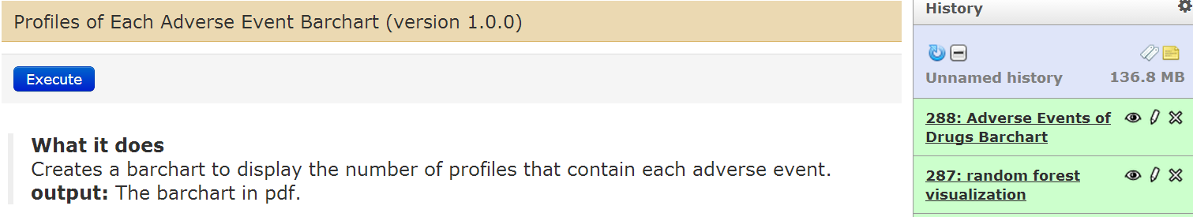

Figure 71: Profiles of Each Adverse Event Barchart

To use this tool the user just needs to press the Execute button. Once the tool is executed, its output is presented in the history pane. The tool outputs a pdf file that has the bar chart. By clicking on the “eye” icon, the bar chart is shown as illustrated in Figure 72. The x axis has the adverse events and y axis the number of profiles which contains each adverse event.

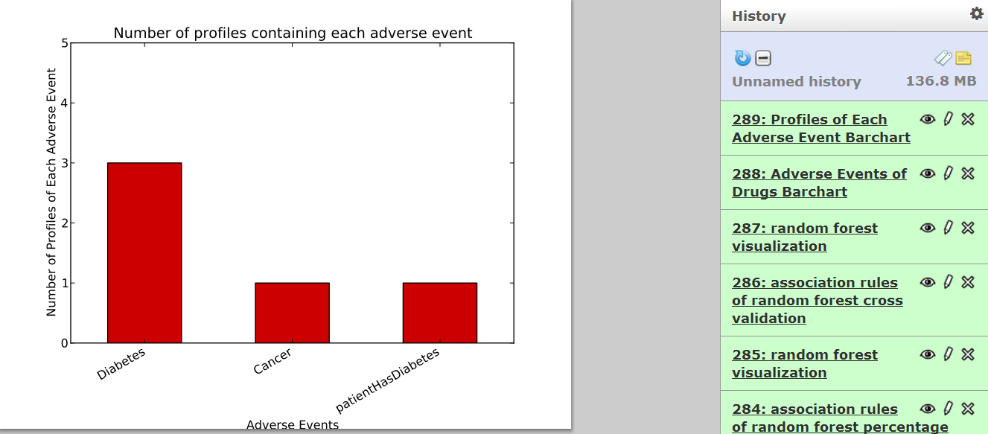

Figure 72: Output of Profiles of Each Adverse Event Bar chart

#### Adverse Events of Each Profile Bar chart

This tool is used to create a bar chart that illustrates the number of adverse events which are contained in each profile in the knowledge base. The user interface of the tool is shown in Figure 73.

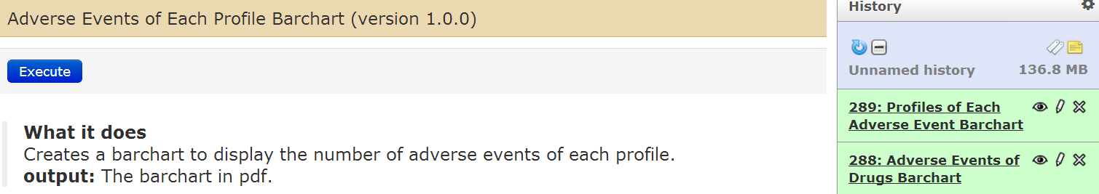

Figure 73: Adverse Events of Each Profile

To use this tool the user just needs to press the Execute button. Once the tool is executed, its output is presented in the history pane. The tool outputs a pdf file that has the bar chart. By clicking on the “eye” icon, the bar chart is shown as illustrated in Figure 74. The x axis has the profiles and y axis the number of adverse events which are contained in each profile.

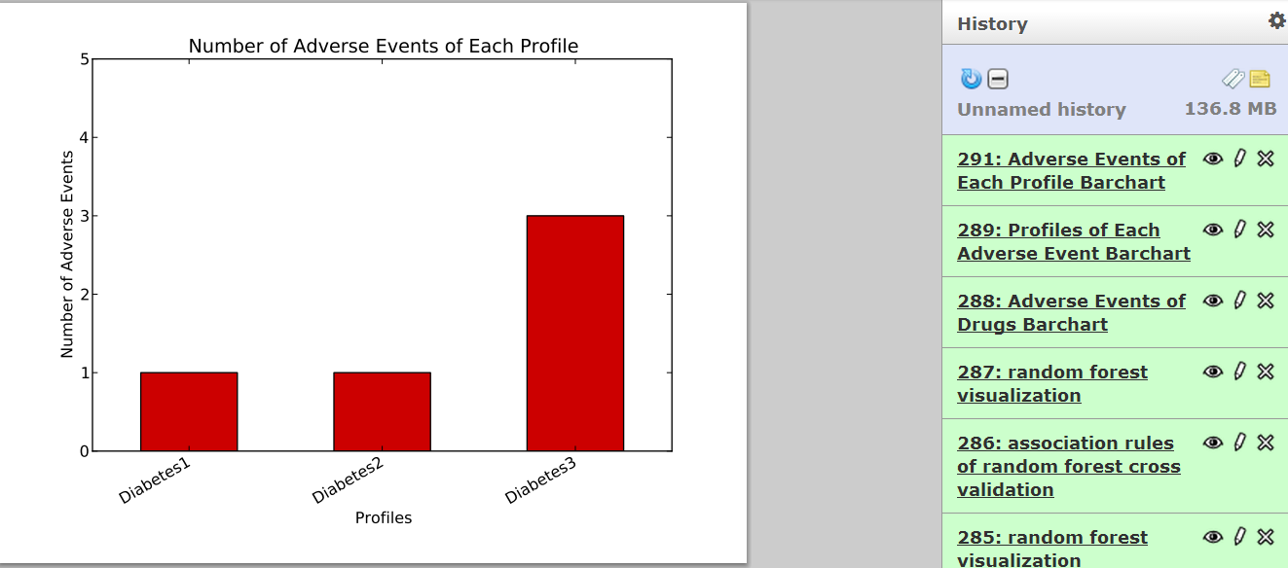

Figure 74: Output of Adverse Events of Each Profile

#### Profile Management

This component of the Data Analysis space is a new component added to the second release of the integrated Linked2Safety platform. This component consists of the following tools:

* Create Profile
* Modify Profile
* Delete Profile
* View Profile

##### Create Profile

This tool is used to create a virtual patient profile. The use of this tool is as follows:

1. Log into this tool by entering the user’s email address and password (Figure 75).
2. An empty profile form is displayed (Figure 76). The form consists of five sections:

* Profile Name: Enter the profile name.
  + Current Drug treatments: Enter any drugs currently taken by the virutal patient by selecting drugs from the drop-down lists of drugs and selecting a value for each selected drug from the drop-down list of the values of that drug.
    1. To add another drug treatment, press the Add Drug Treatment button.
    2. To delete a drug treatment, select ‘delete‘ from the drop-down list of drugs.
  + Medical Measurements: Enter any medical measurements of the virtual patient by selecting measurements from the drop-down lists of medical measurements and selecting a value for each selected measurement from the down-down list of the values of that measurement.
    1. To add another medical measurement, press the ‘Add Measurement’ button.
    2. To delete a drug treatment, select ‘delete‘ from the drop-down list of drugs.
  + SNPs Information: Enter any SNPs information of the virtual patient by selecting the patient’s SNPs from the drop-down list of SNPs and selecting a value for each selected SNP from the drop-down list of the values of that SNP.
    1. To add another SNP, press the ‘Add SNP‘ button.
    2. To delete a SNP, select ‘delete‘ from the drop-down list of SNPs.
* Adverse Events History: Enter any past adverse events of the virtual patient by selecting them from the drop-down lists of adverse events; Enter the date of detection of a past adverse event in the ‘Date of Detection’ text field if the date is known.
  1. To add another past adverse event, press the ‘Add Adverse Event’ button.
  2. To delete an adverse event , select ‘delete‘ from the drop-down list of adverse events.

1. Press the Create button.
2. A confirmation of creating the profile is displayed (Figure 77).
3. Press the Logout button to log out from this tool.

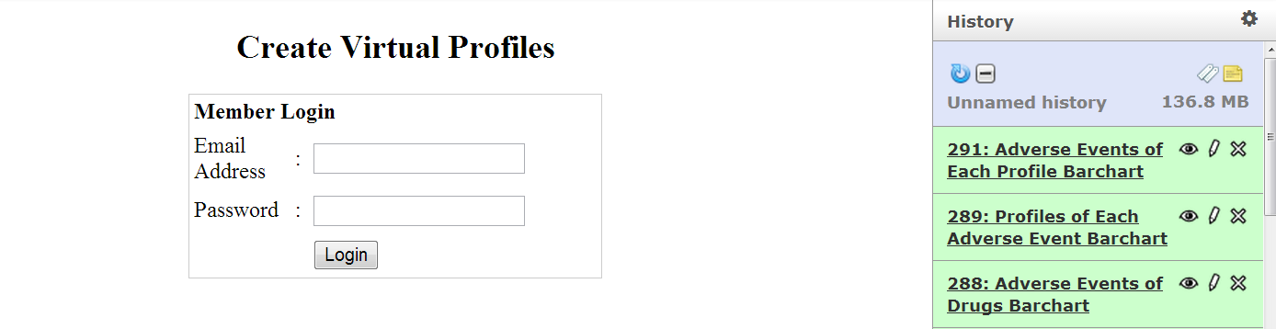

Figure 75: Login Screen of Create Virtual Profiles

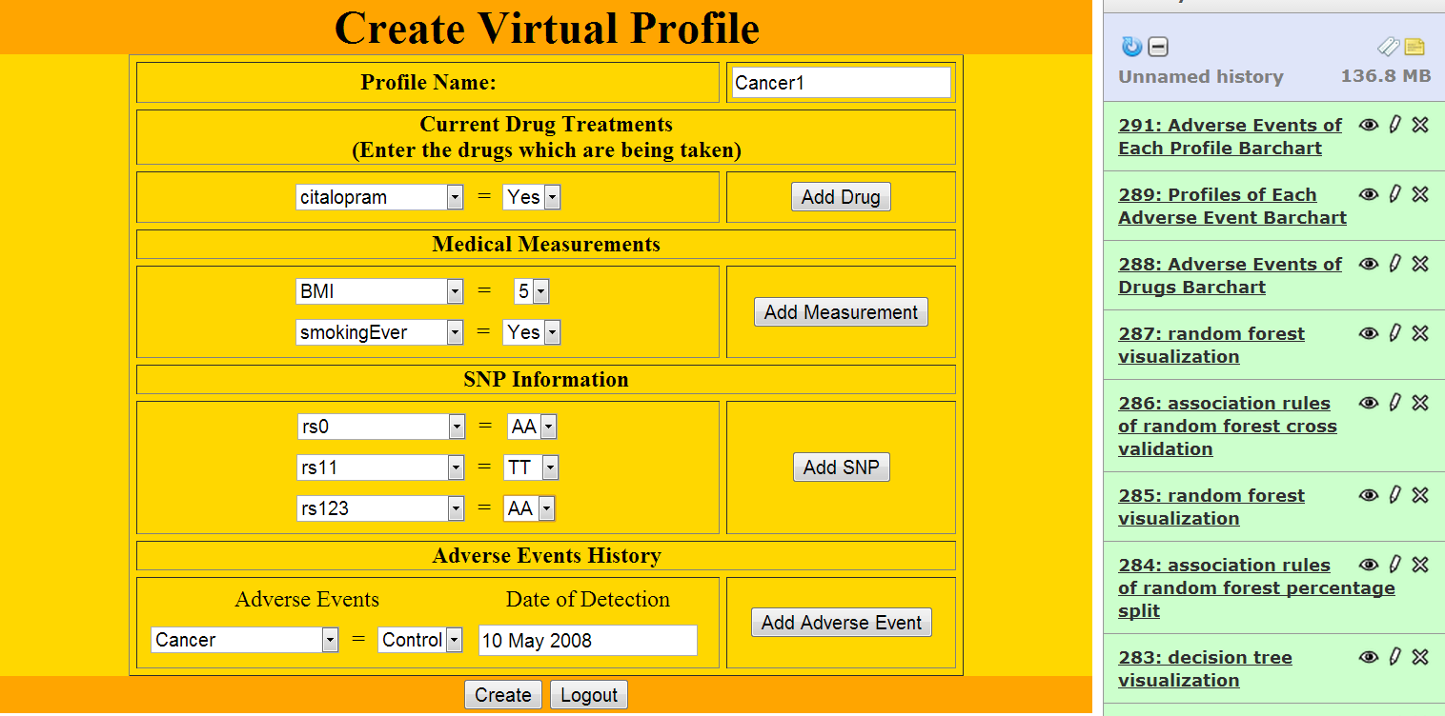

Figure 76: Create Virtual Profile

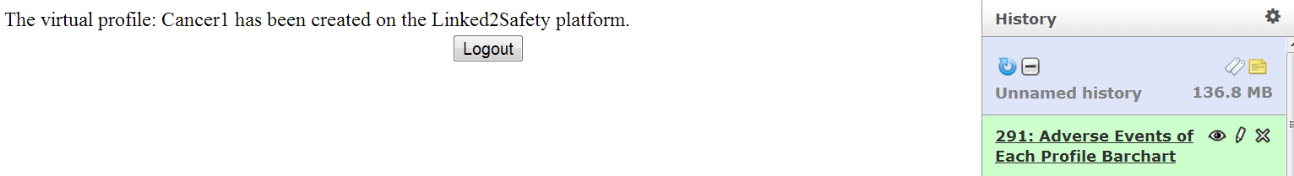

Figure 77: Confirmation of Virtual Profile Creation

##### View Profile

This tool is used to view all the virtual profiles of a user. The use of this tool is as follows:

1. Log into this tool by entering the user’s email address and password (Figure 78).
2. All the profiles of the user are displayed (Figure 79).
3. Press the Logout button to log out from this tool.

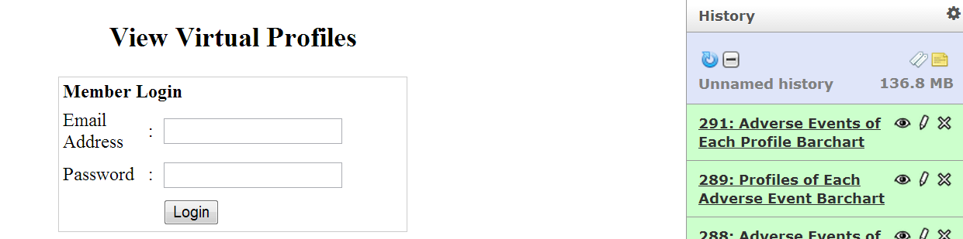

Figure 78: Login Screen of View Virtual Profiles

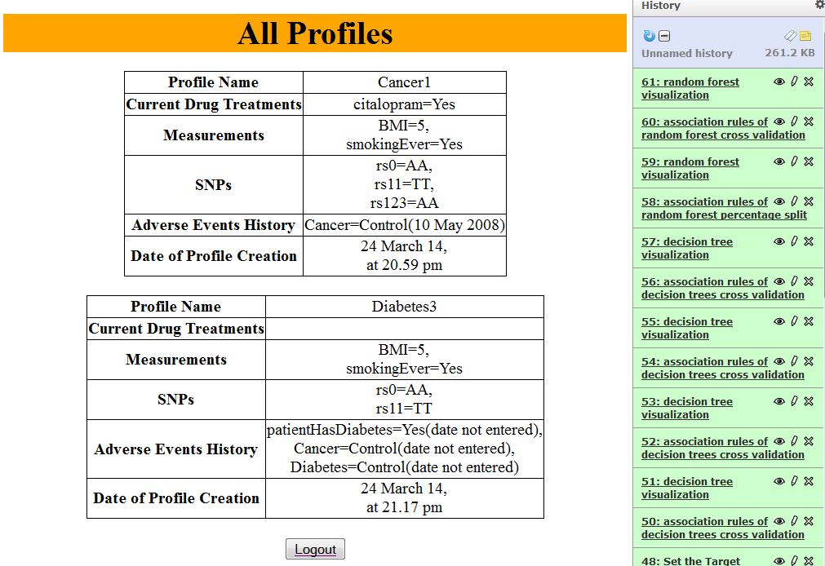

Figure 79: All Profiles of the User

##### Modify Profile

This tool is used to modify a virtual patient’s profile of a user. The use of this tool is as follows:

1. Log into this tool by entering the user’s email address and password (Figure 80).
2. The all the virtual profiles of the user are displayed. Select a profile to modify by selecting the radio button next to it (Figure 81).
3. Press the Select Profile button.
4. The selected profile is displayed (Figure 82).
5. Change the information in the fields of the profile as required.
6. Press the Modify button to save the changes or press the ‘Cancel‘ button to cancel the modification of this profile.
7. A confirmation about the modification of the profile is displayed (Figure 83).
8. Press the Logout button to log out from this tool.

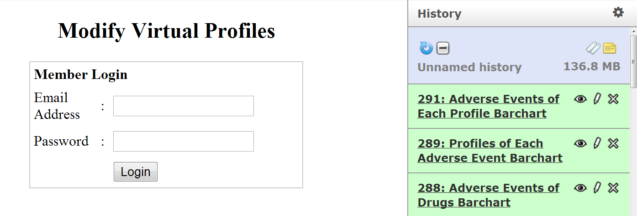

Figure 80: Login Screen of Modify Virtual Profiles

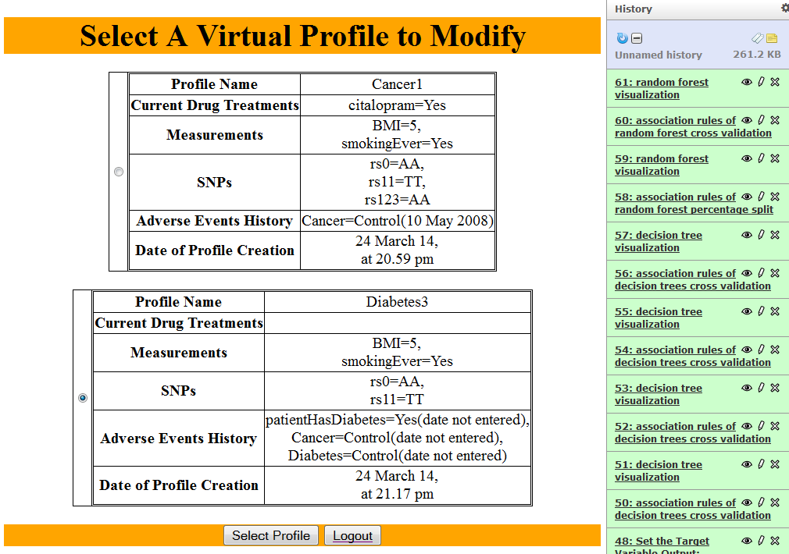

Figure 81: Select A Virtual Profile to Modify

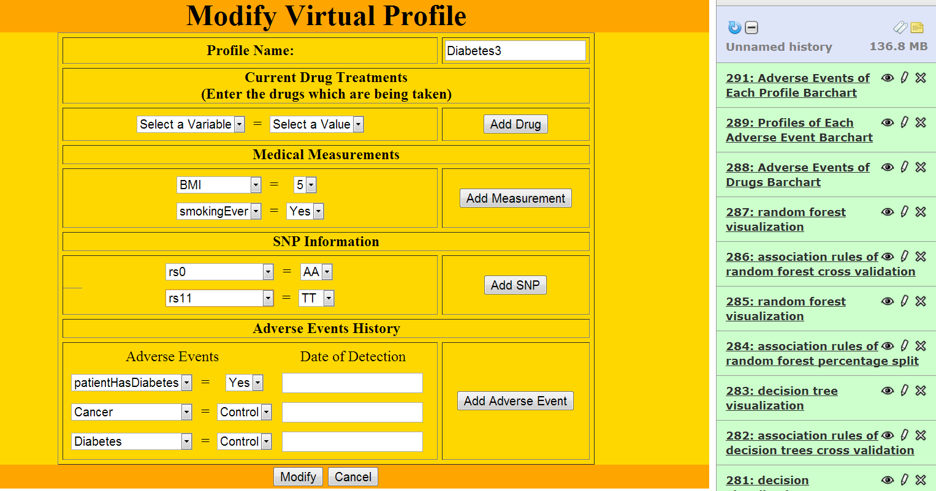

Figure 82: Modify Virtual Profile

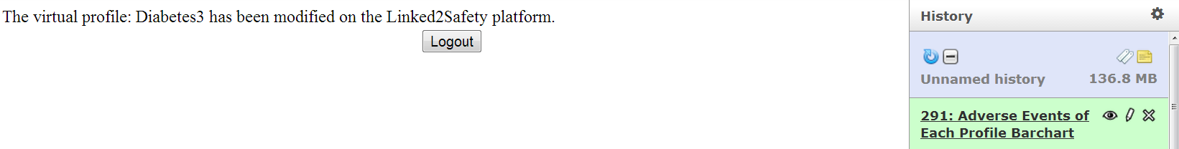

Figure 83: Confirmation of Modification of Virtual Profile

##### Delete Profile

This tool is used to delete virtual patients’ profiles of the user. The use of this tool is as follows:

1. Log into this tool by entering the user’s email address and password (Figure 84).
2. Select the user’s profiles to delete by selecting the check boxes next to the profiles (Figure 85).
3. Press the Delete button. The selected profiles are deleted from the knowledge base.
4. A confirmation about the deletion of the selected profiles is displayed (Figure 86).
5. Press the Logout button to log out from this tool.

## 

Figure 84: Login Screen of Delete Virtual Profiles

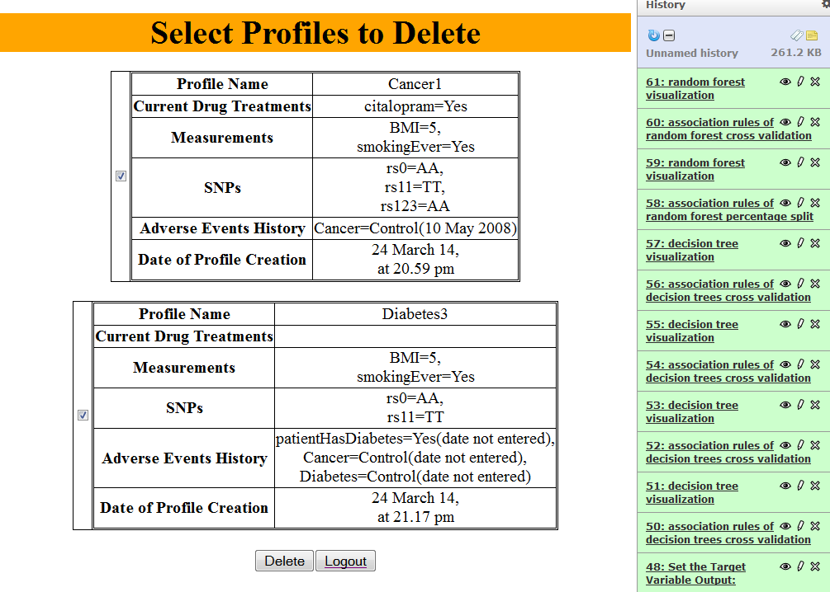

Figure 85: Select Profiles to Delete

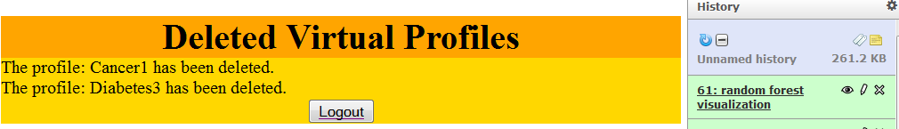

Figure 86: Confirmation of Deletion of Virtual Profiles

#### Adverse Events Detection

This component of the Data Analysis space is a new component added to the 2nd release of the integrated Linked2Safety platform. This component consists of the following tools:

* Generate Safety Alerts
* Safety Alerts Notification Subscription
* Safety Alerts Notification Un-subscription
* View Safety Alerts Notifications
* View Safety Alerts Notification Subscription

#### Generate Safety Alerts

This tool is used to generate safety alerts of virtual patients’ profiles. The use of this tool is as follows:

Log into this tool by entering the user’s email address and password (

1. Figure 87).
2. The virtual patients profiles of the user are displayed. Select the profiles for which safety alerts are to be generated (Figure 88).
3. Press the Generate Safety Alert button. Then, each association rule in the knowledge base is tried to match against each selected profile. If a rule matches a profile, then the rule detects possible adverse events for the profile. A safety alert consists of the adverse events detections of all the matched rules.
4. A safety alert is generated for each selected profile (Figure 89) and stored in the knowledge base. The association rules which are used to generate the safety alert of a profile are displayed. The date of the generation of the safety alert is displayed.
5. Press the Logout button to log out from this tool. To view the safety alerts in the future, use the View Safety Alerts Notifications tool 4.4.3.8.

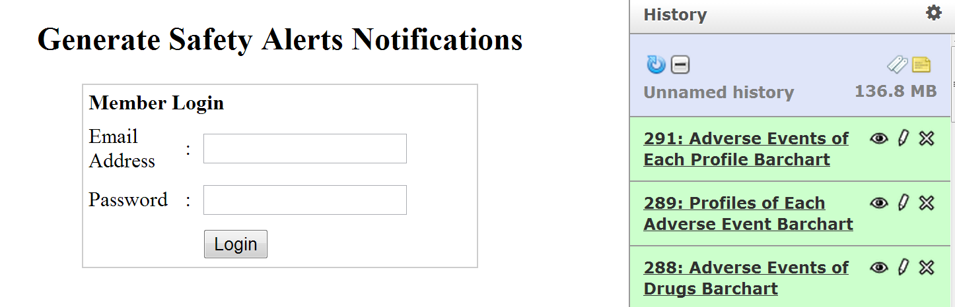

Figure 87: Login Screen of Generate Safety Alerts Notifications

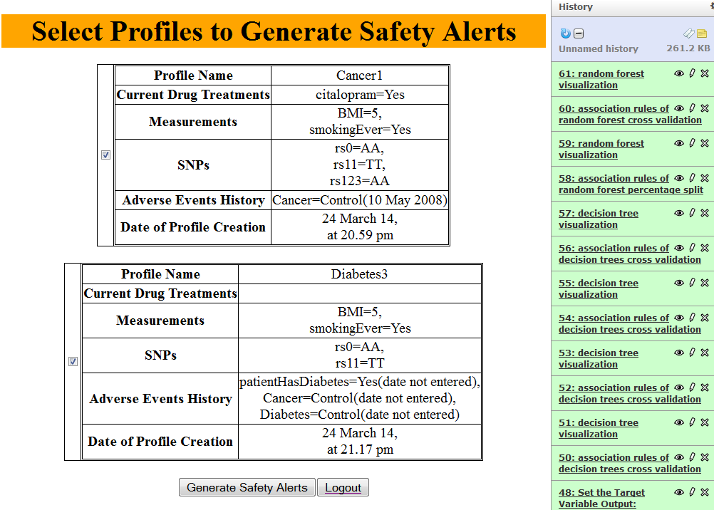

Figure 88: Select Profiles to Generate Safety Alerts

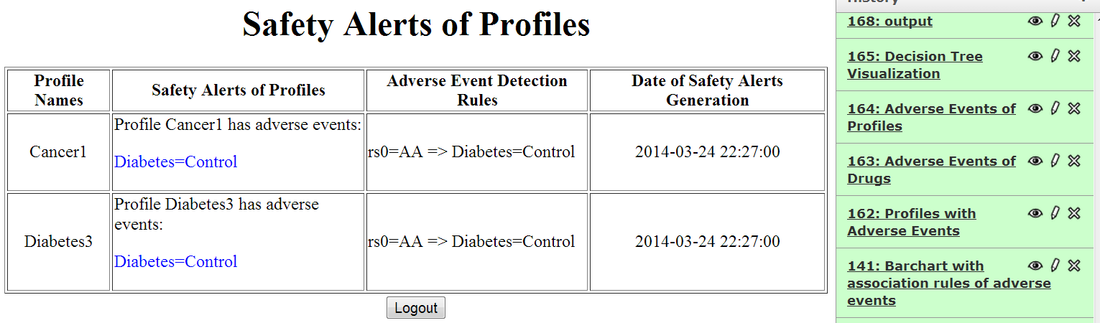

Figure 89: Safety Alerts of Profiles

#### Safety Alerts Notification Subscription

This tool is used to subscribe virtual patients’ profiles of a user to safety alert notification mechanism so that safety alerts are generated automatically for the selected profiles at the scheduled times. The use of this tool is as follows:

1. Log into this tool by entering the user’s email address and password (Figure 90).
2. The virtual profiles of the user are displayed. Select some profiles (Figure 91).
3. Press the Select button.
4. Schedule safety alert notification in terms of minute, hour, date of month, month and day of week by selecting the minute, hour, date of month, month and day of week from the drop-down lists (Figure 92). The allowed ranges of these fields are:

* minute: 0 to 59, * (* = every minute)
* hour: 0 to 23, * (0 = midnight; * = every hour)
* day of month: 1 to 31, * (* = every day)
* month: 1 to 12, * (* = every month)
* day of week: 0 to 6, * (* = every day of week)

For example, to schedule safety alerts notification at 8:30am on 10 June:

*minute: 30, hour: 8, day of month: 10, month: 6, day of week: \**

To schedule safety alert notification at 10pm every day:

*minute: 0, hour: 22, day of month: *, month: *, day of week: \**

To schedule safety alert notification at 8pm on every Wednesday:

*minute: 0, hour: 20, day of month: *, month: *, day of week: 3*

1. Press the Subscribe button to start the subscription so that safety alerts notifications will be generated at the scheduled times and stored into the knowledge base. Press the Cancel button to cancel the subscriptions.
2. A confirmation about the safety alerts notification subscriptions is displayed (Figure 93). To view the safety alerts notifications, use the View Safety Alerts Notifications tool 4.4.3.8.
3. Press the Logout button to log out from this tool.

### 

Figure 90: Login Screen of Safety Alerts Notification Subscription

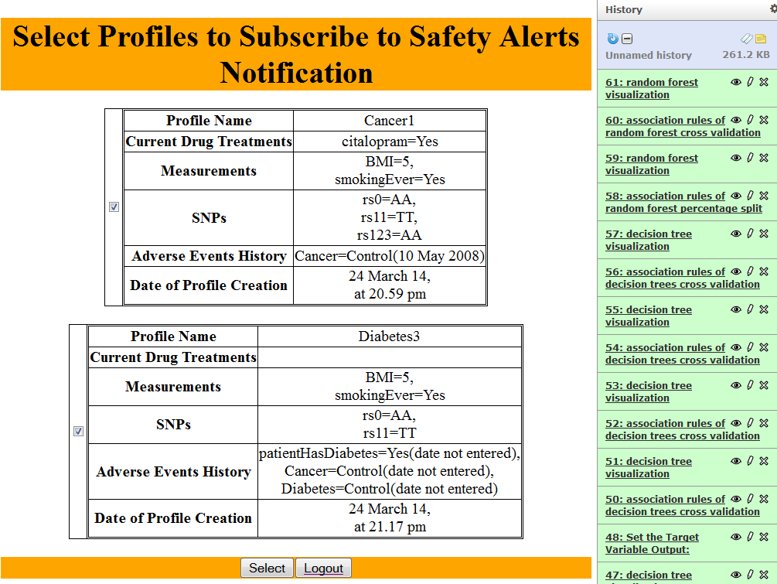

Figure 91: Select Profiles to Subscribe to Safety Alerts Notification

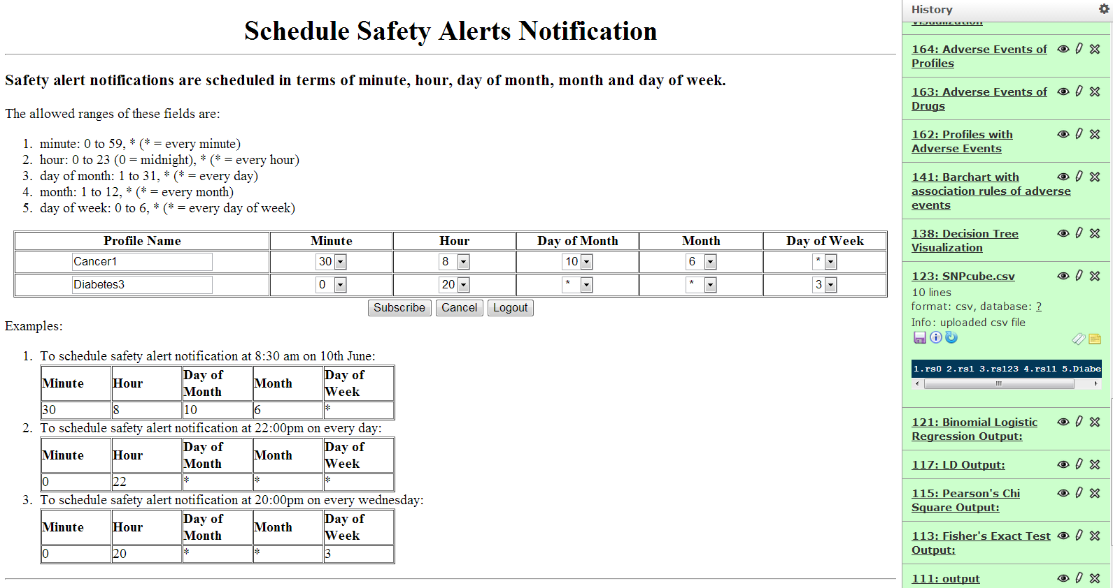

Figure 92: Schedule Safety Alerts Notifications

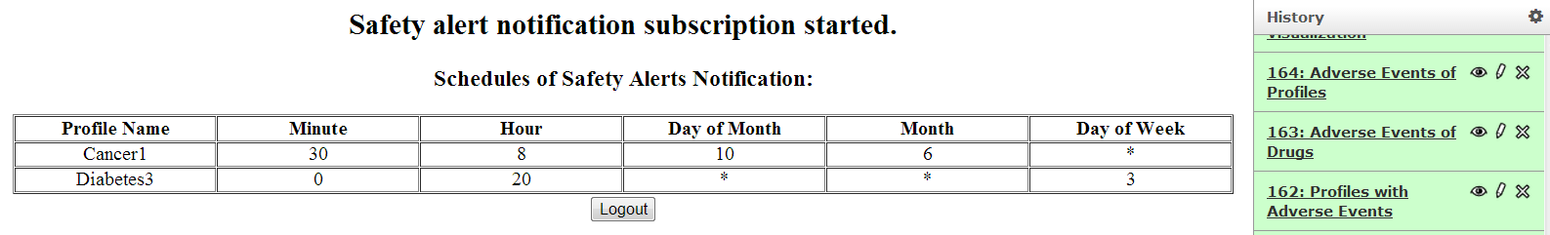

Figure 93: Confirmation of Safety Alerts Notifications Subscription

#### Safety Alerts Notification Un-subscription

This tool is used to cancel safety alerts notification subscriptions of virtual profiles so that safety alerts notifications will no longer be generated automatically. The use of this tool is as follows:

1. Log into this tool by entering the user’s email address and password (Figure 94).
2. The schedules of the safety alert notifications are displayed. Select the schedules to unsubscribe to safety alert notifications (Figure 95). Press the Cancel button to cancel un-subscription of notifications.
3. A confirmation about the unsubscription of safety alerts notifications is displayed (Figure 96).
4. Press the Logout button to log out from this tool.

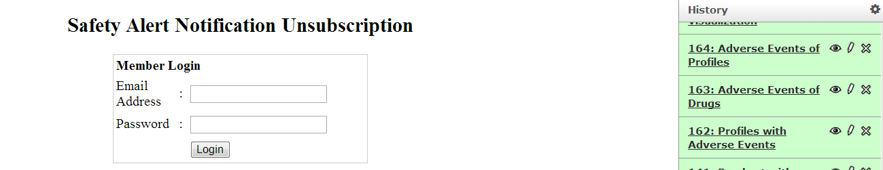

Figure 94: Login Screen of Safety Alerts Notification Un-subscription

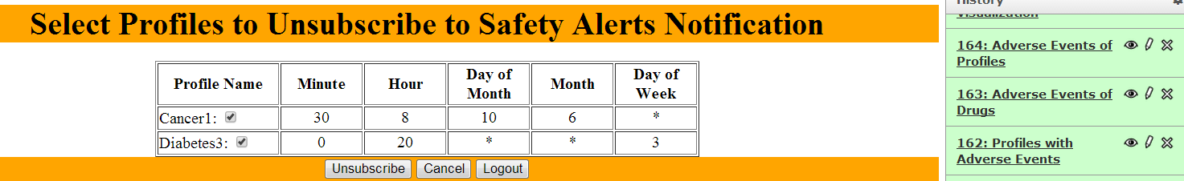

Figure 95: Select Profiles to Unsubscribe to Safety Alerts Notification

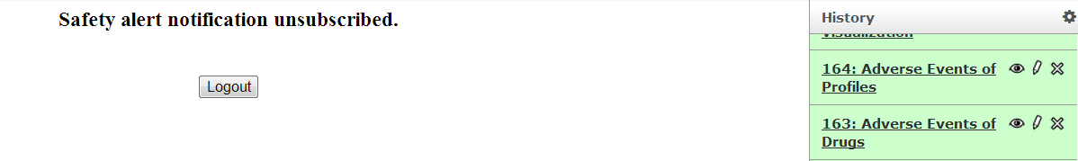

Figure 96: Confirmation of Safety Alerts Notifications Un-subscription

#### View Safety Alerts Notifications

This tool is used to view all the safety alerts notifications which are generated by the Generate Safety Alerts tool or Safety Alerts Notifications Subscription tool. The use of this tool is as follows:

1. Log into this tool by entering the user’s email address and password (Figure 97).
2. All the safety alerts notifications of the user’s profiles are displayed (Figure 98). The most recent safety alert notification is displayed at the top. The association rules which are used to generate the safety alerts are displayed. The dates when the safety alerts were generated are displayed.
3. Press the Logout button to log out from this tool.

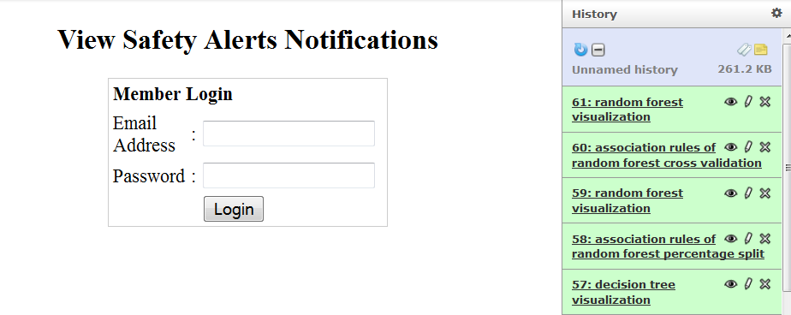

Figure 97: Login Screen of View Safety Alerts Notifications

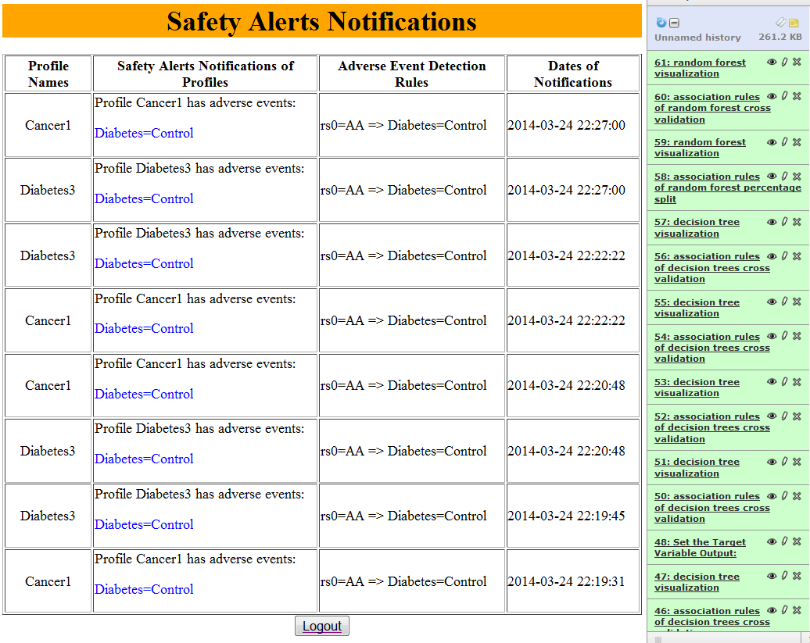

Figure 98: Safety Alerts Notifications of Profiles

#### View Safety Alerts Notification Subscription

This tool is used to view all the subscriptions of safety alerts notifications of virtual patients’ profiles of a user. The use of this tool is as follows:

1. Log into this tool by entering the user’s email address and password (
2. Figure 99).
3. The schedules of safety alerts notifications of profiles are displayed ().
4. Press the Logout button to log out from this tool.

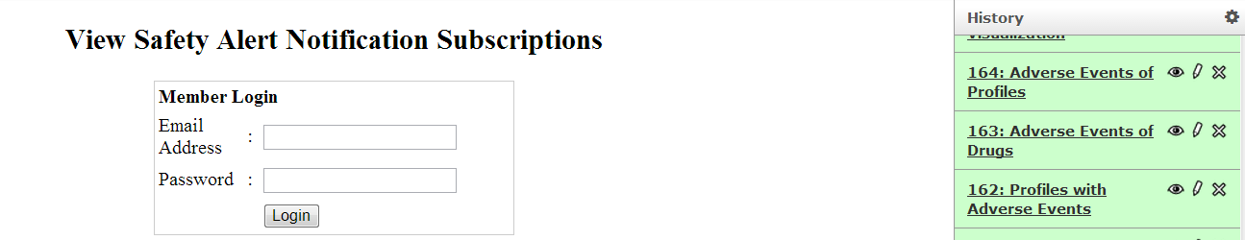

Figure 99: Login Screen of View Safety Alert Notification Subscriptions

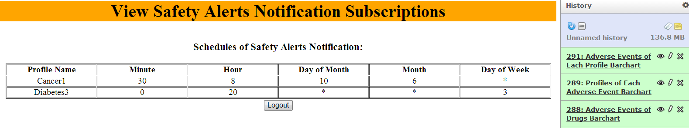

Figure 100: View Safety Alerts Notification Subscriptions

The tools presented in this section are used to visualize the information stored in the knowledge base of Linked2Safety. The tools allow the visualization of the number of associations and association rules available in the knowledge base of Linked2Safety with the use of bar charts and box plots. The visualizations are in pdf format and can be downloaded using the floppy disk icon in the history pane of the Linked2Safety data analysis space.

#### Visualization of Associations

The components of this space which were delivered in the first release of the Integrated Linked2Safety Platform have undergone some User Interface changes. In the following table you will see a revision list of changes made to the components since the first release of Linked2Safety:

Table 9: Revision List of Single Hypothesis Testing Components

|  |  |
| --- | --- |
| Component | Changes Occured |
| Associations Bar Chart | Added option for selecting the adverse events of interest |
| Associations Box Plot | Drop down option with possible variables that can be visualized |

##### Associations Bar Chart

This tool (see ) is used to create a bar chart that illustrates the number of associations that exist in the Linked2Safety Knowledge database for each adverse event.

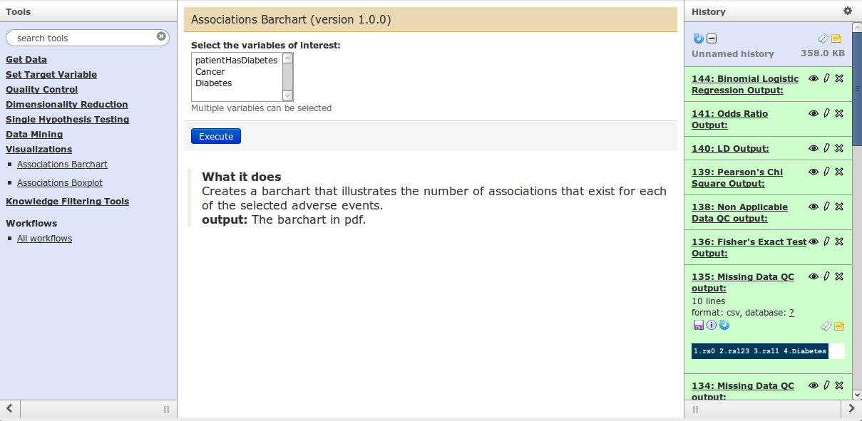

Figure 101: User interface of the Associations Bar Chart tool

To use this tool the user selects the adverse events of interest and then presses the Execute button. Once the tool is executed, its output is presented in the history pane. The tool outputs a pdf file that has the bar chart. By clicking on the “eye” icon, the bar chart is shown as illustrated in . The x axis has the adverse events and y axis the number of associations for each adverse event.

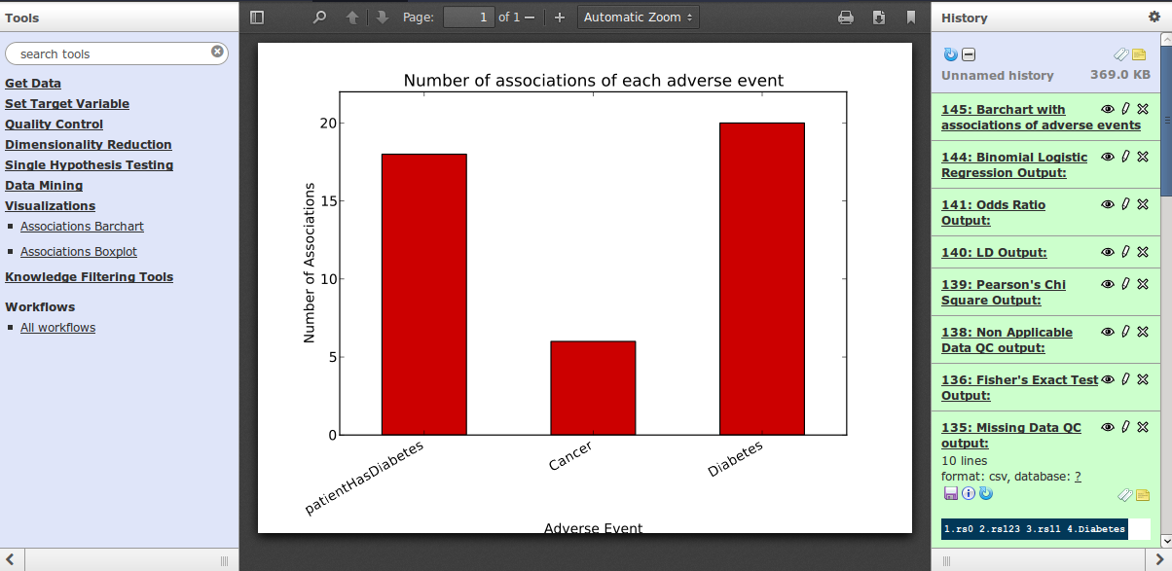

Figure 102: Output of the Associations Bar Chart tool

The programs implementing this tool are listed in Appendix A.

##### Associations Box Plot

This tool is used to create a box plot that illustrates the factors that were found to be associated with a specific variable and the diversion among the significance values of each association. The user interface of the tool is shown in .

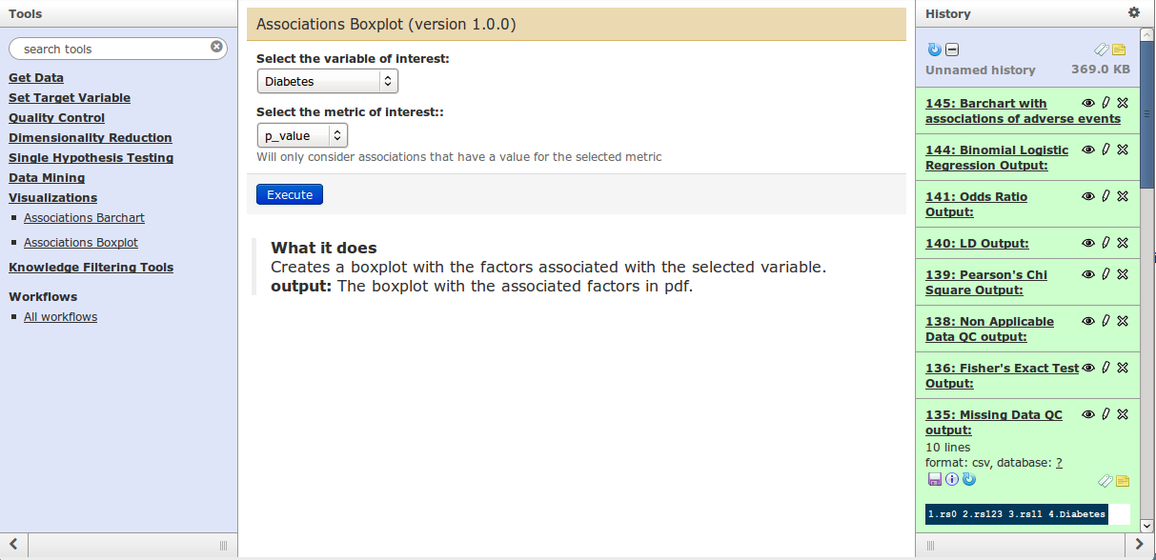

Figure 103: User interface of the Associations Box Plot tool

The use of this tool is as follows:

1. Select the variable of interest from the drop down menu.
2. Select from the menu if you are interested in associations that used the p value metric or the odds ratio metric.
3. Press the Execute button.

Once the tool is executed, its output is presented in the history pane. The tool outputs a PDF file that has the box plot. By clicking on the “eye” icon, the box plot is shown as illustrated in F. The x axis has the odds ratio values or the –log(p value), and the y axis the variables that are associated with the user defined variable of interest.

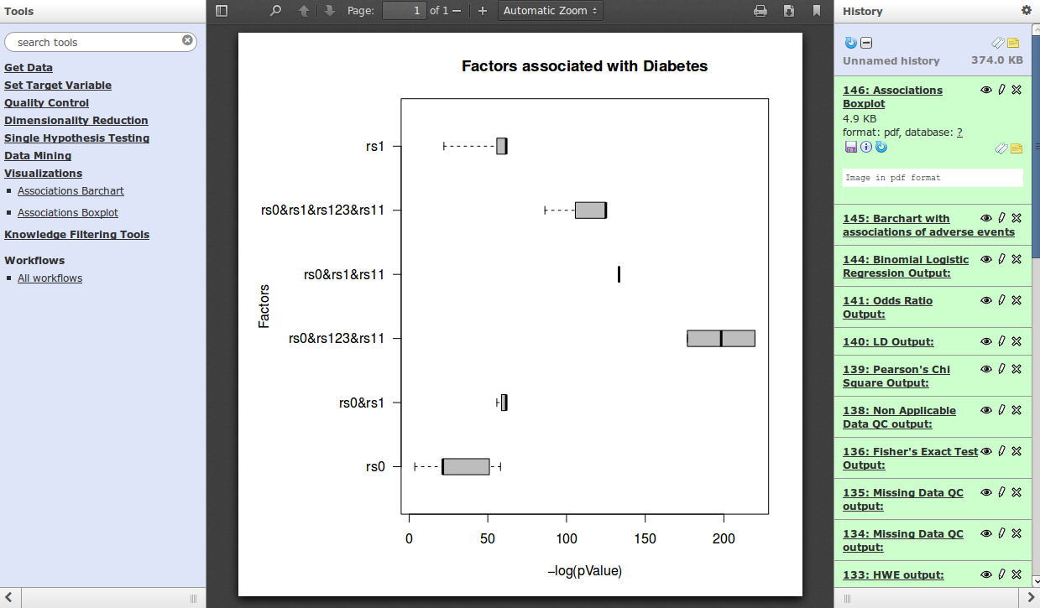

Figure 104: Output of the Associations Box Plot tool

The programs implementing this tool are referenced in Appendix A.

Conclusions

In this deliverable we aimed to provide an installation guide and end-user manual for the final version of the Linked2Safety platform. With this document, the work of the Linked2Safety is concluded, thus presenting the overall final behaviour of the platform. These descriptions on this deliverable include:

1. a top-down presentation of the integrated platform (with the rooms needed, as a minimum requirement for the security/ethical aspect)
2. installation guide and configuration for the Integrated Platform
3. end-user guide

References

[1] D. Blankenberg, G. V. Kuster, N. Coraor, G. Ananda, R. Lazarus, M. Mangan, A. Nekrutenko, and J. Taylor, “Galaxy: A Web-Based Genome Analysis Tool for Experimentalists,” in *Current Protocols in Molecular Biology*, John Wiley & Sons, Inc., 2001.

[2] J. Goecks, A. Nekrutenko, J. Taylor, and T. G. Team, “Galaxy: a comprehensive approach for supporting accessible, reproducible, and transparent computational research in the life sciences,” *Genome Biol.*, vol. 11, no. 8, p. R86, Aug. 2010.

[3] R. Ihaka and R. Gentleman, “R: A Language for Data Analysis and Graphics,” *J. Comput. Graph. Stat.*, vol. 5, no. 3, p. 299, Sep. 1996.

[4] “Admin/Tools/ToolConfigSyntax - Galaxy Wiki.” [Online]. Available: http://wiki.galaxyproject.org/Admin/Tools/ToolConfigSyntax. [Accessed: 03-Sep-2013].

[5] G. H. Hardy, “Mendelian proportions in a mixed population,” *Science*, vol. 28, no. 706, pp. 49–50, 1908.

[6] J. E. Wigginton, D. J. Cutler, and G. R. Abecasis, “A Note on Exact Tests of Hardy-Weinberg Equilibrium,” *Am. J. Hum. Genet.*, vol. 76, no. 5, pp. 887–893, May 2005.

[7] S. Shilaskar and A. Ghatol, “Dimensionality Reduction Techniques for Improved Diagnosis of Heart Disease,” *Int. J. Comput. Appl.*, vol. 61, no. 5, pp. 1–8, Jan. 2013.

[8] D. Tian, X. Zeng, and J. Keane, “Core-generating approximate minimum entropy discretization for rough set feature selection in pattern classification,” *Int. J. Approx. Reason.*, vol. 52, no. 6, pp. 863–880, Sep. 2011.

[9] N. Chu, L. Ma, J. Li, P. Liu, and Y. Zhou, “Rough set based feature selection for improved differentiation of traditional Chinese medical data,” in *2010 Seventh International Conference on Fuzzy Systems and Knowledge Discovery (FSKD)*, 2010, vol. 6, pp. 2667–2672.

[10] H. Hasan and N. M. Tahir, “Feature selection of breast cancer based on Principal Component Analysis,” in *2010 6th International Colloquium on Signal Processing and Its Applications (CSPA)*, 2010, pp. 1–4.

[11] S. H. Huang, L. R. Wulsin, H. Li, and J. Guo, “Dimensionality reduction for knowledge discovery in medical claims database: application to antidepressant medication utilization study,” *Comput. Methods Programs Biomed.*, vol. 93, no. 2, pp. 115–123, Feb. 2009.

[12] I. H. Witten and E. Frank, *Data Mining: Practical machine learning tools and techniques*. Morgan Kaufmann, 2005.

[13] Q. Shen and A. Chouchoulas, “A rough-fuzzy approach for generating classification rules,” *Pattern Recognit.*, vol. 35, no. 11, pp. 2425–2438, 2002.

[14] R. Battiti, “Using mutual information for selecting features in supervised neural net learning,” *Neural Networks IEEE Trans.*, vol. 5, no. 4, pp. 537–550, 1994.

[15] H. Liu and R. Setiono, “Feature selection via discretization,” *Knowl.Data Eng. IEEE Trans.*, vol. 9, no. 4, pp. 642–645, 1997.

[16] K. Pearson, “X. On the criterion that a given system of deviations from the probable in the case of a correlated system of variables is such that it can be reasonably supposed to have arisen from random sampling,” *Lond. Edinb. Dublin Philos. Mag. J. Sci.*, vol. 50, no. 302, pp. 157–175, 1900.

[17] F. Yates, “Contingency tables involving small numbers and the χ 2 test,” *Suppl. J. R. Stat. Soc.*, vol. 1, no. 2, pp. 217–235, 1934.

[18] R. A. Fisher, S. Genetiker, R. A. Fisher, S. Genetician, G. Britain, R. A. Fisher, and S. Généticien, *Statistical methods for research workers*, vol. 14. Oliver and Boyd Edinburgh, 1970.

[19] D. A. Maroof, “Binary Logistic Regression,” in *Statistical Methods in Neuropsychology*, Springer, 2012, pp. 67–75.

[20] D. Pregibon, “Logistic regression diagnostics,” *Ann. Stat.*, pp. 705–724, 1981.

[21] W. G. Hill, “Estimation of linkage disequilibrium in randomly mating populations,” *Heredity*, vol. 33, no. 2, p. 229, 1974.

[22] D. E. Reich, M. Cargill, S. Bolk, J. Ireland, P. C. Sabeti, D. J. Richter, T. Lavery, R. Kouyoumjian, S. F. Farhadian, and R. Ward, “Linkage disequilibrium in the human genome,” *Nature*, vol. 411, no. 6834, pp. 199–204, 2001.

[23] B. Devlin, N. Risch, and others, “A comparison of linkage disequilibrium measures for fine-scale mapping,” *Genomics*, vol. 29, no. 2, pp. 311–322, 1995.

[24] J. Cornfield, “A method of estimating comparative rates from clinical data; applications to cancer of the lung, breast, and cervix.,” *J. Natl. Cancer Inst.*, vol. 11, no. 6, p. 1269, 1951.

[25] F. Mosteller, “Association and estimation in contingency tables,” *J. Am. Stat. Assoc.*, vol. 63, no. 321, pp. 1–28, 1968.

[26] Antoniades, Athos, et al. "Linked2Safety: A secure linked data medical information space for semantically-interconnecting EHRs advancing patients' safety in medical research." Bioinformatics & Bioengineering (BIBE), 2012 IEEE 12th International Conference on. IEEE, 2012

[27] Forgó, Nikolaus, Magdalena Góralczyk, and Constantin Graf von Rex. "Security issues in research projects with patient's medical data." Bioinformatics & Bioengineering (BIBE), 2012 IEEE 12th International Conference on. IEEE, 2012

[28] D1.2 – Linked2Safety Reference Architecture, http://www.linked2safety-project.eu/node/30, 2012

[29] D1.1 – Requirements Analysis, http://www.linked2safety-project.eu/node/30, 2012

[30] D6.1 – Linked2Safety Platform Integrated Architecture, http://www.linked2safety-project.eu/node/30, 2013

APPENDIX A: Linked2Safety Software Components Listing

### Query Interface

|  |  |
| --- | --- |
| **L2SQueryInterface.war** | Linked2Safety Query Interface  *The archive size is 22,6 MB.*  The folder contains of the implementation of the Query Interface incorporated into Galaxy |

### Knowledge Base Search

|  |  |
| --- | --- |
| **L2SKnowBase.war** | Linked2Safety Query Interface  *The archive size is 13,6 MB.*  The folder contains of the implementation of the Knowledge Base Search Interface incorporated into Galaxy |

### Periodic Validation of Workflow Results

|  |  |
| --- | --- |
| **WorkflowValidator.zip** | Linked2Safety Cron Job Script for Periodic Workflow Results  *The archive size is 6,8 MB.*  The folder contains of the implementation of the Periodic Validation of Workflow results |

### Interoperable EHR Data Space Tools

Table5 below presents the attached files that constitute Interoperable EHR data space.

|  |  |
| --- | --- |
| **Mapping and Transformation/Linked2safetywin32.exe** | Linked2Safety Interoperable EHR Data Space  *The archive size is 35.7 MB.*  The folder contains of the implementation of the Schema Alignment, Transformation Tool, Non-Identifiable Data cube and RDF Data cubes software. |

### Data Analysis Space and Database

|  |  |
| --- | --- |
| **galaxyDB_schema.sql** | Linked2Safety Database schema  *The file size is 52.2 KB* |
| **Galaxy-dist** | Galaxy updated version of tools  *The file size is 114.0 MB* |

**File Structure of Data Analysis Space**

**Set the Target Variable Tool**

The programs implementing this tool are the following:

* setTarget
* setTarget.xml
* runSetTarget.sh

To install this tool on the Linked2Safety platform, these programs are placed under a directory ‘SetTarget’ under the directory ‘galaxy-dist/tools’.

**Quality Control Programs**

**Hardy-Weinberg Equilibrium Test**

The programs implementing this tool are the following:

* hardyWeinbergEquilibrium
* hardy_weinberg.xml
* runHWE.sh

To install this tool on the Linked2Safety platform, these programs are placed under a directory ‘QualityControl’ under the directory ‘galaxy-dist/tools’.

**Allele Frequency Test**

The programs implementing this tool are the following:

* alleleFrequencyQC
* alleleFrequencyQC.xml
* runAlleleFreq.sh

To install this tool on the Linked2Safety platform, these programs are placed under a directory ‘QualityControl’ under the directory ‘galaxy-dist/tools’.

**Missing Data Test**

The programs implementing this tool are the following:

* missingDataQC
* missingDataQC.xml
* runMissingData.sh

To install this tool on the Linked2Safety platform, these programs are placed under a directory ‘QualityControl’ under the directory ‘galaxy-dist/tools’.

**Non-Applicable Data Test**

The programs implementing this tool are the following:

* nonApplicableDataQC
* nonApplicableDataQC.xml
* run nonApplicableDataQC.sh

To install this tool on the Linked2Safety platform, these programs are placed under a directory ‘QualityControl’ under the directory ‘galaxy-dist/tools’.

**Single Hypothesis Testing Programs**

**Pearson’s Chi Square test**

The programs implementing this tool are the following:

* chiSquareTest.R
* chiSquareTest.xml
* runChiSquare.sh

To install this tool on the Linked2Safety platform, these programs are placed under a directory ‘SingleHypothesisTesting’ under the directory ‘galaxy-dist/tools’.

**Fisher’s Exact Test**

The programs implementing this tool are the following:

* fisherExactTest.R
* fisherExactTest.xml
* runFisherExact.sh

To install this tool on the Linked2Safety platform, these programs are placed under a directory ‘SingleHypothesisTesting’ under the directory ‘galaxy-dist/tools’.

**Binomial Logistic Regression**

The programs implementing this tool are the following:

* BinomialLogisticRegression.R
* BinomialLogisticRegression.xml
* runBinomialLR.sh

These programs are placed under a directory ‘SingleHypothesisTesting’ under the directory ‘galaxy-dist/tools’.

**Linkage Disequilibrium**

The programs implementing this tool are the following:

* linkageDisequilibrium.R
* linkageDisequilibrium.xml
* runLD.sh

These programs are placed under a directory ‘SingleHypothesisTesting’ under the directory ‘galaxy-dist/tools’.

**Odds Ratio**

The programs implementing this tool are the following:

* oddsRatio
* oddsRatio.xml
* runOR.sh

To install this tool on the Linked2Safety platform, these programs are placed under a directory ‘SingleHypothesisTesting’ under the directory ‘galaxy-dist/tools’.

## Dimensionality Reduction Programs

### Rough Set Dimensionality Reduction

The programs implementing this tool are the following:

* ReduceDataRSFS.class
* RSys.class
* BitSet.class
* DataCube.class
* DataMatrix.class
* DimensionalityReduction.jar
* Reduce_data_rsfs.xml
* runReduceDataRSFS.sh

To install this tool on the Linked2Safety platform, these programs are placed under a directory ‘DimensionalityReduction’ under the directory ‘galaxy-dist/tools’.

### Information Gain Dimensionality Reduction

The programs implementing this tool are the following:

* ReduceDataInformationGainFeatureSelection.class
* DataCube.class
* DataMatrix.class
* Weka-3-6-7.jar
* DimensionalityReduction.jar
* reduce_data_igfs.xml
* runReduceDataIGFS.sh

To install this tool on the Linked2Safety platform, these programs are placed under a directory ‘DimensionalityReduction’ under the directory ‘galaxy-dist/tools’.

### Chi Squared Dimensionality Reduction

The programs implementing this tool are the following:

* ReduceDataChiSquaredFeatureSelection.class
* DataCube.class
* DataMatrix.class
* Weka-3-6-7.jar
* DimensionalityReduction.jar
* reduce_data_csfs.xml
* runReduceDataCSFS.sh

To install this tool on the Linked2Safety platform, these programs are placed under a directory ‘DimensionalityReduction’ under the directory ‘galaxy-dist/tools’.

### Decision Trees (Cross Validation)

The programs implementing this tool are the following:

* DecisionTrees.class
* DataCube.class
* DataMatrix.class
* Weka-3-7-7.jar
* DataMining.jar
* decisiontrees_cv.xml
* runDecisionTrees_cv.sh

To install this tool on the Linked2Safety platform, these programs are placed under a directory ‘DataMining’ under the directory ‘galaxy-dist/tools’.

### Random Forest (Percentage Split)

The programs implementing this tool are the following:

* RandomForest.class
* DataCube.class
* DataMatrix.class
* Weka-3-7-7.jar
* DataMining.jar
* randomforest.xml
* runRandomForest.sh

To install this tool on the Linked2Safety platform, these programs are placed under a directory ‘DataMining’ under the directory ‘galaxy-dist/tools’.

### Decision Trees (Percentage Split)

The programs implementing this tool are the following:

* DecisionTrees.class
* DataCube.class
* DataMatrix.class
* Weka-3-7-7.jar
* DataMining.jar
* decisiontrees.xml
* runDecisionTrees.sh

To install this tool on the Linked2Safety platform, these programs are placed under a directory ‘DataMining’ under the directory ‘galaxy-dist/tools’.

**Random Forest (Cross Validation)**

The programs implementing this tool are the following:

* RandomForest.class
* DataCube.class
* DataMatrix.class
* Weka-3-7-7.jar
* DataMining.jar
* randomforest_cv.xml
* runRandomForest_cv.sh

To install this tool on the Linked2Safety platform, these programs are placed under a directory ‘DataMining’ under the directory ‘galaxy-dist/tools’.

**Visualization Programs**

**Associations Bar chart**

The programs implementing this tool are the following:

* assocBarchart.py
* assocBarchart.xml
* retrieveAssocBarchartSelectValues.py

To install this tool on the Linked2Safety platform, these programs are placed under a directory ‘Visualizations’ under the directory ‘galaxy-dist/tools’.

**Associations Box Plot**

The programs implementing this tool are the following:

* assocBoxplot.R
* assocBoxplot.xml
* retrieveAssocBoxPlotSelectValues.py
* runAssocBoxPlot.sh

To install this tool on the Linked2Safety platform, these programs are placed under a directory ‘Visualizations’ under the directory ‘galaxy-dist/tools’.

**Knowledge Extraction and Filtering Programs**

**Knowledge Extraction Mechanism**

The programs implementing this tool are the following:

* workflowLogging.py
* insert_workflow.py
* getCategoriesMeaning.py

To install this tool on the Linked2Safety platform, these programs are placed under a directory ‘KnowledgeExtractionAndFilteringMechanism’ under the directory ‘galaxy-dist/tools’.

**Filter Association**

The programs implementing this tool are the following:

* filterAssociation.py
* filterAssociation.xml
* retrieveAssociations.py

To install this tool on the Linked2Safety platform, these programs are placed under a directory ‘KnowledgeExtractionAndFilteringMechanism’ under the directory ‘galaxy-dist/tools’.

**Filter Association Rule**

The programs implementing this tool are the following:

* filterAssociationRule.py
* filterAssociationRule.xml
* retrieveAssociationRules.py

To install this tool on the Linked2Safety platform, these programs are placed under a directory ‘KnowledgeExtractionAndFilteringMechanism’ under the directory ‘galaxy-dist/tools’.

**Insert Association**

The programs implementing this tool are the following:

* insertAssociation.py
* insertAssociation.xml

To install this tool on the Linked2Safety platform, these programs are placed under a directory ‘KnowledgeExtractionAndFilteringMechanism’ under the directory ‘galaxy-dist/tools’.

**Insert Association Rule**

The programs implementing this tool are the following:

* insertAssociationRule.py
* insertAssociationRule.xml

To install this tool on the Linked2Safety platform, these programs are placed under a directory ‘KnowledgeExtractionAndFilteringMechanism’ under the directory ‘galaxy-dist/tools’.

## Profile Management Programs

The source code mentioned in the section can be located at <https://github.com/linked2safety/code>, under section “Open Access Room/Galaxy/tools/”.

### Create Virtual Profile

The programs implementing this tool are as follows:

* create_profile.xml
* createProfile.html
* main_login.html
* logout.php
* checklogin.php
* db.php
* createProfile.js

To install this tool on the Linked2Safety platform:

* ‘create_profile.xml’ is placed under a directory ‘VirtualProfile’ under the directory ‘galaxy-dist/tools’.
* The remaining programs are placed under a directory ‘createprofile’ under the directory ‘/var/www’.
* Set the permission of the directory ‘createprofile’ and that of the programs under ‘createprofile’ as described in .

### Modify Virtual Profile

The programs implementing this tool are the following:

* modify_profile.xml
* modifyProfile.html
* main_login.html
* logout.php
* checklogin.php
* selectProfile.php
* modifyProfile.php
* storeModifiedProfile.php
* db.php
* createProfile.js

To install this tool on the Linked2Safety platform:

* ‘modify_profile.xml’ is placed under a directory ‘VirtualProfile’ under the directory ‘galaxy-dist/tools’.
* The remaining programs are placed under a directory ‘modifyprofile’ under the directory ‘/var/www’.
* Set the permission of the directory ‘modifyprofile’ and that of the programs under ‘modifyprofile’ as described in .

### Delete Virtual Profile

The programs implementing this tool are the following:

* delete_profile.xml
* main_login.html
* logout.php
* checklogin.php
* db.php
* deleteProfile.php
* selectProfile.php

To install this tool on the Linked2Safety platform:

* ‘delete_profile.xml’ is placed under the directory ‘VirtualProfile’ under the directory ‘galaxy-dist/tools’.
* The remaining programs are placed under a directory ‘deleteprofile’ under the directory ‘/var/www’.
* Set the permission of the directory ‘deleteprofile’ and that of the programs under ‘deleteprofile’ as described in .

### View Virtual Profiles

The programs implementing this tool are the following:

* view_profile.xml
* main_login.html
* logout.php
* checklogin.php
* db.php
* viewProfile.php

To install this tool on the Linked2Safety platform:

* ‘view_profile.xml’ is placed under the directory ‘VirtualProfile’ under the directory ‘galaxy-dist/tools’.
* The remaining programs are placed under a directory ‘viewprofile’ under the directory ‘/var/www’.
* Set the permission of the directory ‘viewprofile’ and that of the programs under ‘viewprofile’ as described in .

## Adverse Event Early Detection Mechanism Programs

### View Safety Alerts Notifications

The programs implementing this tool are the following:

* viewSafetyAlertsNotifications.xml
* main_login.html
* logout.php
* checklogin.php
* db.php
* viewSafetyAlertsNotifications.php

To install this tool on the Linked2Safety platform:

* ‘viewSafetyAlertsNotifications.xml’ is placed under a directory ‘SafetyAlert’ under the directory ‘galaxy-dist/tools’.
* The remaining programs are placed under a directory ‘viewsafetyalertsnotifications’ under the directory ‘/var/www’.
* Set the permission of the directory ‘viewsafetyalertsnotifications’ and that of the programs under ‘viewsafetyalertsnotifications’ as described in .

### Generate Safety Alerts

The programs implementing this tool are the following:

* safetyAlertGeneration.xml
* main_login.html
* logout.php
* checklogin.php
* db.php
* safetyAlertGeneration.php
* SafetyAlert.php
* selectProfile.php
* safetyalert (Postgres dump file containing the SafetyAlert table)

To install this tool on the Linked2Safety platform:

* ‘safetyAlertGeneration.xml’ is placed under the directory ‘SafetyAlert’ under the directory ‘galaxy-dist/tools’.
* The remaining programs are placed under a directory ‘generatesafetyalerts’ under the directory ‘/var/www’.
* Add the SafetyAlert table to the database usingpsql galaxy_prod <safetyalert.
* Set the permission of the directory ‘generatesafetyalerts’ and that of the programs under ‘generatesafetyalerts’ as described in .

### Safety Alerts Notification Subscription

The programs implementing this tool are the following:

* safetyAlertNotificationSubscription.xml
* main_login.html
* logout.php
* checklogin.php
* db.php
* safetyAlertNotificationSubscription.php
* specifyTimeToGenerateSafetyAlert.php
* generateSafetyAlert.php
* SafetyAlert.php
* Ssh2_crontab_manager2.php
* selectProfile.php
* safetyalert (Postgres dump file containing the SafetyAlert table)
* cron_job (Postgres dump file containing the cron_job table)
* PHP libssh2 library
* cron (a job scheduler software pre-installed on unix and linux operating systems)

To install this tool on the Linked2Safety platform:

* ‘safetyAlertNotificationSubscription.xml’ is placed under the directory ‘SafetyAlert’ under the directory ‘galaxy-dist/tools’.
* The remaining programs are placed under a directory ‘safetyalertsubscription’ under the directory ‘/var/www’.
* Add SafetyAlert and cron_job tables to the galaxy_prod database using:

psql galaxy_prod <<table file>

* Install PHP libssh2 library as follows:

apt-get install libssh2-1-dev libssh2-php

Then, restart Apache:  
  
sudo /etc/init.d/apache2 restart

or

/etc/init.d/apache2 restart

* Set the permission of the directory ‘safetyalertsubscription’ and that of the programs under ‘safetyalertsubscription’ as described in .

### Safety Alerts Notification Unsubscription

The programs implementing this tool are the following:

* safetyAlertNotificationUnsubscribe.xml
* main_login.html
* logout.php
* checklogin.php
* db.php
* safetyAlertNotificationUnsubscription.php
* Ssh2_crontab_manager2.php
* selectProfile.php
* cron_job (Postgres dump file containing the cron_job table)
* PHP libssh2 library
* cron (a job scheduler software pre-installed on unix and linux operating systems)

To install this tool on the Linked2Safety platform:

* ‘safetyAlertNotificationUnsubscribe.xml’ is placed under the directory ‘SafetyAlert’ under the directory ‘galaxy-dist/tools’.
* The remaining programs are placed under a directory ‘safetyalertunsubscription’ under the directory ‘/var/www’.
* Add the cron_job table to the galaxy_prod database using:

psql galaxy_prod <cron_job

* Install PHP libssh2 library as follows:

apt-get install libssh2-1-dev libssh2-php

Then, restart Apache: “sudo /etc/init.d/apache2 restart” or “/etc/init.d/apache2 restart”

* Set the permission of the directory ‘safetyalertunsubscription’ and that of the programs under ‘safetyalertunsubscription’ as described in .

### View Safety Alert Notification Subscription

The programs implementing this tool are the following:

* viewSafetyAlertSubscriptions.xml
* main_login.html
* logout.php
* checklogin.php
* db.php
* viewSafetyAlertsSubscriptions.php
* cron_job (Postgres dump file containing the cron_job table)

To install this tool on the Linked2Safety platform:

* ‘viewSafetyAlertSubscriptions.xml’ is placed under the directory ‘SafetyAlert’ under the directory ‘galaxy-dist/tools’;
* The remaining programs are placed under a directory ‘viewsubscriptions’ under the directory ‘/var/www’;
* Set the permission of the directory ‘viewsubscriptions’ and that of the programs under ‘viewsubscriptions’ as described in .

## Setting of Permissions of Folders and Files

Set the permissions of the directory safetyalertsubscription to drwxrwxrwx using chmod 777 /var/www/safetyalertsubscription

Set the permissions of the directory safetyalertunsubscription to drwxrwxrwx using chmod 777 /var/www/safetyalertunsubscription

Set the permissions of the following directories to drwxr-xr-x using chmod 755 <directory>:

* generatesafetyalerts
* viewsafetyalertsnotifications
* viewsubscriptions
* createprofile
* deleteprofile
* modifyprofile
* viewprofile

Change the permissions of all the .php files and .html files under each folder above to the permission: rwxr-xr-x using chmod 755 <file name>.

To check the permissions of the files and folders under a directory, use ls -l

1. http://www.meddra.org
2. http://www.ejbca.org
3. https://www.jboss.org/overview/
4. http://tomcat.apache.org/